Much research activity associated with finfish in 2014 has been in the form of targeted pieces of work, generating reports throughout the year, rather than as one monolithic piece of work reporting at the year end. Many of these reports have been connected with developing understanding of and management measures for the Bass fishery.
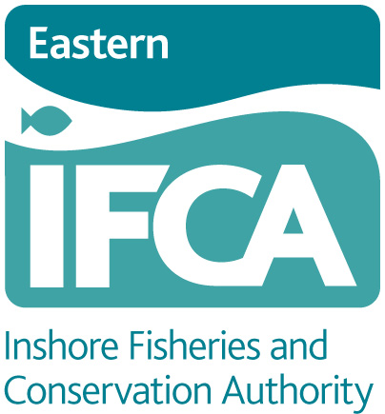

RESEARCH REPORT
2014

Finfish

S. Thompson

These reports, together with the Contents, where appropriate, are –
- Composition of commercial finfish catch
  - Figures 2
  - Introduction 3
  - Overview & Major Species 3
  - Reconciliation of EIFCA and MMO landings data 3
  - All Species overview 9
  - Bass 12
  - References 15
- Brief summary of Environment Agency Water Framework Directive sampling results
- Considerations in connection with bass stocks and management
  - Figures 2
  - Introduction 3
  - Relevant facts of Bass biology 5
  - Current situation in the Eastern IFCA area 6
  - The bigger picture 9
  - Management factors & options 13
    - Spatial & temporal closures 13
      - Distribution of Bass in our district 13
      - Spawning aggregations 17
    - Method control 19
    - MLS (Minimum Landing Size) / Mesh size 20
    - Direct control of fishing mortality 20
    - Protection of vulnerable stages 21
    - Bycatch from shrimp fishing, especially in estuaries 22
    - Bycatch in other fisheries 22
  - Bass – Fast Facts 23
  - References 24
  - Appendix 1 – Extracts from transcript of UK Parliament debate 3rd December 2014 26
  - Appendix 2 – EU Emergency Measures 26th January 2015 27
  - Appendix 3 – Press Release from EU newsroom 26th January 2015
28
- Bass minimum landing size (MLS) considerations
- Points of concern in connection with Saltmarsh “Enhancement” schemes
- An assessment of the Anglian Coast Net Limitation Order and its implications for management of inshore finfish stocks
- An assessment of Unlicensed Herring fishing in Eastern IFCA waters and its implications for management of inshore finfish stocks
- A report on the Fish Survey on the River Deben in July 2014
  - Figures 2
  - Introduction 3
  - Location, conditions and method 3
  - Results 5
  - Discussion 9
  - Appendix 1. Results of R. Deben Fish Survey July 2014 10

All of these pieces of work can be found as individual reports within this general folder.

