

**Papers for a meeting of the**

**FINANCE & PERSONNEL SUB-COMMITTEE**

**to be held at**

**Eastern IFCA Offices,**

**6 North Lynn Business Village, Bergen Way, King’s Lynn, PE30 2JG**

**15th January 2014**

**1030 hours**

Meeting: **Finance and Personnel Sub-Committee**

Date: 15 January 2014

Time: 10.30 hours

Venue: Eastern IFCA Office

6 North Lynn Business Village

Bergen Way

King’s Lynn

Norfolk

PE30 2JG

*“Eastern Inshore Fisheries and Conservation Authority will lead, champion and manage a sustainable marine environment and inshore fisheries, by successfully securing the right balance between social, environmental and economic benefits to ensure healthy seas, sustainable fisheries and a viable industry.”*

**Agenda**

1. Welcome by the Chair
2. Apologies for absence
3. Declaration of members’ interests

**Action Items**

1. Minutes of the Finance & Personnel Sub-Committee meeting on 17 October 2013
2. Matters Arising
3. Provisional Estimates of Expenditure for the period 1 April 2014 to 31 March 2015 – *Hd Fin*
4. Provisional Forecasts of Estimates of Expenditure for the period 1 April 2015 to 31 March 2018 – *Hd Fin*
5. Future accommodation options – *CEO*
6. Deployable office infrastructure – *CEO*
7. Introduction of a payback policy related to developmental training funded by EIFCA – *Hd HR*
8. Salary Scale Point Review – *Hd HR*
9. To resolve that under Section 100(A)(4) of the Local Government Act 1972, the public be excluded from the meeting for items 9 and 10 on the grounds that it involves the likely disclosure of exempt information as defined in Paragraph 1 of Schedule 12A of the Act
10. To receive a report on the six month probationary period of Mate/IFCA – *Hd HR*

**Information Items**

1. HR Update – *Hd HR*
2. Any other urgent business

*To consider any other items which the Chair is of the opinion are matters of urgency by reason of special circumstances which must be specified*

Philip Haslam

Chief Executive Officer

Date: 23 December 2013

**Finance & Personnel Sub-Committee**

*“EIFCA will lead, champion and manage a sustainable marine environment and inshore fisheries,*

*by successfully securing the right balance between social, environmental and economical benefits*

*to ensure healthy seas, sustainable fisheries and a viable industry”.*

A meeting of the Finance & Personnel Sub-Committee took place at the EIFCA offices, 6 North Lynn Business Village, King’s Lynn, on 17th October at 1030 hours.

**Members Present:**

Cllr Tony Goldson Chair Suffolk County Council

Mr Peter Barham Vice Chair MMO Appointee

Cllr Hilary Cox Norfolk County Council

Cllr Richard Fairman Lincolnshire County Council

Cllr Keith Patience Suffolk County Council

Cllr Margaret Wilkinson Norfolk County Council

**Eastern IFCA Officers Present:**

Philip Haslam CEO

Christine Hurley Head of Finance

Nichola Freer Head of Human Resources (HR)

**F&P13/22 Welcome by the Clerk**

The Clerk welcomed members to the meeting.

**F&P13/23 Apologies for absence**

Apologies for absence were received from Cllr Tony Turner (LCC), Dr Bolt & Mr Worrall (MMO Appointees).

**F&P13/24 Declarations of Interest**

There were no declarations of interest by Members.

**F&P13/25 Election of Chair & Vice Chair**

**Following nominations for the post of Chair of the sub-committee it was Resolved that Cllr Goldson would take on the role.**

**Proposed: Peter Barham**

**Seconded: Hilary Cox**

**All Agreed**

**It was Resolved the position of Vice-Chair would be held by Cllr Wilkinson.**

**Proposed: Hilary Cox**

**Seconded: Tony Goldson**

**All Agreed.**

**F&P13/26 Minutes of the Finance and Personnel Sub-Committee meeting held on 25th June 2013**

Members agreed to accept the minutes of the meeting as a true record of proceedings.

**F&P13/27 Matters Arising**

F&P13/17 CEO JOB EVALUATION: As part of this process it had previously been agreed there would be a review of the Authority’s pay scale points after a 12 month period. The CEO requested confirmation that the sub-committee members still wished this process to be carried out by June 2014.

Members confirmed it was still their intention that this process would be carried out.

**F&P13/28 Preliminary provisional estimates of expenditure for the period 1 April 2014 to 31 March 2015**

The Head of Finance advised that the Preliminary estimates had been compiled to allow members to see the projected income and expenditure for the current financial year as well as assessing what the requirements were likely to be for the following financial year. It was felt it was particularly important in the current financial climate as it would give members the opportunity to consider the preliminary levy proposal and allow time to avoid any problems which may occur when setting the levy budget in January. The figures provided were based on 5 months actual figures, these would be revised to reflect 8 months actual expenditure in January.

Members were advised of how the figures had been arrived at and potential savings and increases in specific budget headings were explained.

It was noted that some areas of potential income were hard to budget for as it is not possible to predict if licences are going to be issued or the vessels are going to be chartered. It was also noted that funding provision had to be made in order to be prepared in the event of a legal dispute regarding the proposed new byelaws. Having spoken to the County Councils, an allowance of 1% on salaries and 2% on prices had been incorporated.

Mr Barham questioned whether EIFCA staff was aware of how good the pension scheme is, which the Head of Finance advised that she believed they were aware of this, she also advised that the scheme was being revamped in 2014 which may mean the employer’s contribution would reduce.

The reserve balances were discussed, with particular regard to whether or not the Authority was likely to be pressurised to reduce the reserve balances. The Internal Auditor had commented that the reserves should be reviewed to ensure the Authority thought they were at an appropriate level, which is why funds are held in ‘committed ear-marked reserves’.

Reference was made to the suggested replacement of Authority vehicles and whether or not they were actually at the end of their useful life as there was a thought that in some cases ‘servicing was cheaper than depreciation’. The CEO explained that an evaluation of the current vehicles was being carried out. It had already been ascertained that there were areas of the district which were difficult to access in the type of vehicle being used. The evaluation would determine what type of vehicles were most appropriate then a review would be carried out of the pros/cons of new or secondhand, purchased or leased vehicles were most cost effective for the Authority.

It was noted under the salaries heading that some full-time posts were being carried out on a part-time basis. Mr Barham questioned whether the full workload was being completed, the CEO believed in these instances more than sufficient work was being undertaken.

**Members Agreed to note and agree the Preliminary Estimates of Expenditure**.

**F&P13/29 Preliminary Provisional forecasts of estimates of expenditure for the period 1 April 2015 to 31st March 2018**

Preliminary forecasts of estimates up to 31st March 2018 had been prepared. An assumption was made that the full complement of staff would remain in place and progress through the scales, however nothing had been included for salary pay awards.

The Head of Finance provided explanation for the predicted increases/decreases over the period and advised that no major capital expenditure had been included.

**Members Agreed to note the Preliminary Forecasts of estimates of expenditure for the period 1st April 2015 to 31st March 2018.**

**F&P13/30 Report on the External Audit for 2012/2013 carried out by Mazars LLP on behalf of the Audit Commission**

The report back from the external auditors gave an ‘unqualified opinion’ with no issues and the report had been advertised as required.

**Members Agreed to Note the External Auditor’s certificate and opinion.**

**F&P13/31 Report and Recommendations on future accommodation requirements for the Authority**

The CEO advised members the current accommodation had been reviewed and a range of options had been prepared for consideration.

It was noted that since moving to these premises as ESFJC 20 years ago the premises had been more than adequate. However, owing to the transition to EIFCA, there was now a need to accommodate more desk space and provide for a lack of storage and security for the Authority’s assets. The CEO felt this was particularly important as he hoped that by providing suitable storage for personally issued equipment individuals could be held responsible for it and the ‘disposable culture’ could be avoided.

Members discussed the four options put forward. It was acknowledged that there was a need to provide some form of additional accommodation, however the remaining 5 years on the lease needed to be taken into consideration.

**Members Agreed that the officers should further consider the possibility of either expanding into the neighbouring office accommodation, purchasing office accommodation plus storage, or commissioning a bespoke purpose built unit.**

**F&P13/32 Report & Recommendations on proposed deployable office infrastructure**

The CEO had previously raised the possibility of a form of mobile office structure to enable more consultation opportunities with stakeholders which could eliminate the scenario of a room full of stakeholders at a meeting with only a small number able to be heard.

Having now worked with EIFCA for a year he still believed there was a need for some form of outreach office however, its use would be limited to only a few months each year and it was now his belief that it would not be wise to purchase such a commodity, it was therefore, his suggestion that possibilities of hiring or borrowing should be looked into.

Members agreed the opportunity to hold clinics at certain times throughout the district could enhance the communication between EIFCA and stakeholders

**Members Agreed that the CEO should pursue the possibility of borrowing or hiring a trailer based mobile office for use throughout the district.**

**F&P13/33 Exclusion of the Public**

**It was resolved that under Section 100(A)(4) of the Local Government Act 1972, the public be excluded from the meeting for the following 2 items of business on the grounds that they involve the likely disclosure of exempt information as defined in Paragraph 1 of Schedule 12A of the Act**

**Proposed: Councillor Cox Seconded: Peter Barham**

***Summary in accordance with Section 100(C)(2) of the Local Government Act 1972***

**F&P13/34 Report on the six month probationary period of two Research Officers and One Engineer/IFCO**

Members were advised that three members of staff had completed six months employment with EIFCA. During this period their performances had been reviewed. All of them were considered to have settled into their duties well and any development gaps needed to fulfill their full role were not significant.

**Members Resolved to confirm the permanent employment of two Research Officers and One Engineer/IFCO.**

**Proposed: Cllr Goldson**

**Seconded: Peter Barham**

**All Agreed**

**F&P13/35 To finalise arrangement for the new bank mandate**

Members were advised that to complete the bank mandate necessary documentation was required. Those to whom this applied where asked to provide the Head of Finance with any outstanding paperwork.

**F&P13/36 Update on New Burdens Funding and parliamentary review of IFCAs**

The CEO advised that the initial four year phase of New Burden Funding ends on 31st March 2015. Defra had applied for the funding required for all their departments for the next four years and had been advised they would fall short of their request by £200m. Consequently there was now a debate as to which departments and areas would be affected. Unfortunately the process had stalled due to a new Minister being appointed, at this stage New Burden Funding is not being discussed.

The worst case scenario is that this money will no longer be forthcoming. If this is the case it will be necessary to reconsider the expected workload of IFCAs and which elements would have to be dropped or done to a lesser standard to fit in with the budget.

**F&P13/37 Retirement and Recruitment of Head of Finance**

Members were advised that the Head of Finance, who had been a key member of the authority for 27 years was retiring. The role had been discussed and it was considered that the immediate need was to replace on a like for like basis. An interview panel had been selected and the selection process would begin later in the day. It was hoped to have the new incumbent in place prior to the current one leaving.

The CEO advised that in the event that a suitable replacement is not found for any length of time it may be necessary to buy in the service to complete the tasks which are not routine.

Peter Barham asked for it to be noted that when he joined EIFCA in 2011 the Authority were some very troubled times and he realized that throughout all those difficulties a steady even direction had been provided by Christine, the current Head of Finance. He felt she kept the organisation straight and allowed those involved to remain focused.

This sentiment was seconded by Cllr Goldson.

Cllr Cox agreed that “without Christine the Authority would have been in a huge muddle. Christine’s stability right up to the papers prepared for the current meeting meant the Authority was set up for the future and the next incumbent should have a good solid grounding.”

**F&P13/38 Recruitment policy & process**

The paper was included for information purposes.

**F&P13/39 HR Update**

This item was included for information purposes only.

**F&P13/21 Any other urgent business**

The only remaining business was for the Chair to thank Christine for the work she has done on behalf of the Committees both past and present.

*The meeting closed at 1210 hours*

**Vision**

**The Eastern Inshore Fisheries and Conservation Authority will lead, champion and manage a sustainable marine environment and inshore fisheries, by successfully securing the right balance between social, environmental and economic benefits to ensure healthy seas, sustainable fisheries and a viable industry**

**Action Item 6**

**Finance & Personnel Sub-Committee**

**Provisional Estimates of Expenditure for the period 1st April 2014 to 31st March 2015**

**Report by:** Andrew Bakewell – Head of Finance

**Purpose of report**

To set out the background information and calculations used to determine the Provisional Estimates for 2014/2015. These provisional estimates are based upon eight months expenditure in 2013/2014.

**Recommendations**

Members are asked to consider, note and agree the Provisional Estimates of Expenditure for 2014/2015.

**Background**

The Provisional Estimates of Expenditure for the financial year 2014/2015 are summarised under the main budget headings shown on Table 1 (page 15). The details of expenditure are shown in Tables 2 & 3 (pages 16& 17) which are attached.

Table 1 also shows the budget approved for the current financial year (2013/2014) and projected outcome for this year. The format of Table 1 shows the Total Estimates of Expenditure less Income including ‘New Burden’ costs. The New Burden Funding is then deducted from the Total Expenditure less Income to establish the Levy contribution from County Council Funds.

The projected expenditure less income for 2013/2014 shows a saving of £64,495. This saving is made up of an above budget increase in income of £26,075 derived from unbudgeted income from Licence tolls and CEFAS surveys and higher than budgeted bank interest. There have also been savings in expenditure mainly in salaries and vessel costs amounting to £38,420.

The calculation of the Provisional Estimate for 2014/2015 Table 1 (page 15) shows a virtual stand-still Levy to be funded by the County Councils (+£40) after salary and cost inflation has been accounted for. This means that for the second year a 25% reduction from base levy in 2011 £1,329,236 has been achieved.

Notes on Expenditure

Members may find the notes below helpful in relation to tables 1, 2 & 3 (pages 15, 16 & 17).

Variations from 2013/2014 Budget (including inflation) of the 2013/2014 Projection and 2014/2015 Provisional Estimate are summarised under the main budget headings in the following table:

2013/2014 2013/2014 2014/2015

Budget incl inflation Projection Provisional Estimate

£ £ £

Salaries & Wages 930,912 -33,255 +8,928

General Expenditure 209,073 +20,056 +13,341

Departmental Op Costs 61,200 0 -9,900

Vessels 182,474 -25,306 -27,123

Vehicles 23,411 +85 -1,509

TOTAL 1,407,070 -38,420 -16,263

**Salaries & Wages**

|  |  |
| --- | --- |
| 2013/2014 Projection | 2014/2015 Provisional Estimate |
| 1. Salaries have been calculated incorporating the 2012 staff salary review and the 2013 Local Government Services pay award 2. Employer’s NI contributions are calculated at 2013/2014 rates. 3. Employer’s pension contributions are calculated at 19.5% pensionable pay.   The saving in salaries compared to 2013/2014 Budget is due in part to staff turnover and also part-time working arrangements currently undertaken by certain officers. | 1. Salaries have been calculated for the whole complement of staff using the salary rates agreed at the 2012 staff salary review and modified by the 2013 Local Government Services pay award. 2. Salary increments are included where appropriate. 3. Employer’s NI Contributions are calculated at 2013/2014 rates 4. Employer’s pension contributions are calculated at 20.0% pensionable pay.   The increase in salaries compared with 2013/2014 Budget is due to assumed progression of staff through the Salary scales agreed in the 2012 staff salary review including allowances for annual increments.  Provision is also made for anticipated increase in employer’s pension costs. |

**General Expenditure**

|  |  |
| --- | --- |
| 2013/2014 Projection | 2014/2015 Provisional Estimate |
| Cost increases compared to 2013/2014 Budget are mainly due to:-   1. Anticipated additional advertising costs related to the mandatory advertisement of the European Marine Site (EMS) Byelaw 2. Additional costs of telephones due to the proposed upgrade of all mobile phones to improve communications and networking 3. Additional costs of postage associated with the increased postal communication with stakeholders in connection with the necessary consultation relating to the proposed EMS Byelaw. 4. Additional costs of equipment hire associated with the proposed acquisition of suitable tracking / communication apparatus to protect the Authority’s officers in ‘Lone Working’ situations. This addresses a Health & Safety requirement. 5. Additional costs due to changes to enforcement officers’ uniform.   These increases are partially offset by anticipated savings in Officers’ and Members’ Expenses and an assumption of no Rent Increase at the rent review due on 10th December 2013. | Cost increases compared to 2013/2014 Budget are mainly due to:-.   1. An increase in Accommodation costs associated with the costs of re-decoration. This is a mandatory requirement of the office lease. This would be the last time the offices would need decorating before the end of our lease in 2018. 2. Anticipated additional advertising costs relating to the advertisement of further Byelaws. 3. Additional costs of equipment hire associated with the personal safety / tracking devices to address Lone Working. This cost represents a full year’s hire. |

**Departmental Operational Costs**

|  |  |
| --- | --- |
| 2013/2014 Projection | 2014/2015 Provisional Estimate |
| No change from the budgeted costs is anticipated. | Savings due to:-   1. Reduction in Communication and Development costs as the majority of the bespoke expenditure will have been met in the 2013/2014 projection 2. Anticipated savings in Marine Protection expenditure due to the reduced provision for costs associated with further byelaw making procedures. |

**Vessels**

The 2013/2014 budget provided for the operating costs of an enforcement Vessel or vessels which would replace ESF Protector III. At present only one vessel, John Allen, is in service.

There is to be a further comprehensive review of the Authority’s enforcement needs and further vessel requirements. At present, the timetable suggests that, depending on the outcome of the review with the possibility of entering into a tendering process and/or a bespoke build, it is unlikely that the entire operating costs included in the 2013/2014 budget will be utilised in 2013/2014 or the whole of 2014/2015. This assumption forms the basis of the cost savings included in the 2013/2014 projection and the 2014/2015 Provisional Estimates.

|  |  |
| --- | --- |
| 2013/2014 Projection | 2014/2015 Provisional Estimate |
| Savings are due to anticipated lower than budgeted operating costs for the enforcement vessels.  These savings are partially offset by:-   1. An increase in the cost of moorings due to the three-year rent review. 2. An increase in operating costs of Three Counties due to anticipated replacement of the deck-crane at refit. 3. Increase Operating costs of Pisces III due to the provision of ‘lifting eyes’, to enable use with Three Counties. | Savings are due to:   1. Assumed lower operating costs as additional enforcement vessel not expected to be operational for the full year. 2. No requirement for vessel hire is anticipated. 3. Savings in Pisces III operational costs.   These saving are partially offset by an increase in berthing and harbour dues associated with the operation of two enforcement vessels. |

**Vehicles**

|  |  |
| --- | --- |
| 2013/2014 Projection | 2014/2015 Provisional Estimate |
| Vehicle operating costs estimated to be close to 2013/2014 budget | Assumed saving in service costs associated with the planned replacement of several of the Authority’s older vehicles. |

**Inflation Contingency**

An inflation contingency of 1% on salaries and 2% on prices excluding Rent and Rates is included in the Provisional Estimate.

**Income**

|  |  |
| --- | --- |
| 2013/2014 Projection | 2014/2015 Provisional Estimate |
| The increase in income compared to 2013/2014 budget is due to:-   1. Unbudgeted income from Licence tolls – so far amounting to £9,625 2. Unbudgeted income from CEFAS in association with a Cobble & Boulder Survey, amounting to £13,500 3. Interest on bonds amounting to £17,950 for the year, plus bank interest. | Income for 2014/2015 includes an estimate of Bank Interest plus a modest allowance for miscellaneous income. |

**Reserves**

The amounts held in EIFCA’s ear-marked reserves estimated at 31.12.2013 are set out below:

£

Fixed Penalty Fine Fund 1,000

ICT Fund 26,242

IVMS Fund 300,000

Legal and Enforcement Fund 75,000

Office Improvement Fund 10,000

Operational Fund 250,000

Research Fund 89,921

Vehicle Renewals Fund 60,000

Vessel Contingency Fund 209,000

Vessel Replacement Fund 821,133

1,842,296

**Levies**

The resultant Levies on the constituent County Councils from the Provisional Estimates of Expenditure for 2014/2015 are:

|  |  |  |  |
| --- | --- | --- | --- |
|  | Norfolk | Suffolk | Lincolnshire |
|  | County Council | County Council | County Council |
|  | £ | £ | £ |
| Contribution from County Council Funds | 383,832 | 288,123 | 325,010 |
| New Burden Funding Allocation | 151,999 | 114,420 | 127,726 |
| Total Levy | 535,831 | 402,543 | 452,736 |

38.5% 28.9% 32.6%

For Information

2013/2014 Total Levy 535,815 402,531 452,724

|  |  |  |  |  |  |  |  |
| --- | --- | --- | --- | --- | --- | --- | --- |
|  |  |  |  |  |  | **Table 1** |  |
| **Provisional Estimates of Expenditure 2014/2015** | | | | |  |  |  |
|  |  |  |  |  |  |  |  |
|  |  |  |  |  |  |  |  |
|  |  | 2013/2014 |  | 2013/2014 |  | 2014/2015 |  |
|  |  | Budget |  | Act/Proj |  | Provisional |  |
|  |  | Inc. Infl |  |  |  | Estimate |  |
|  |  |  |  |  |  |  |  |
|  |  | £ |  | £ |  | £ |  |
| Salaries & Wages |  | 930,912 |  | 897,657 |  | 939,840 |  |
| General Expenditure |  | 209,073 |  | 229,129 |  | 222,414 |  |
|  |  |  |  |  |  |  |  |
| Departmental Operational Costs |  |  |  |  |  |  |  |
| Research and Environment |  | 15,300 |  | 15,300 |  | 15,300 |  |
| Marine Protection |  | 25,500 |  | 25,500 |  | 20,000 |  |
| Communication and Development |  | 20,400 |  | 20,400 |  | 16,000 |  |
|  |  |  |  |  |  |  |  |
| **Vessels** |  |  |  |  |  |  |  |
| Moorings & Harbour Dues |  | 17,540 |  | 19,955 |  | 21,992 |  |
| Research Vessel - Three Counties |  | 70,380 |  | 78,514 |  | 70,514 |  |
| Enforcement Vessels - ESF Protector III/ RIB(S) |  | 76,500 |  | 38,904 |  | 57,500 |  |
| Pisces III/Pacific 22 |  | 7,854 |  | 9,595 |  | 5,345 |  |
| Vessel Hire |  | 10,200 |  | 10,200 |  | 0 |  |
|  |  |  |  |  |  |  |  |
| Vehicles |  | 23,411 |  | 23,496 |  | 21,902 |  |
|  |  |  |  |  |  |  |  |
|  |  |  |  |  |  |  |  |
| **TOTAL EXPENDITURE** | **£** | **1,407,070** | **£** | **1,368,650** | **£** | **1,390,807** |  |
|  |  |  |  |  |  |  |  |
|  |  |  |  |  |  |  |  |
| INFLATION CONTINGENCY |  | 0 |  | 0 |  | 17,303 |  |
|  |  |  |  |  |  |  |  |
| INCOME |  | -16,000 |  | -42,075 |  | -17,000 |  |
|  |  |  |  |  |  |  |  |
| **EXPENDITURE LESS INCOME** | **£** | **1,391,070** | **£** | **1,326,575** | **£** | **1,391,110** |  |
|  |  |  |  |  |  |  |  |
| *LESS New Burden Funding* |  | -£394,145 |  |  |  | **-£394,145** |  |
|  |  |  |  |  |  |  |  |
| **LEVY to be funded by County Councils** | **£** | **996,925** |  |  | **£** | **996,965** |  |
|  |  |  |  |  |  |  |  |
| Percentage reduction from Base Levy  **( £1,329,236)** | | **-25.0%** |  |  |  | **-25.0%** |  |
|  |  |  |  |  |  |  |  |

|  |  |  |  |  |  |  |
| --- | --- | --- | --- | --- | --- | --- |
| **Provisional Estimates of Expenditure 2014/2015** | | | | | | **Table 2** |
| Details of Expenditure - Salaries & Wages and General Expenditure | | | | | |  |
|  |  |  |  |  |  |  |
|  |  | 2013/2014 |  | 2013/2014 |  | 2014/2015 |
|  |  | Budget Inc. Infl |  | Projection |  | Provisional Estimate |
| **SALARIES** |  |  |  |  |  |  |
| Staff Remuneration |  | 734,131 |  | 706,038 |  | 736,238 |
| Superannuation |  | 139,778 |  | 134,424 |  | 147,247 |
| National Insurance |  | 57,003 |  | 57,195 |  | 56,355 |
| **TOTAL** |  | **930,912** |  | **897,657** |  | **939,840** |
| **GENERAL EXPENDITURE** |  |  |  |  |  |  |
| *Accommodation* |  |  |  |  |  |  |
| *(Rent,Rates, Insurances,Utilities)* |  |  |  |  |  |  |
| Rent |  | 27,000 |  | 26,000 |  | 26,000 |
| Business Rates |  | 12,500 |  | 12,127 |  | 12,500 |
| Water Rates |  | 408 |  | 520 |  | 550 |
| Service Charges |  | 2,938 |  | 3,194 |  | 3,194 |
| Insurance - Buildings |  | 357 |  | 395 |  | 400 |
| Insurance Office & General |  | 17,500 |  | 17,678 |  | 18,000 |
| Electricity |  | 3,675 |  | 3,500 |  | 3,570 |
| Cleaning |  | 2,907 |  | 2,950 |  | 3,000 |
| Maintenance & Redecoration |  | 1,020 |  | 1,000 |  | 4,000 |
| TOTAL |  | 68,305 |  | 67,364 |  | 71,214 |
| *General Establishment* |  |  |  |  |  |  |
| Advertisements & Subscriptions |  | 16,830 |  | 24,500 |  | 24,500 |
| Legal & Professional Fees |  | 15,300 |  | 15,000 |  | 15,000 |
| Telephones (Office & Mobile) |  | 6,120 |  | 8,000 |  | 6,500 |
| Postage & Stationery |  | 6,120 |  | 9,000 |  | 8,000 |
| Equipment Hire & Renewals |  | 5,100 |  | 11,000 |  | 9,000 |
| IT Support (including Citrix) |  | 20,153 |  | 19,750 |  | 19,750 |
| Uniforms & Protective Clothing |  | 5,100 |  | 10,500 |  | 5,000 |
| Medical Fees |  | 765 |  | 765 |  | 450 |
| Recruitment |  | 2,000 |  | 2,000 |  | 2,000 |
| Sundry Expenditure inc. Meeting Costs | | 3,100 |  | 4,000 |  | 3,000 |
| TOTAL |  | 80,588 |  | 104,515 |  | 93,200 |
| *Officers' Travel & Subsistence* |  |  |  |  |  |  |
| General Travel - Fares, Taxis etc |  | 2,570 |  | 2,750 |  | 2,500 |
| Subsistence Payments |  | 10,200 |  | 9,000 |  | 9,000 |
| Overnight Subsistence |  | 1,000 |  | 1,000 |  | 1,000 |
| Hotel - Accommodation & Meals |  | 2,550 |  | 2,500 |  | 3,500 |
| TOTAL |  | 16,320 |  | 15,250 |  | 16,000 |
|  |  |  |  |  |  |  |
| *Members' Travel* |  | 6,120 |  | 5,000 |  | 5,000 |
| *Training* |  | 37,740 |  | 37,000 |  | 37,000 |
|  |  |  |  |  |  |  |
| **TOTAL GENERAL EXPENDITURE** |  | **209,073** |  | **229,129** |  | **222,414** |
| **Departmental Operational Costs** |  |  |  |  |  |  |
| *Research and Environment* |  | 15,300 |  | 15,300 |  | 15,300 |
| *Marine Protection* |  | 25,500 |  | 25,500 |  | 20,000 |
| *Communication and Development* |  | 20,400 |  | 20,400 |  | 16,000 |

|  |  |  |  |  |  |  |
| --- | --- | --- | --- | --- | --- | --- |
| **Provisional Estimates of Expenditure 2014/2015** | | | |  |  | **Table 3** |
| Details of Expenditure - Vessels & Vehicles | | |  |  |  |  |
|  |  |  |  |  |  |  |
|  |  | **2013/2014** |  | **2013/2014** |  | **2014/2015** |
|  |  | Budget Inc. Infl |  | Projection |  | Provisional Estimate |
|  |  |  |  |  |  |  |
| **MOORINGS & HARBOUR DUES** |  |  |  |  |  |  |
| Rent - Sutton Bridge Moorings |  | 15,050 |  | 17,465 |  | 16,492 |
| Maintenance |  | 765 |  | 765 |  | 1,500 |
| Berthing & Harbour Dues |  | 1,725 |  | 1,725 |  | 4,000 |
| ***TOTAL*** |  | **17,540** |  | **19,955** |  | **21,992** |
| **RESEARCH VESSEL** |  |  |  |  |  |  |
| **Three Counties** |  |  |  |  |  |  |
| Maintenance & Repairs |  | 20,400 |  | 20,000 |  | 20,500 |
| Refit |  | 20,400 |  | 27,000 |  | 20,500 |
| Insurance & Certification |  | 10,200 |  | 9,514 |  | 9,514 |
| Fuel |  | 19,380 |  | 22,000 |  | 20,000 |
| ***TOTAL*** |  | **70,380** |  | **78,514** |  | **70,514** |
| **ENFORCEMENT VESSELS** |  |  |  |  |  |  |
| **John Allen/ANO Enforcement Vsl** |  |  |  |  |  |  |
| Maintenance & Repairs |  | 7,650 |  | 15,000 |  | 10,000 |
| Insurance & Certification |  | 10,200 |  | 4,665 |  | 7,500 |
| Fuel |  | 58,650 |  | 12,000 |  | 35,000 |
| New Vessel Provisional Costs |  | 0 |  | 7,239 |  | 5,000 |
| ***TOTAL*** |  | **76,500** |  | **38,904** |  | **57,500** |
| **PiscesIII/Pacific 22 RIB** |  |  |  |  |  |  |
| Staff Accommodation |  | 0 |  | 0 |  | 0 |
| Maintenance & Repairs |  | 2,550 |  | 8,000 |  | 2,500 |
| Refit |  | 0 |  | 0 |  | 0 |
| Insurance & Certification |  | 510 |  | 845 |  | 845 |
| Fuel |  | 4,794 |  | 750 |  | 2,000 |
| ***TOTAL*** |  | **7,854** |  | **9,595** |  | **5,345** |
|  |  |  |  |  |  |  |
| **Vessel Hire** |  | **10,200** |  | **10,200** |  | **0** |
|  |  |  |  |  |  |  |
| **VEHICLES** |  |  |  |  |  |  |
| Insurance |  | 5,661 |  | 5,594 |  | 5,750 |
| Fuel & Sundries |  | 13,260 |  | 12,500 |  | 13,000 |
| Servicing |  | 3,338 |  | 4,250 |  | 2,000 |
| Vehicle Tracking |  | 1,152 |  | 1,152 |  | 1,152 |
| **TOTAL** |  | **23,411** |  | **23,496** |  | **21,902** |

**Vision**

**The Eastern Inshore Fisheries and Conservation Authority will lead, champion and manage a sustainable marine environment and inshore fisheries, by successfully securing the right balance between social, environmental and economic benefits to ensure healthy seas, sustainable fisheries and a viable industry**

**Action Item 7**

**Finance & Personnel Sub-Committee**

**15th January 2014**

**Provisional Forecast of Estimates of Expenditure for the period 1st April 2015 to 31st March 2018**

**Report by:** Andrew Bakewell – Head of Finance

**Purpose of report**

To set out the background information and calculations used to determine the Provisional Forecast of Estimates of Expenditure for the period 1st April 2015 to 31st March 2018.

**Recommendations**

Members are asked to note the Provisional Forecasts of estimates of expenditure for the period 1st April 2015 to 31st March 2018.

**Background**

The Forecasts of estimates of expenditure 2015/2018 use the 2014/2015 budget including inflation as a base.

Salaries and Wages

Salaries in the forecast years are calculated for the whole complement of staff as envisaged in the approved Staff Structure, assuming normal progression through the Authority’s agreed new salary scales.

Employer’s NI is calculated at current rates for the period to March 2016, thereafter the rates are increased by 3.4% due to the removal of the contracted out employers rebate.

Employer’s pension contributions are calculated at 20.5% & 21.0% and 21.5% of gross pay respectively, in the forecast years.

General Expenditure

Costs are expected to fall in the first forecast year (2015/2016) as there is no requirement for additional costs for re-decoration and advertising costs are anticipated to reduce. Thereafter costs remain stable except for the provision for above inflation increases in business rates.

Departmental Operational Costs

Expenditure for Communication and Development and Marine Protection is anticipated to reduce in the Forecast years. Expenditure relating to Research and Environment is forecast to remain at the same level as the 2013/2014 Provisional Estimate.

Vessels

Costs are anticipated to increase in the first forecast year (2015/2016) as provision is made for the full cost of operating all enforcement vessels. Thereafter costs are forecast to remain stable.

Vehicles

Vehicle costs are forecast to remain stable over the forecast years as it is assumed that as older vehicles are replaced newer vehicles will benefit from more economical running costs and from being in warranty.

Inflation Contingency

No allowance has been made for pay inflation in the forecast years.

An inflation contingency of 2% on prices excluding rent and rates is included in the forecast years.

LOCAL GOVERNMENT (ACCESS TO INFORMATION) ACT 1985

List of Background Papers

There are no background papers to this report.

|  |  |  |  |  |  |  |  |  |
| --- | --- | --- | --- | --- | --- | --- | --- | --- |
| **EASTERN INSHORE FISHERIES AND CONSERVATION AUTHORITY** | | | | |  |  |  |  |
|  |  |  |  |  |  |  |  |  |
| **Provisional Forecast of Estimates 2015/2018** | | |  |  |  |  |  |  |
|  |  |  |  |  |  |  |  |  |
|  |  | **2014/2015** | | **2015/2016** |  | **2016/2017** |  | **2017/2018** |
|  |  | **Estimate** |  | **Forecast** |  | **Forecast** |  | **Forecast** |
|  |  | **Incl. Infl** |  |  |  |  |  |  |
|  |  | **£** |  | **£** |  | **£** |  |  |
| **SALARIES & WAGES** |  |  |  |  |  |  |  |  |
| Staff Remuneration |  | 743,600 |  | 755,174 |  | 761,818 |  | 766,685 |
| Superannuation |  | 148,720 |  | 154,810 |  | 159,980 |  | 164,838 |
| National Insurance |  | 56,920 |  | 58,226 |  | 84,562 |  | 85,102 |
| **TOTAL** |  | **949,240** |  | **968,210** |  | **1,003,360** |  | **1,016,625** |
| **GENERAL EXPENDITURE** |  |  |  |  |  |  |  |  |
| Accommodation |  | 71,868 |  | 69,163 |  | 69,844 |  | 70,400 |
| General Establishment |  | 95,048 |  | 90,894 |  | 90,984 |  | 90,984 |
| Officers' Travel and Subsistence |  | 16,320 |  | 16,320 |  | 16,320 |  | 16,320 |
| Members' Travel |  | 5,100 |  | 6,120 |  | 6,120 |  | 6,120 |
| Training |  | 37,740 |  | 37,740 |  | 37,740 |  | 37,740 |
| **TOTAL** |  | **226,076** |  | **220,237** |  | **221,008** |  | **221,564** |
| **DEPARTMENTAL OPERATIONAL COSTS** |  |  |  |  |  |  |  |  |
| **Research and Environment** |  | **15,606** |  | **15,606** |  | **15,606** |  | **15,606** |
| **Marine Protection** |  | **20,400** |  | **15,300** |  | **15,300** |  | **15,300** |
| **Communication and Development** |  | **16,320** |  | **12,240** |  | **12,240** |  | **12,240** |
|  |  |  |  |  |  |  |  |  |
| **VESSELS** |  |  |  |  |  |  |  |  |
| Moorings & Harbour Dues |  | 22,102 |  | 21,592 |  | 21,592 |  | 21,592 |
| **Three Counties** |  |  |  |  |  |  |  |  |
| Operating Costs |  | 71,924 |  | 71,924 |  | 71,924 |  | 71,924 |
| **Enforcement Vessels** |  |  |  |  |  |  |  |  |
| **RIB(S)** |  |  |  |  |  |  |  |  |
| Operating Costs |  | 58,650 |  | 79,050 |  | 79,050 |  | 79,050 |
| **Pisces III/Pacific 22 RIB** |  |  |  |  |  |  |  |  |
| Operating Costs |  | 5,452 |  | 5,452 |  | 5,452 |  | 5,452 |
| **TOTAL VESSEL COSTS** |  | **158,128** |  | **178,018** |  | **178,018** |  | **178,018** |
| **VEHICLES** |  |  |  |  |  |  |  |  |
| **Operating Costs** |  | **22,340** |  | **23,105** |  | **23,360** |  | **23,615** |
|  |  |  |  |  |  |  |  |  |
| **TOTAL EXPENDITURE** |  | **1,408,110** |  | **1,432,716** |  | **1,471,892** |  | **1,482,968** |
| Inflation Contingency |  |  |  | 8,180 |  | 16,375 |  | 24,850 |
| INCOME |  | -17,000 |  | -15,000 |  | -15,000 |  | -15,000 |
| **LEVY (Expenditure less Income)** |  | **1,391,110** |  | **1,425,896** |  | **1,473,267** |  | **1,492,818** |
|  |  |  |  |  |  |  |  |  |
| *LESS New Burden Funding* |  | -394,145 |  | -394,145 |  | -394,145 |  | -394,145 |
|  |  |  |  |  |  |  |  |  |
| **LEVY to be funded by County Councils** |  | **996,965** |  | **1,031,751** |  | **1,079,122** |  | **1,098,673** |
| **Memo Base Levy = £1,329,236 (2010/2011)** | |  |  |  |  |  |  |  |

**Vision**

**The Eastern Inshore Fisheries and Conservation Authority will lead, champion and manage a sustainable marine environment and inshore fisheries, by successfully securing the right balance between social, environmental and economic benefits to ensure healthy seas, sustainable fisheries and a viable industry**

**Action Item 8**

**Finance & Personnel Sub-Committee**

**15th January 2014**

**Future office infrastructure options**

**Report by:** P J Haslam – Chief Executive Officer

**Purpose of report**

To report back to the Authority with indicative costs of:

* an option to increase office accommodation by renting the ground floor of the adjacent unit;
* an option to purchase suitable office accommodation;
* options to procure a plot of land on which to build suitable office accommodation;
* an option to rent new offices and an associated storage and maintenance facility.
* an option to rent an storage and maintenance facility

**Recommendations**

**Authority members are recommended to:**

1. **Note the contents of the paper.**
2. **Agree that in the current financial climate, the most financially literate and risk free route is to continue to rent accommodation until the current lease has expired or a substantial reduction in penalty clauses has been brokered.**
3. **Agree to Option 3, to rent a building to provide appropriate storage and maintenance facilities and to provide for suitable security arrangement to protect Authority assets.**
4. **Direct the CEO to engage in negotiations to broker the most favourable price for the facility for a 5 year lease.**
5. **Direct that an ear marked reserve is created and managed to provide for office accommodation options as the current lease approaches expiry and/or is re-negotiated.**
6. **Direct that the CEO engages with the current Landlord to seek to re-negotiate the existing lease.**
7. **Direct that the CEO reports progress to the Authority meeting of April 2014.**

**Background**

At the meeting of the Finance and Personnel sub-committee of 17 Oct 13, members agreed:

* that the current accommodation, storage, maintenance and security solution is no longer cost efficient or fit for purpose in terms of desk space, storage space, maintenance facilities and overall security infrastructure.
* that Options 1 and 2 as presented, (Do nothing and Re-organise existing office space) do not present the best value for money in delivering an end to end solution for the Authority’s accommodation, storage, maintenance and security requirements.
* that Options 3 & 4 (Increase office accommodation by renting the ground floor of Unit 5 (next door) and purchase of a suitable property or commissioning a bespoke purpose built unit) should be pursued further.

The requirements set out at that meeting indicated that the following were the minimum requirements for office accommodation:

* desk space to routinely provide for 21 authority officers including sufficient storage space for professional documentation and limited amounts of archived material.
* storage space to:
  + enable officers to store clothing and equipment issued to them on Authority premises. The storage needs to provide for the care and maintenance of personal protective equipment subject to the seagoing environment and other items of uniform or branded work-wear clothing.
  + To provide for the appropriate storage, care and maintenance of corporate equipment of significant value including a side scan sonar worth in excess of £50,000.
* maintenance facilities to enable more in-house routine maintenance to be conducted thus drawing a benefit from the recruitment of staff for engineering duties and to enable the reduction of cost for outsourcing engineering support.
* security infrastructure to assure that Authority equipment in not overtly accessible and is appropriately protected when the office is not populated.

**Assumptions**

In compiling this paper is has been assumed that:

* Future offices will be located in King’s Lynn
* The location of the existing offices in North Lynn Business Park is appropriate and provides for reasonable lines of communication by road and rail
* The Hardwick industrial estate to the south of King’s Lynn presents an alternative site with similarly reasonable lines of communications.
* Any future office accommodation shall be accessible to all, comfortable, functional and deliver the key requirements outlined above. There are no other bespoke business requirements such as ‘kerb appeal’ that need to be factored into the options.
* There is a preference to acquire buildings as a capital asset as opposed to paying rent.
* Funding will initially be sourced from existing reserves.
* Alternative funding options will be worked up in parallel but should not constrain the ability of officers to move forward to secure appropriate accommodation.

**Rental Options**

**Option 1 - Rent additional floor space in the adjacent office unit**

There may be an opportunity to acquire floor-space in the adjacent unit which would provide for additional desk space, a degree of extra storage space and would provide an opportunity to host some committee meetings.

**Strengths**

* The provision of additional office space approximately 605 ft².

This would provide:

1. A meeting room of a suitable size that may support all Authority meetings
2. Additional desk space
3. Additional storage
4. A recreational area
5. Additional WC facilities

* There would be minimal upheaval.
* IT connections would be relatively straightforward.
* Potential to broker a competitive lease to be coterminous with the existing lease for unit 6 & 7b. However, the landlord’s agents are unlikely to agree to anything less per square foot than we are currently paying for Units 6 & 7b.
* No removal costs.
* No project management costs.

**Weaknesses**

* No provision for external storage.
* No provision for carrying out maintenance.
* No provision for increased security for the Authority’s assets.
* Not a long term solution.
* Does not accrue an asset for the Authority.
* Does not represent best value for money.

**Opportunities**

* Gives immediate relief in terms of additional desk and storage space.
* Most ‘process-light’ solution.

**Threats**

* Still burdened with an uncompetitive lease.
* Creates additional costs.
* There is an element of making do and not addressing the bigger picture representing the Authority’s future accommodation needs.
* Does not make best use of public money reserves.

**Option 2 – rent new office space and an adjacent storage and maintenance facility.**

Lincoln Court is a new development within walking distance of the present office. It has been developed by a local building firm to accommodate both their office functions and to provide for office space for a third party. The office accommodation is located on the second floor and offers c2000ft² of floor-space, kitchen facilities and a meeting room which could support sub committee meetings. In addition, there is a garage space which would accommodate all Authority equipment and also allow for maintenance to be carried out.

The office space is not developed and presents a blank canvass which will allow for the office to be designed to best suit the Authorities purposes. The space is both air conditioned and benefits from modern air source heats pumps and heat recovery system which would represent a saving in utility bills. Other service charges would be split on a pro rata basis between all tenants of the facility which again, should enable savings.

Further detail is at Appendix 1.

**Strengths**

* + Provides for all essential requirements.
  + Has sufficient floor space to allow for discretionary requirements such as an Authority meeting space.
  + Immediate availability.
  + Ability to maintain project momentum.
  + Competitive rent and less than that for current premises.
  + Reduced support costs enabled by modern building practices and essential services provision solutions.
  + Relatively straightforward procurement process.
  + No project management overheads.
  + No design and build overheads.

**Weaknesses**

* + Upheaval and costs necessitated by a move.
  + Further investment likely to be required to adapt premises to Authority’s purposes.
  + Does not provide for possible future downsizing.
  + Does not accrue an asset for the Authority

**Opportunities**

* + Upheaval minimised by adjacency to existing office.
  + Modern office space that can be designed to support professional public service practice.
  + Shorter lease term to enable future agility in terms of subsequent premises purchase.
  + Co-location with Landlord enabling mutually beneficial support.

**Threats**

* + Financial liabilities associated with withdrawing early from the existing lease. The Authority is responsible for the cost of rent until the end of the lease in 2018. The authority can sub-let but would have to guarantee the rent should the sub-tenant default on the rent.

**Option 3 – rent storage and maintenance facility**

This option is a hybrid of Option 2 whereby only the storage and maintenance facility would be sourced at this stage with an option to move to the office accommodation once the current lease has expired.

Further detail is at Appendix 2.

**Strengths**

* + Provides for most of the essential requirements namely: storage, maintenance and security
  + Immediate availability.
  + Ability to maintain project momentum.
  + Competitive rent
  + Reduced support costs enabled by modern building practices and essential services provision solutions.
  + Does not challenge overall financial resilience in uncertain times.
  + Relatively straightforward procurement process.
  + No project management overheads.
  + No design and build overheads.
  + Represents the best value for money method to achieve the essential requirements within current constraints.

**Weaknesses**

* + Does not accrue an asset for the Authority
  + A limited support facility will still be required at the moorings.

**Opportunities**

* + Existing storage solutions can be rationalised into one facility
  + Ability to co-locate all Authority equipment under one roof near to the office premises
  + Ability to provide appropriate storage and maintenance of equipment issued to staff
  + A very secure site.
  + Ability to renegotiate insurance costs based upon better storage and security solutions.
  + Ability to conduct more ‘in house’ engineering and maintenance with associated efficiencies and cost savings.
  + Shorter lease term to enable future agility in terms of subsequent premises purchase.
  + Co-location with Landlord enabling mutually beneficial support.

**Threats**

* Does not drawdown upon significant cash reserves

**Purchasing options**

Searches of the North Lynn Business Park and the Hardwick industrial estate have identified the following opportunities:

* **Option 4 – Purchase of Anglia House, North Lynn Business Park**

Anglia House is a hybrid between industrial and office space. Internally it is sub-divided in to two main areas, each of which is principally office with ancillary workshop/storage space. The offices provide a good standard of working space with satisfactory natural light.

The property provides for all of the key requirements. In addition, there is an opportunity to sub-let a portion of the building to another occupier as a means to generate income and could be used to mitigate any losses incurred by exiting the existing lease on the current office building

Anglia House is within walking distance of the current office

Further detail is at Appendix 3

Indicative income from sub letting (based on current market rate of £72 per m²):

Two units of 251 m² = £ 36,144

**Strengths**

* + Provides for all essential requirements.
  + Has sufficient floor space to allow for discretionary requirements such as an Authority meeting space with room to accommodate members of the public.
  + Immediate availability.
  + Ability to maintain project momentum.
  + Competitive price.
  + Relatively straightforward procurement process.
  + No project management overheads.
  + No design and build overheads.

**Weaknesses**

* + Over provision of office space – more than is needed.
  + Upheaval and costs necessitated by a move.
  + Further investment likely to be required to adapt premises to Authority’s purposes.
  + Does not provide for possible future downsizing.

**Opportunities**

* + Potential for additional income through sub-letting of adjoining premises.
  + Upheaval minimised by co-location with existing office.
  + Accrues an asset for the Authority.
  + Authority is a cash buyer in advantageous property market.

**Threats**

* + Financial liabilities associated with withdrawing early from the existing lease. The Authority is responsible for the cost of rent until the end of the lease in 2018. The authority can sub-let but would have to guarantee the rent should the sub-tenant default on the rent.
  + Reduction of funding reserves and associated ramifications for financial resilience.
* **Option 5 – Purchase a building plot with planning permission.**

A site is currently for sale within walking distance of the current office with planning permission for the construction of a pair of light industrial units with a good level of well specified office space.

Designing a bespoke building will allow all requirements detailed above to be provided for. The permission to build a pair of light industrial units will also allow options to be developed to exploit the income generation potential to either build and let a second building or, to lease the land for building purposes by a third party with clauses to allow benefit from any subsequent rental.

Further detail is at Appendix 4

**Strengths**

* + Allows bespoke provision for all essential requirements.
  + Bespoke design will allow for discretionary requirements such as an Authority meeting space with space for members of the public.
  + Immediate availability.
  + Competitive price.

**Weaknesses**

* + Initial procurement of site relatively straightforward but subsequent development may be protracted.
  + Additional resource expenditure required to support procurement and development.
  + Upheaval and costs necessitated by a move.
  + Does not provide for possible future downsizing.
  + Requirement for outsourced architectural and project management services with associated costs.

**Opportunities**

* + Additional income through sub-letting of adjoining premises.
  + Upheaval minimised by co-location with existing office.
  + Accrues an asset for the Authority.
  + Authority is a cash buyer in advantageous property market.

**Threats**

* + Financial liabilities associated with withdrawing early from the existing lease. The Authority is responsible for the cost of rent until the end of the lease in 2018. The authority can sub-let but would have to guarantee the rent should the sub-tenant default on the rent.
  + Reduction of funding reserves and associated ramifications for financial resilience.
  + More complex procurement process.
  + Potential for design and/or construction complications and delays.
  + Potential for budget to need to expand.
* **Option 6 – purchase a building plot without planning permission**

A site immediately adjacent to the current office is offered for sale. The site was previously levelled and a subsequent archaeological survey has been carried out for which a report is available. Previously Planning Permission was granted for two, two storey units of mixed use – Class B1 & B8[1] industrial and office premises.

As above, a new build would allow for provision of all the requirements detailed above. Similarly, there may be additional opportunity for income generation activity.

Further detail is at Appendix 5.

**Strengths**

* + Potential to provide for all essential requirements.
  + Has sufficient floor space to allow for discretionary requirements such as an Authority meeting space with space for members of the public.
  + Availability.
  + Competitive price.
  + Relatively straightforward procurement process.

**Weaknesses**

* + No planning permission as yet - potential for difficulties and ensuing protracted processes.
  + Initial procurement of site relatively straightforward but subsequent development may be protracted.
  + Upheaval necessitated by a move.
  + Does not provide for possible future downsizing.
  + Requirement for outsourced architectural and project management services with associated costs.

**Opportunities**

* + Additional income through sub-letting of adjoining premises.
  + Upheaval minimised by co-location with existing office.
  + Accrues an asset for the Authority.
  + Authority is a cash buyer in advantageous property market.

**Threats**

* + Financial liabilities associated with withdrawing early from the existing lease. The Authority is responsible for the cost of rent until the end of the lease in 2018. The authority can sub-let but would have to guarantee the rent should the sub-tenant default on the rent.
  + Reduction of funding reserves and associated ramifications for financial resilience.
  + Potential for planning, design and build complications and delays.
  + Potential for budget to need to expand.

**Costs**

|  |  |  |  |  |  |  |  |
| --- | --- | --- | --- | --- | --- | --- | --- |
|  | | **Options** | | | | | |
| **Capital Cost (£)** | | **1** | **2** | **3** | **4** | **5** | **6** |
| Plot Purchase | | 0 | 0 | 0 | 0 | 225,000 | 150,000 |
| Building | | 0 | 0 | 0 | 475,000 | 500,000[2] | 500,000 |
| **Total** | | **0** | **0** | **0** | **475,000** | **725,000** | **650,000** |
|  |  | |  |
| **Revenue Costs (£)** | | **1** | **2** | **3** | **4** | **5** | **6** |
| Rental (pa) | | 7,562.50 | 29,000 | 8,000 | 0 | 0 | 0 |
| Stamp duty | | 0 | 0 | 0 | 14,250 (3% of purchase price) | 2,250 (1% of purchase price) | 1,500 (1%) |
| Agent’s/Solicitors fees[3] | | 0 | 0 | 0 | 1,800 | 900 | 900 |
| Construction services[4] | | 0 | 0 | 0 | 15,000 | 0 | 0 |
| Architectural services[5] | | 0 | 0 | 0 | 0 | 23,633 | 23,633 |
| Quantity surveyor services[6] | | 0 | 0 | 0 | 0 | 19,685 | 19,685 |
| Engineering fees | | 0 | 0 | 0 | 0 | 15, 748 | 15,748 |
| Removal costs | | 0 | 2,000 | 0 | 2,000 | 2,000 | 2,000 |
| Service charges | | 900.00 | 500 | 250 | 0 | 0 | 0 |
| Maintenance | | 1,000 | 1,000 | 1,000 | 6,000 | 6,000 | 6,000 |
| Insurance Office & General | | 8,000 | 18,000 | 18,000 | 18,000 | 18,000 | 18,000 |
| Insurance Buildings | | 500 | 1,250 | 2,000 | 5,000 | 5,000 | 5,000 |
| Water | | 250 | 250 | 150 | 500 | 500 | 500 |
| Electricity | | 500 | 200 | 1200 | 1200 | 1200 | 1200 |
| Rates | | 3,413.00 | 9,400 | 6,000 | 9,400 | 9,400 | 9,400 |
| Cleaning | | 0 | 1,000 | 0 | 3,000 | 3,000 | 3,000 |
| **Total** | | **22125\*** | **62600** | **36600** | **76150\*\*** | **107,316** | **106,566** |

* Option 1 costs would be in addition to existing premises costs of £50,148.25.

** Option 2 costs potentially offset by sub-letting earnings of £36,144

|  |  |  |  |  |  |  |
| --- | --- | --- | --- | --- | --- | --- |
|  | **Options** | | | | | |
| **Totals** | **1** | **2** | **3** | **4** | **5** | **6** |
| Capital | 0 | 0 | 0 | 475000 | 725000 | 650000 |
| Revenue | 64273.25 | 62600 | 36600 | 76150 | 107316 | 106566 |
| **Grand Total** | **£64,273.25** | **£62,600** | **£36,600** | **£551,150 (without sub letting)**  **£515,006 (with sub letting)** | **£832,316** | **£756,566** |

**Discussion**

It has been agreed that the current accommodation provision is no longer fit for purpose in terms of providing appropriate desk space, storage, maintenance facilities and security. There is a need to source extra space.

The Authority currently has significant reserves of funding which, in the current financial climate may represent a liability which needs to be managed if it is not to be viewed as over provision of funds from the constituent councils. The inherent risk this presents is that previous financial discipline might be interpreted as too high a rate of levy, despite a 25% reduction since inception, resulting in funding being reclaimed or bids for levies reduced against a backdrop of notable reserves.

A reasonable suggestion is to seek to invest an element of the reserve funds by purchasing a property that will both satisfy the new accommodation requirements of an enlarged Authority and accrue a capital asset for the Authority. The net result will be a reduction in scale of reserves held by the Authority and the inherent risks therein.

**Financial implications**

The option to rent additional floor space in the adjacent office unit is relatively risk free and does not represent a large and complex capital outlay programme. That said, a judgement will need to be made whether continuing to rent represents best use of public money in the current financial climate. This will need to be balanced with the costs of ownership that will be incurred with purchasing a commercial property and set against the efficiencies that can be achieved with leased, fully serviced, office accommodation.

Continuing to rent premises represents a limited additional resource outlay, will not draw down upon earmarked reserves and will not reduce the inherent financial risk of holding significant reserves of monies, albeit committed funding, in the face of the scale of savings expected of County councils following their latest financial settlements from central government.

To commit to large capital outlay during a period of austerity will always draw scrutiny and will need to resist perceptions of profligacy. The need to upgrade the Authority’s premises is acknowledged. Accruing an asset for the Authority is intuitively sensible, reasonable and should bear scrutiny from constituent county councils, stakeholders, taxpayers and the media. The Authority does currently have the financial latitude to move forward with this project, a position that cannot be assured into the future. In contrast, the reserves do provide for financial resilience and once a large amount is committed, it will not be subsequently available for contingencies.

There is arguable merit in options to either continue to rent, or to buy outright. The variables reside with the complexity of buying (either a building or land on which to build), and the subsequent costs of ownership. A key issue is that any resolution to move now will incur significant penalty clauses in the existing lease will does have a constraining effect on the options presented. Should Authority members wish to make immediate progress with sourcing new premises, there will have to acceptance of the liability which currently would be of the order of £128,000 reducing by 20% each year as the lease expiry date in 2018 approaches. It may represent better business to dwell for a period so that the liability will reduce and can be offset against any offer made on new premises.

In the final analysis, it is incumbent on Members to ensure that the Authority provides appropriate office, storage and maintenance facilities to enable officers to carry out the duties of IFCA in the most cost efficient manner. Following significant analysis, it is contended that whilst there is a clear need to upgrade the Authorities office accommodation, now is not the moment to move forward with purchasing options.

There is a need to secure appropriate storage and maintenance facilities and for a relatively small increase in rental costs a suitable facility can be sourced relatively adjacent to the existing office. This will provide for storage of both corporate and personal equipment, maintenance facilities and requisite security. If this space is required, it will allow adjustments to the current office space to be made which will allow for improvements to make it more conducive to modern, professional public service practice.

**Legal implications**

Other than routine property rental conveyance processes there are no other envisaged legal risks or implications. Initial procurement advice has been sourced from both Norfolk and Suffolk County councils and the constituent councils will be engaged throughout the process as a source of professional advice and guidance to ensure adherence to regulations.

**Communications**

To prevent charges of profligacy in the current public finance climate, it is recommended that the most cost efficient option is preferred at this stage. There will be an argument that the Authority has and is spending a lot of money to rent premises and is seeking to perpetuate this situation. The counter argument would be that the costs and risks of owning property are a factor and above all, the penalties of withdrawing from the current lease early are too great for the Authority to bear.

There is an ongoing requirement to attract and retain officers of the quality and calibre required to deliver the outputs of IFCA. These recruits and the current incumbents need to feel valued and well supported and having to compete for desk and/or storage space on a routine basis does not serve the Authority well in this regard. Furthermore, valuable and sophisticated personal issue and corporate equipment is not able to be stored, protected and maintained as required which risks its longevity and the ability to realise the full benefit of substantial investments. Access to appropriate workshop facilities will enable greater use if ‘in house’ engineering capability and will deliver savings in terms of outsourced maintenance service. Finally, the overall security of boats and vehicles requires fuller checks and balances if, for no other reason, than to convince insurance providers that assets are appropriately secured on a routine basis.

**Conclusion**

There is a clear need to improve office space and associated infrastructure to ensure that Eastern IFCA can perform its duties in a professional and cost effective manner whilst valuing its staff and looking after corporate equipment appropriately. The attractiveness of purchasing premises is recognised and would present a useful mechanism to drawdown cash reserves whilst accruing a tangible asset. The key constraint is the liabilities associated with ending the current lease agreement early which, in the current public sector financial climate, will risk adverse publicity. It is against this backdrop that the recommendation to rent a storage and maintenance facility is forwarded for consideration. This preferred option will satisfy the immediate requirements for improvements, will enable some re-organisation of existing office space to promote professionalism and comfort and will allow the Authority further time to consider its options. It will not reduce the reserves held but equally, it will not challenge the financial resilience of the Authority in what are still uncertain times.

**Background Papers**

Minutes of the 11th Authority meeting

Appendices:

1. Details of Lincoln Court
2. Details of storage and maintenance facility
3. Details of Anglia House
4. Details of building plot with planning permission
5. Details of building plot without planning permission



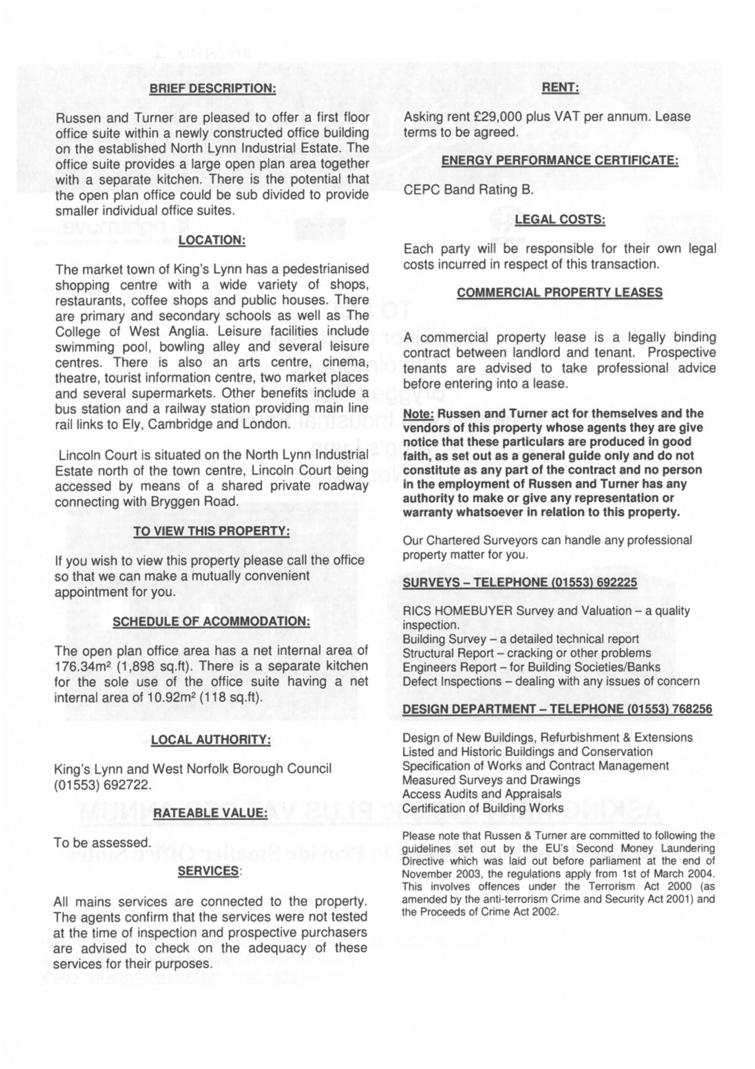



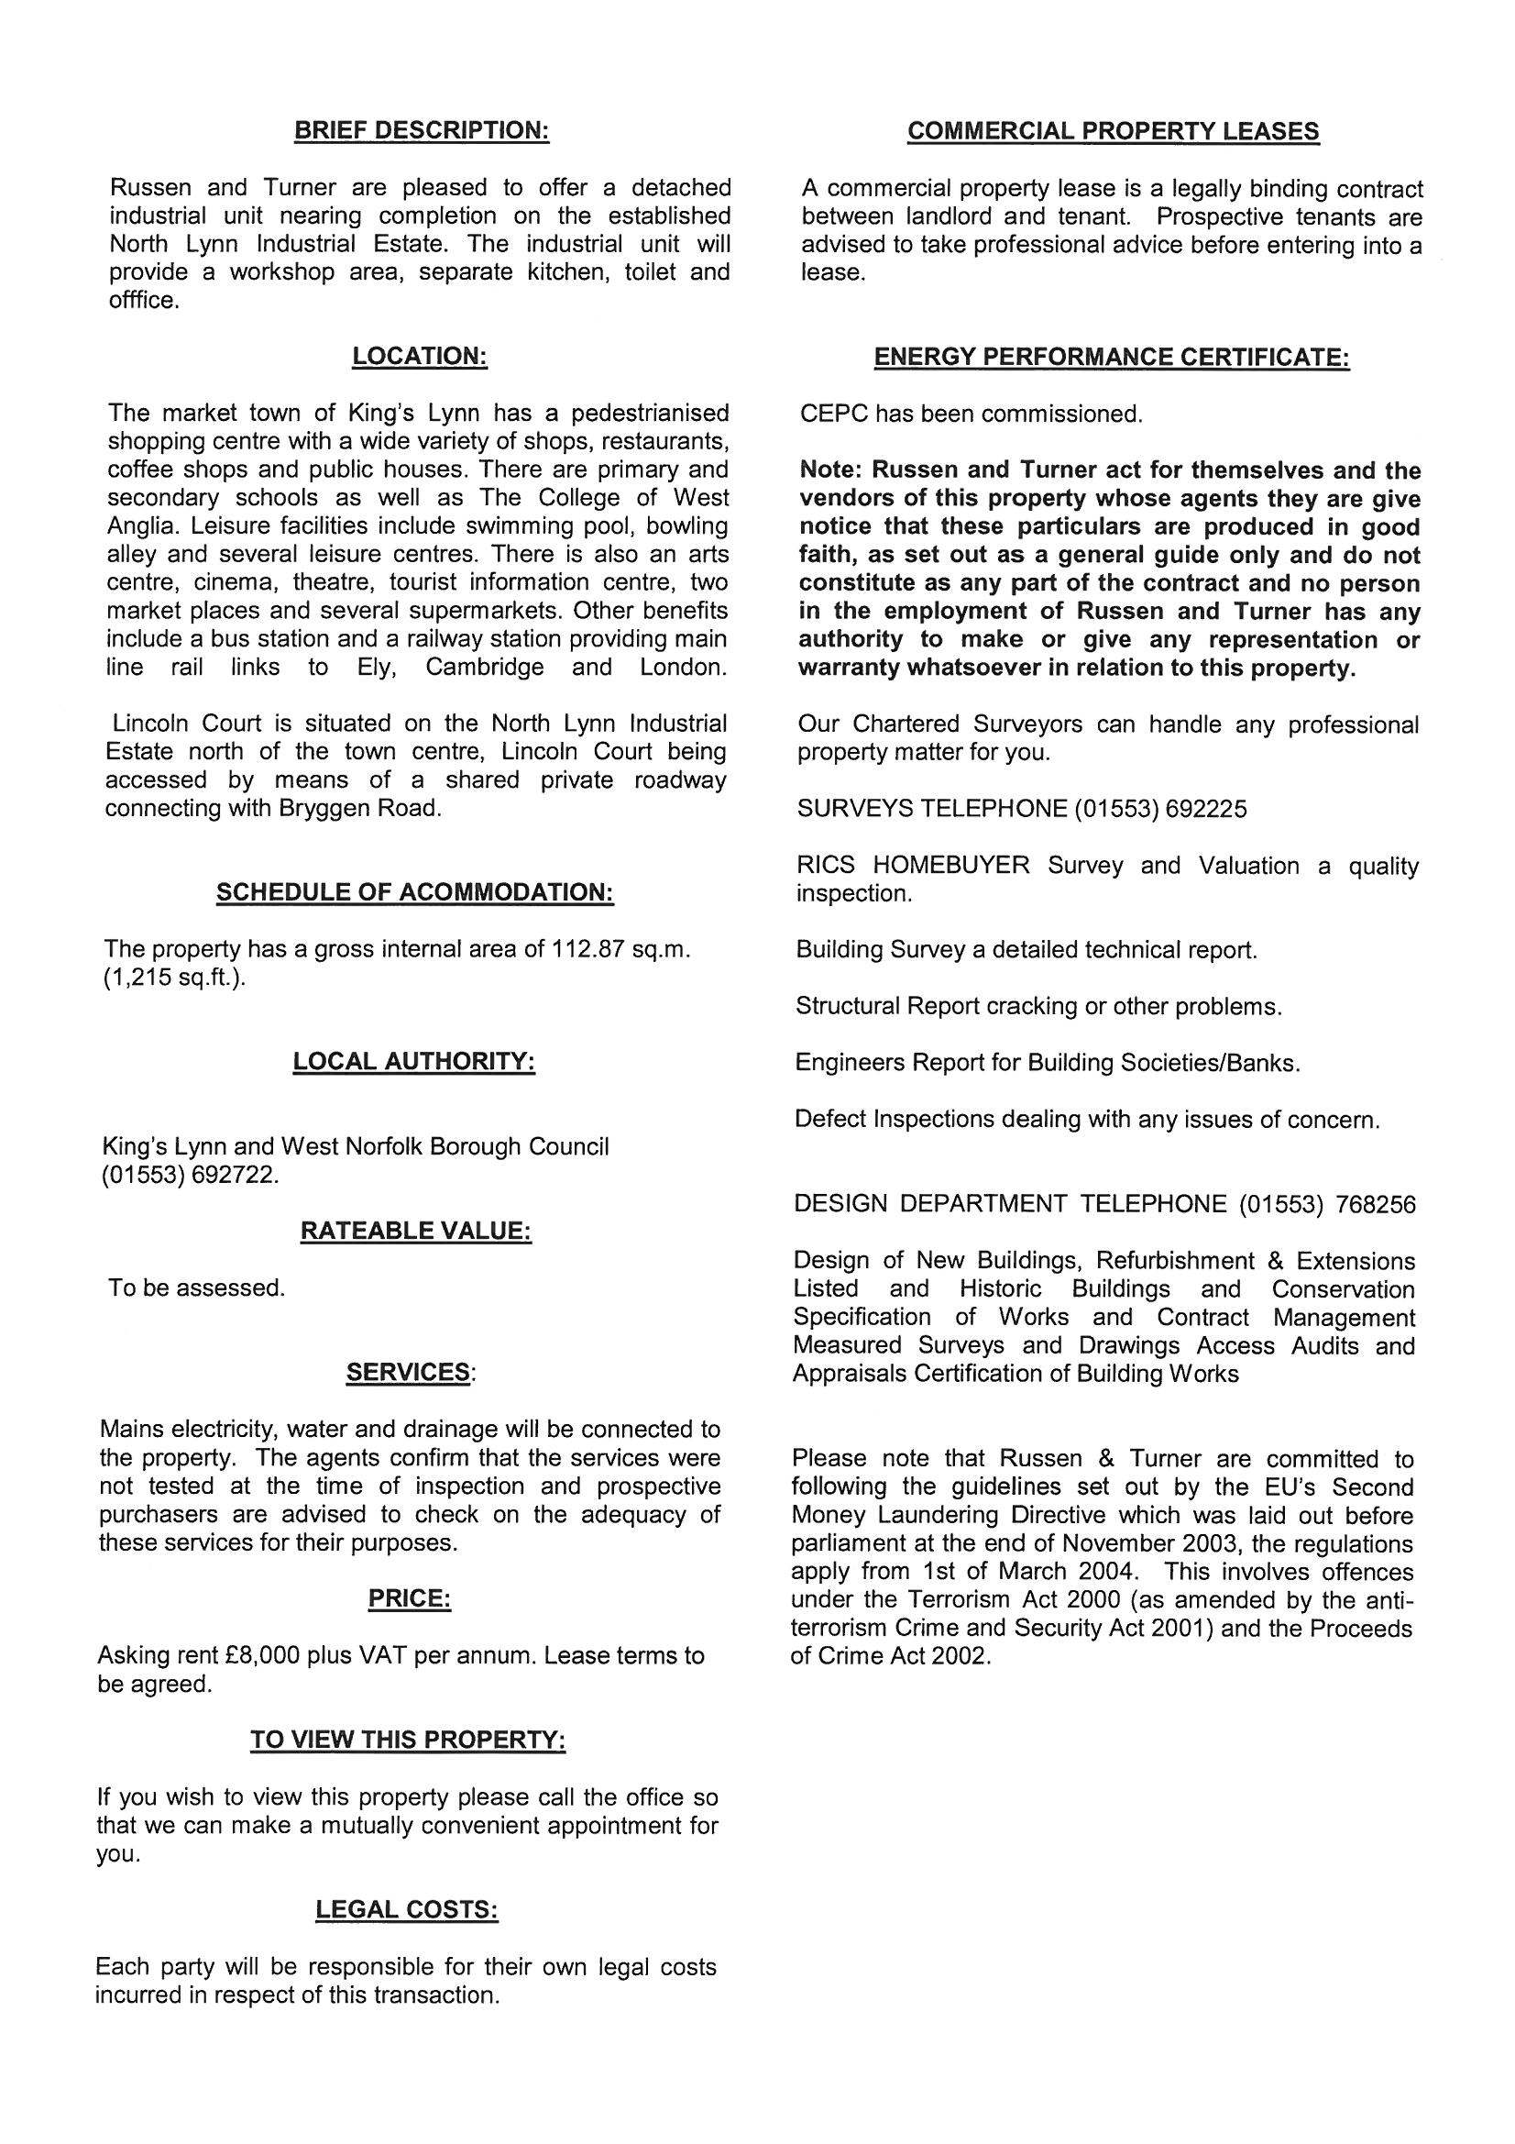

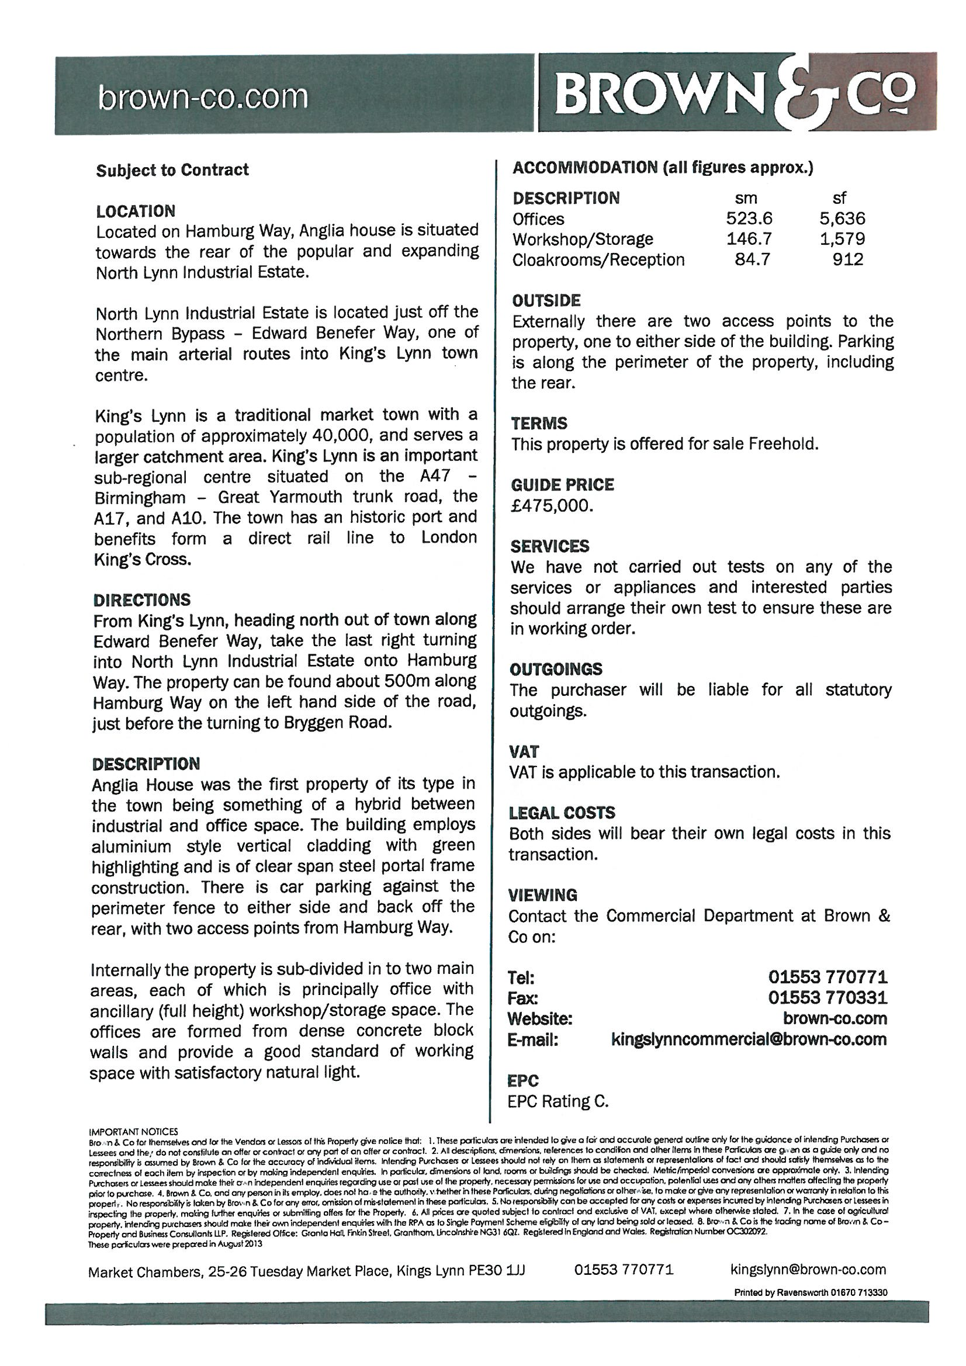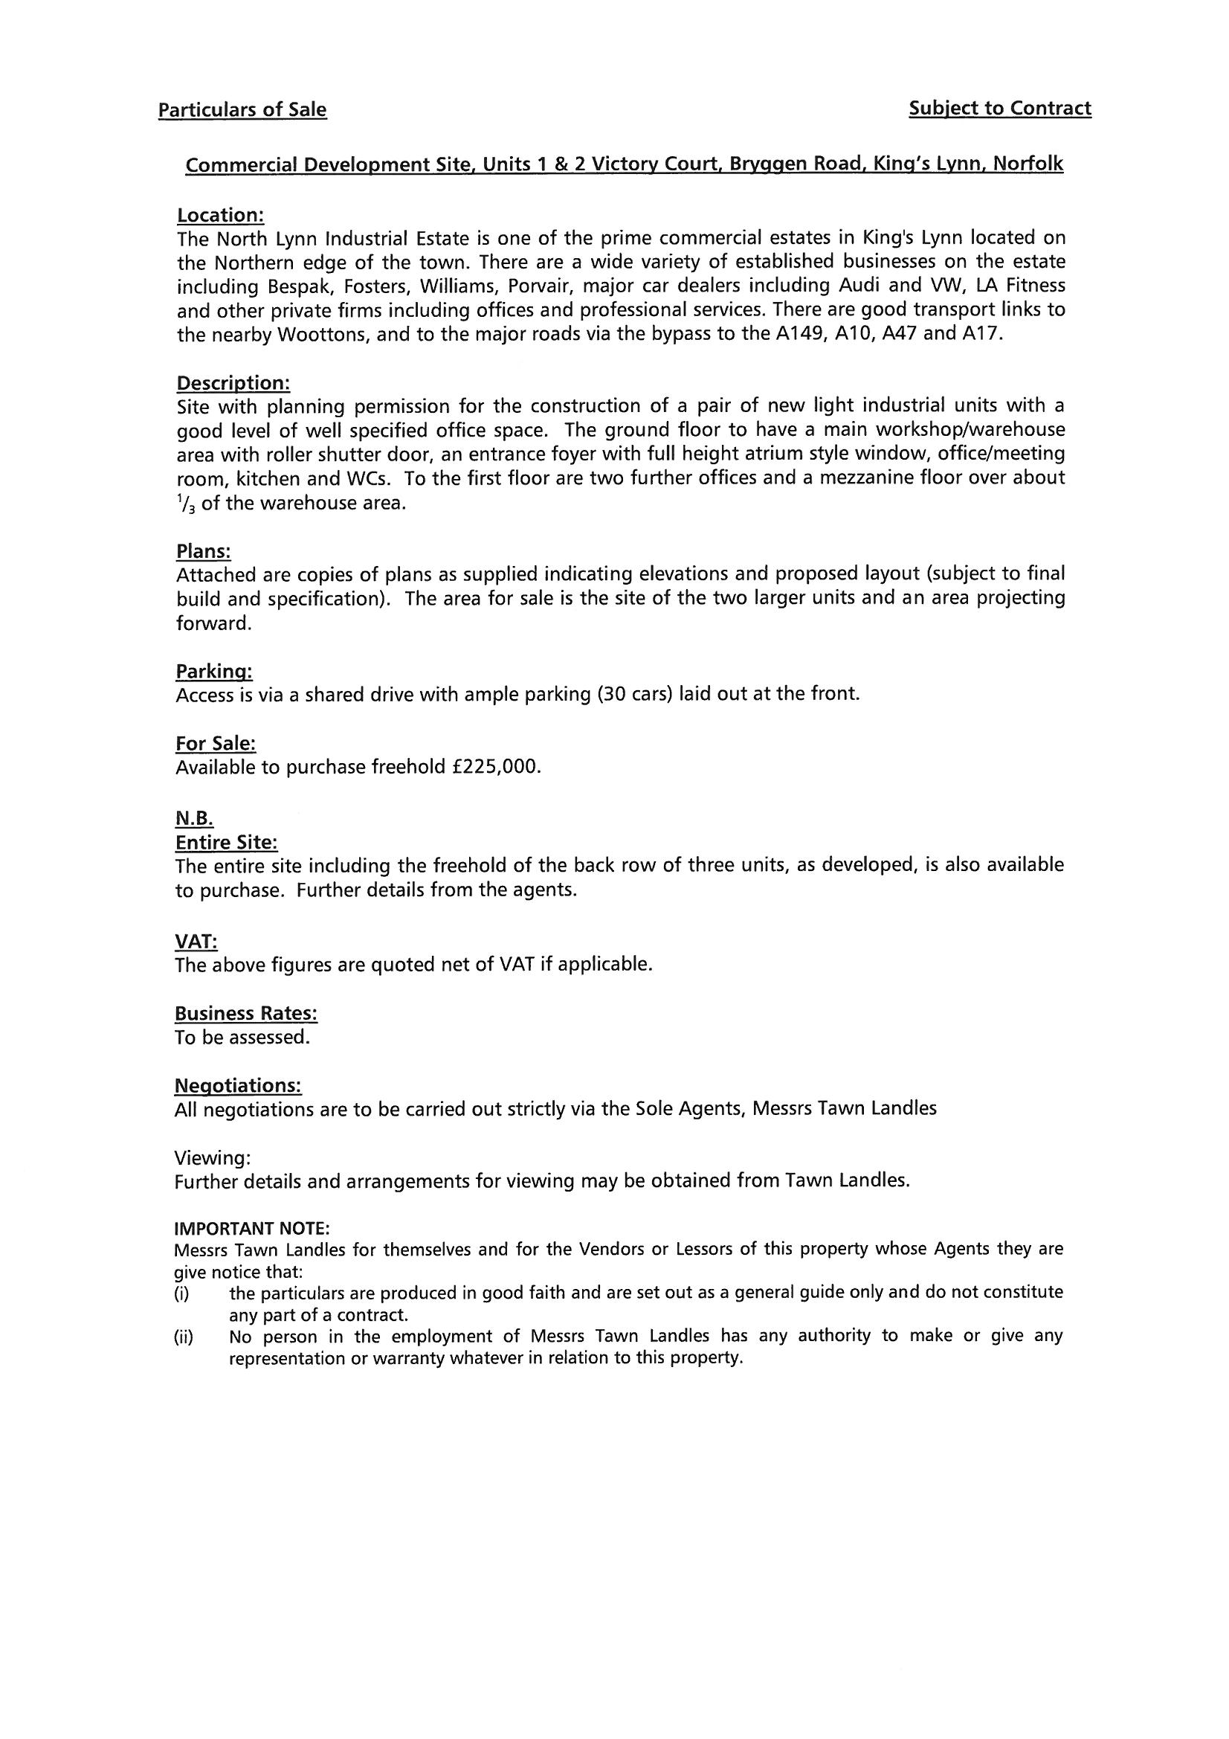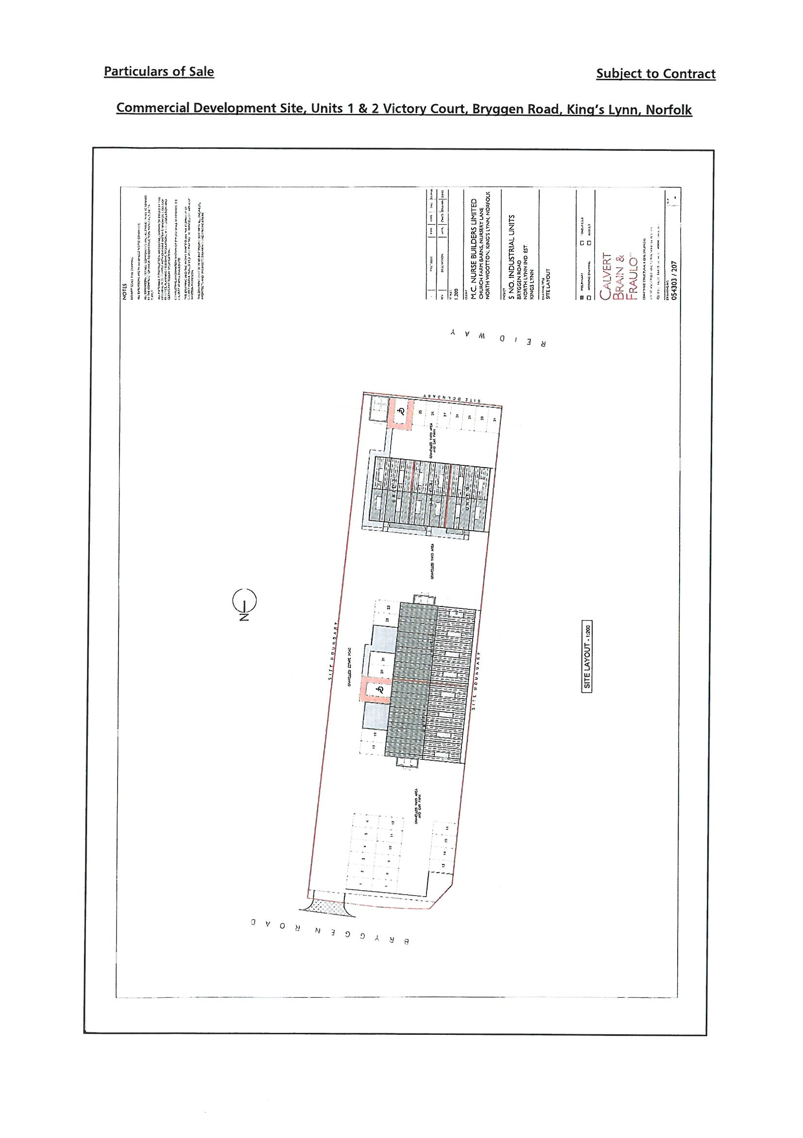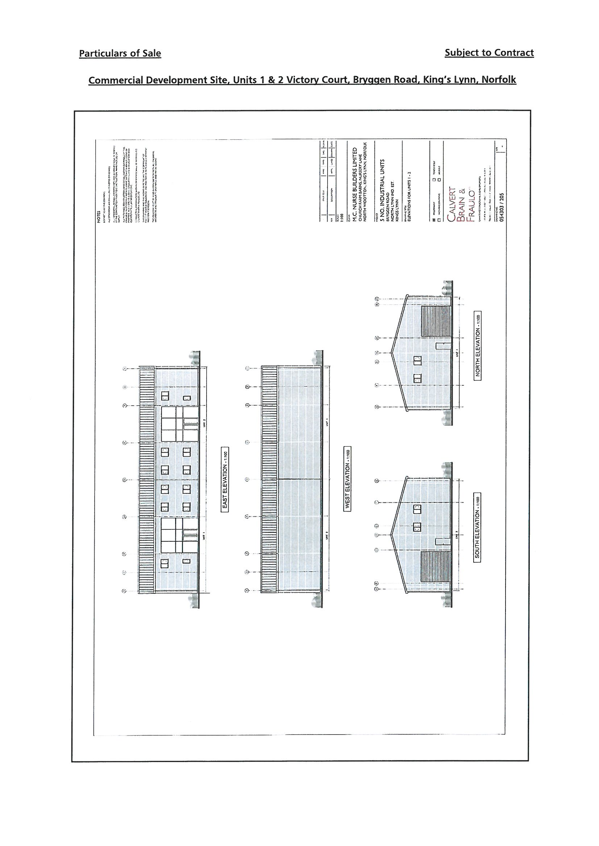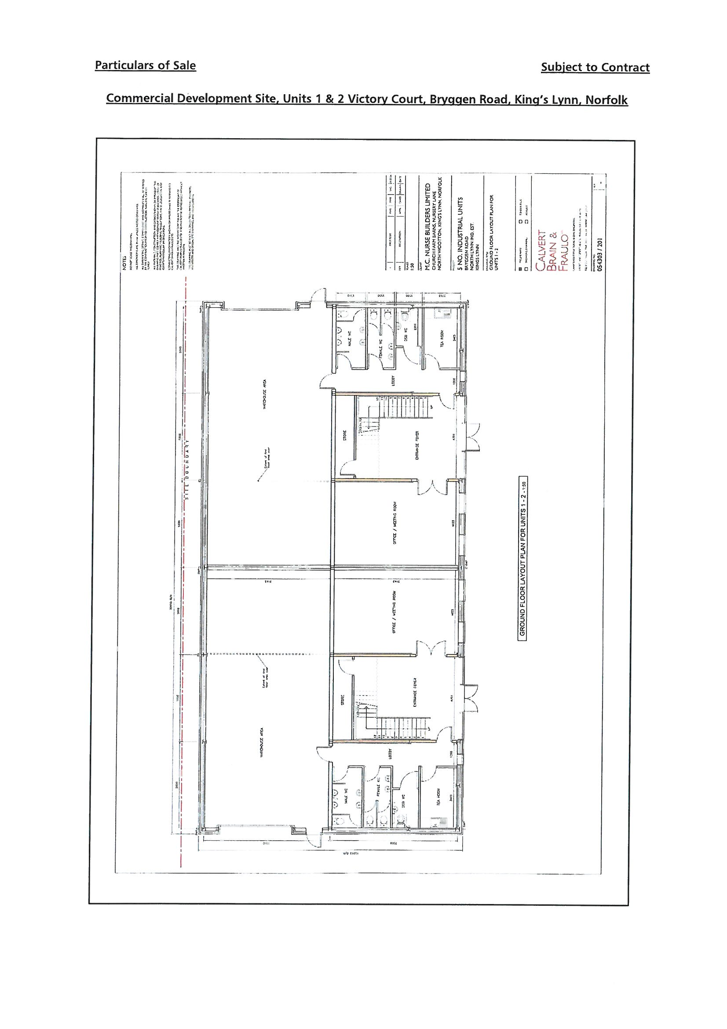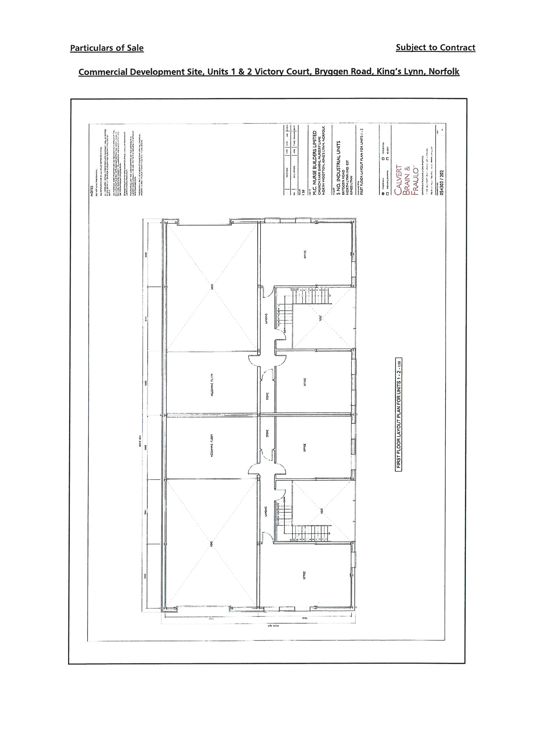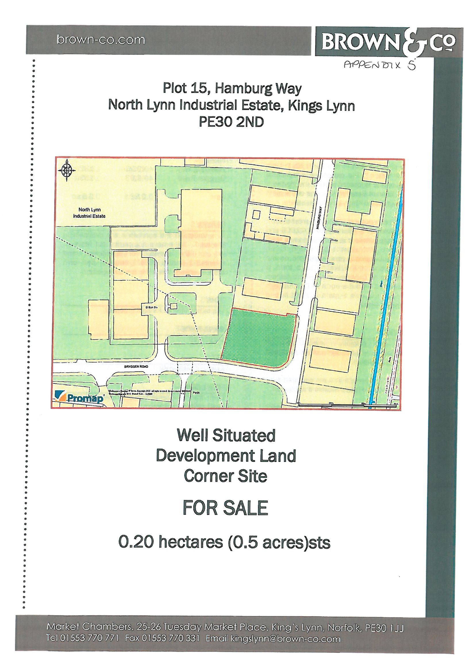



**Vision**

**The Eastern Inshore Fisheries and Conservation Authority will lead, champion and manage a sustainable marine environment and inshore fisheries, by successfully securing the right balance between social, environmental and economic benefits to ensure healthy seas, sustainable fisheries and a viable industry**

**Finance & Personnel Sub-Committee meeting**

**Action Item 9**

**15 January 2014**

**Deployable Office Infrastructure**

**Report by:** Lucy Ritchie,Community and Development Officer;Philip Haslam, Chief Executive Officer

**Purpose of report**

To present Members with a recommendation regarding the procurement and use of deployable office infrastructure.

**Recommendations**

**It is recommended that Members:**

* **Note the contents of this report.**
* **Agree to Option 2.**
* **Direct the CEO to explore the possibilities to purchase a trailer from the Environment Agency to test the utility of the deployable office concept in 2014.**

**Background**

At the meeting of the Finance & Personnel Sub-Committee held on 17 October 2013, it was agreed that the CEO should pursue the possibility of borrowing or hiring a trailer based mobile office for use throughout the district to enhance communication between Eastern IFCA and stakeholders.

Since that meeting, Eastern IFCA approached the Environment Agency (EA) about the possibility of borrowing or hiring a trailer they have in storage in Northamptonshire. The trailer (pictured below) is in good condition having been serviced regularly and stored securely.

The EA is adamant that they would like to sell the trailer as soon as possible and will not consider the possibility of loan or hire for any duration.

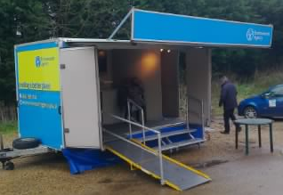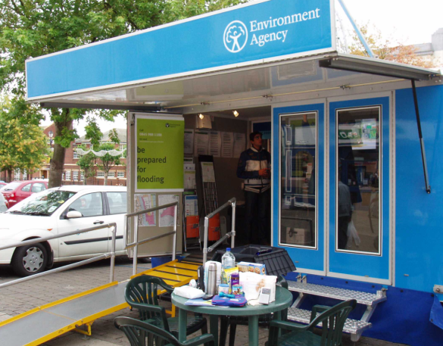

*The EA trailer when set up for use (on the left) and in its current condition (right)*

The company who store the trailer have offered the EA £1000 for the trailer. The EA would accept a similar offer from Eastern IFCA.

**Options**

**Option 1 – Status quo**

This Option considers and quantifies doing nothing. Quarterly evening meetings will be held and outreach events will be attended.

We currently hold 16 x 2 hour community engagement meetings pa (i.e. 32 hours of community engagement) attended by the approx. 60 different people pa as the same people attend the same meetings each quarter. This requires;

* 100 miles in Peugeot 308 (at 48mpg) costs £15.04 (at 135ppl) = £240.64 pa (based on 16 trips)
* 2 senior officers and 1 IFCO per meeting (4-5 hours each depending on location)
* Venues cost between £30 and £80 (av. £65). 16 meetings = £1040 pa

**Costs**

Total cost pa (exc. Officer time) = £1280.64

Total cost per trip (exc. Officer time) = £80.04 (based on 16 meetings)

**Total cost per hour of stakeholder engagement (exc. Officer time) = £40.02 (based on 32 hours)**

By the end of 2013, we will also have attended 14 shows and events with the aquatic tank. The tank has received a lot of positive comments and has attracted press attention including in Eastern Daily Press and Fishing News. It has also proved an excellent way of engaging with stakeholders as all events have been extremely well attended. To attend these events requires;

* The tank and trailer costing c. £10,000 in total however this was a one off purchase and is estimated to last 10 years meaning it cost £1,000 pa
* Entry to the shows varies depending on the event but in total, Eastern IFCA has spent c. £4,300 in entry fees or c. £307 per show
* 5-15 days of officer time depending on the show

Total cost pa (exc. Officer time) = £5,300

Total cost per trip (exc. Officer time) = £378.57

**Total cost per hour of stakeholder engagement (exc. Officer time) = £28 (based on 188 hours of events)**

Status Quo total pa (exc. Officer time pa) = £6580.64

**Advantages**

* Established system.
* Costs are known.
* Achievable within current manpower resource.

**Disadvantages**

* Significant demand on manpower resource.
* The same people attend the community engagement meetings each time.
* Reputational risk associated with Community Engagement meetings.
  + Dominated by commercial sector.
  + Avoided/dismissed by other stakeholder groups.
  + Narrow geographical focus.
  + Counter productivity – trying to improve the Authorities reputation amongst stakeholders results in poorer perceptions.
* Antagonistic atmosphere often generated by large community engagement meetings affects staff morale.

**Option 2 – Buy trailer from Environment Agency**

This option considers buying the below trailer from the Environment Agency



Capital outlay c£1,500 initially for purchase and branding = c£1,000 to buy the shell and c£500 for basic branding.

* Resource outlay c£2,000 pa – comprising fuel, maintenance and storage costs.
  + Fuel: The 4 x 4 with trailer is estimated to do around 24mpg. At a cost of 135p per litre = £30.08 for a 100 mile trip (£902.40 pa – based on 30 trips)
  + Routine maintenance/operating costs
    - Cleaning c. £5 per month. = £60 pa
    - Storage costs £24.34 = £292 pa
    - May need rebranding after 5 years at a cost of c£2,000 = £200pa

Total cost pa (exc. Officer time) = £1604.40

Total cost per trip (exc. Officer time) = £53.48 (based on 30 trips)

**Total cost per hour of stakeholder engagement (exc. Officer time) = £10.69 (based on 150 hours)**

**Advantages**

* Lowest ownership cost option
* Could be sold for same or higher price should concept not be proven
* High visibility and potential to fulfil ‘recognised and heard’ objective
* Could be mobilised at short notice
* Potential to reach a more stakeholders than Option 1
* Potential to reach a greater breadth of stakeholders than current community Engagement meetings
* Choice of where to site and minimal costs to attend
* Lowest cost option per hour of stakeholder engagement
* Ability to visit more locations than CE meetings
* Possibility to rent trailer to neighbouring IFCAs to bring cost down

**Disadvantages**

* Significant demand on manpower resource
* Cost of ownership (maintenance, licensing, and depreciation)
* Drives secure storage costs
* Trailer is 10 years old so maintenance will be on going
* Higher resource costs than Option 1
* Risk of underuse and associated negative perceptions

**Option 3 – Borrow or rent a trailer based mobile office**

Option 3 presents the middle ground of renting a trailer from a commercial outlet for a defined period. This drives down the cost or ownership and negates the requirement for a large capital outlay but it does constrain the ability to react to emerging events/issues. Quotations for rental are also prohibitively expensive.

**Costs**

Indicative costs to hire an appropriate trailer from a commercial outlet are c£6,000 per month.

* Resource outlay c£8,254 pa – comprising hire costs for one month, fuel, maintenance and storage costs.
  + Fuel: The 4 x 4 with trailer is estimated to do around 24mpg. At a cost of 135p per litre = £30.08 for a 100 mile trip (£902.40 pa – based on 30 trips)
  + Routine maintenance/operating costs
    - Cleaning c. £5 per month. = £60 pa
    - Storage costs £24.34 = £292 pa
    - Rebranding c£1,000

Total cost pa to hire commercially (exc. Officer time) = £8254

Total cost per trip (exc. Officer time) = £275.14 (based on 30 trips)

**Total cost per hour of stakeholder engagement (exc. Officer time) = £55.03 (based on 150 hours)**

**Advantages**

* High visibility and fulfil ‘recognised and heard’ objective.
* Could be mobilised at short notice.
* Potential to reach more stakeholders than Option 1
* Reach a wider range of stakeholders than current Community Engagement meetings
* Choice of where to site and minimal costs to attend
* Lowest cost option per hour of stakeholder engagement
* Ability to visit more locations than CE meetings
* No cost of ownership (maintenance, licensing, depreciation)
* Can be hired to exploit periods of maximum officers availability
* Little reputational threat concerning frivolous discretionary spend in current economic climate.

**Disadvantages**

* Highest cost option
* Significant demand on manpower resource in order to generate sufficient return on investment
* Reactivity limited to period of borrow/hire only
* Drives secure storage costs
* Hire cost disproportionately expensive

**Option Comparison**

Option 1 is for consideration as broader outreach activities this year have been very productive and will be replicated in successive years. That said it does not immediately address the difficulties with bespoke Community engagement meetings and the relatively narrow attendance from stakeholders groups. Since the last meeting of the F & P Sub-Committee, 4 community engagement events have been held with poor attendance at all. It is contended that Eastern IFCA needs to revise its engagement activities with a view to operating in a smarter manner more conducive to a small workforce. As a result option 1, to maintain the status quo, is recommended to be discounted.

Option 2 is attractive as it provides autonomy and choice in where and when to deploy the mobile office which will aid our reputation in terms of reactivity to emergent events/issues. Initially, to keep costs to a minimum, it could be partially branded to cover the EA branding but so that it was still highly visible as an Eastern IFCA trailer. In time, if the concept proved successful, it could be fully branded at a higher cost to provide a more permanent solution. Furthermore, in the current financial climate, Option 2 could prove to be a shrewd option as, if the concept were to prove unsuccessful, it is thought the trailer could be sold for the same amount (or slightly more) than the purchase cost.

Notwithstanding, manpower and storage costs are substantial considerations with option 2. The trailer would require 2 people to operate and man it each day and would also require frequent maintenance which would put more demands on the time of senior staff. Furthermore, storage costs may be an issue as would storing the trailer overnight when it is out on the road. Hotel costs may also be incurred by staff manning the trailer. It is unlikely that a trailer can be borrowed for an extended period so it is recommended that option 2 be agreed to allow the trial to be conducted.

Option 3 remains a pragmatic option as it does not drive cost of ownership demands. It will allow for a period of pre-planned and reactive outreach at a moment when manpower resource can be best made available. However, there is risk that once it has been used there will be an ensuing demand for more of the same which would then lead to the purchase of a trailer at a far higher cost than Option 2 which the EA have said they will sell in January 2014.

**Conclusion**

Previous direction to borrow or hire a trailer has unearthed a viable option to purchase a trailer at a very competitive rate that can be used to trial the deployable office concept. This will stress further an already tight manpower budget but with judicious prioritisation it is considered feasible. It is judged that the current model for community engagement is limited in its scope and the provision of a trailer based office may allow for greater engagement with a broader cross section of stakeholders.

**Background paper**

1. Action Item 11, Finance & Personnel Sub-Committee meeting 17 October 2013

**Vision**

**The Eastern Inshore Fisheries and Conservation Authority will lead, champion and manage a sustainable marine environment and inshore fisheries, by successfully securing the right balance between social, environmental and economic benefits to ensure healthy seas, sustainable fisheries and a viable industry**

**Action Item 10**

**Finance & Personnel Sub-Committee meeting**

**Report by:** Nichola Freer, Head of HR

**Purpose of report**

To present recommendations to the Members regarding the introduction of a payback policy relating to funded developmental training for Officers

**Recommendation**

**It is recommended that Members:**

* **Agree the proposal to adopt a payback policy as outlined**
* **Direct the Head of HR to develop a payback policy for the Authority**

**Background**

With regard to expenditure on staff training, the National Joint Council ‘Green Book’ states:

‘*Some training can be very expensive and authorities may require repayment of all or part of the costs incurred should an employee leave the authority before a reasonable time period has expired.*’

The Authority does not currently have any provisions in place to ensure a return on investments made in funding developmental training for officers.

**Report**

It is common practice amongst many employers to request some form of recompense from an employee to whom investment has been provided in terms of training. That said, there is currently little consistency in terms of what employers require to be paid back by their employees and over what period.

Research suggests that the following principles are usually applied:

* 100% of fee is to be paid back if the employee leaves before the end of the course and/or fails to take the examination/competence assessment
* If the employee leaves within 2 years of completing the course, then they are required to pay a percentage of the cost back to the employer
* Costs are not required to be paid back in the event of redundancy, ill health retirement / termination
* The percentage cost to be paid back varies greatly, but is usually on a diminishing scale

Norfolk County Council adopt the approach that the employee will be required to repay 1/24th of the total amount of cost for each month of the 2 year period not completed. This would appear to be a reasonable requirement.

**Financial implications**

Electing to develop a payback policy with regard to investment of Authority funds towards developmental training of its Officers will help to secure a return on its investment. Officers being invested in will use their enhanced skills for the benefit of Authority business for at least the specified retained period, and thus giving value for money for the taxpayer.

Employee turnover during 2013 equates to 4 Officers (16.5% turnover).

Training spent so far this year equates to £17936. Of this, £2501 has been for developmental training.

Whilst the total spend on developmental training in 2013 may not appear excessive, members should be reminded that the HR plan for this year has been to equip all officers with the essential skills to carry out their roles. Developmental training will be the focus of 2014 and beyond, so the amount of Authority funds invested in this area is expected to increase.

To give an illustration of individual investment that can be expected, at the beginning of 2012, £4725 was spent on developmental training for one Officer alone.

**Legal Implications**

There is minimal legal risk. This practice is supported by the National Joint Council and many Local Authorities (including Norfolk County Council and Kings Lynn & West Norfolk Borough Council), as well as private companies have such a policy in place.

**Communications/Publicity**

Negative publicity is not foreseen. Indeed, this is a common approach that has been established in many other organisations for some time. If approval is given, Officers would be fully communicated to with regard to the new policy.

**Conclusion**

Taking the above into consideration, it is recommended that the Authority adopt a payback policy with regard to the funding of developmental training.

The policy to include:

* Developmental training only to be covered by the policy. Essential job training falls out of scope
* A percentage of costs to be paid back if the employee leaves within 2 years of completing the course/programme
* Payback requirement to be:
  + 100% of cost if employee leaves before the end of the course and / or fails to take the examination or competence assessment
  + The employee will be required to repay 1/24th of the total amount of cost for each month of the 2 year period not completed
* Exceptions to the policy will be made in cases of redundancy and ill health termination

**Vision**

**The Eastern Inshore Fisheries and Conservation Authority will lead, champion and manage a sustainable marine environment and inshore fisheries, by successfully securing the right balance between social, environmental and economic benefits to ensure healthy seas, sustainable fisheries and a viable industry**

**Action Item 11**

**Finance & Personnel Sub-Committee meeting**

**Report by:** Nichola Freer, Head of HR

**Purpose of report**

To present recommendations to Members regarding the commencement with the salary scale point review.

**Recommendation**

**It is recommended that Members:**

* **Agree that a salary scale point review in advance of April 2015 may be premature.**
* **Agree that there are a number of financial variables that need to be resolved before the Authorities future funding position can be fully understood.**
* **Direct that the review of the salary scale points is postponed and should commence once the relevant financial is agreed and available, and in any case, by April 2015.**

**Background**

It was agreed at the Finance & Personnel Sub-Committee meeting of the 25 Jun 13, that following the outcome of the CEO job evaluation, a review of all the Authority’s pay scale points within the current structure would be carried out in 12 months’ time, taking into account the financial climate.

**Authority’s scale points**

The Authority’s scale runs from point 4 – 61 (Appendix 1). Points 4 – 49 are derived from the Local Government Services (LGS) published salary point scale. As the LGS scale only goes up to point 49, points 50 – 61 within the Authority’s (former Eastern Sea Fisheries Joint Committee) scale were created in 2002 as reserved scale points to allow for proportionate remuneration of the CEO post holder in relation to their duties and responsibilities over and above other Officers within the Authority.

**Report**

The direction given to officers to review the current pay scale was taken from the outcome of the CEO job evaluation. Members chose not to look at the remuneration for the CEO role in isolation to the other roles. At the time, directing officers to revisit the entire pay scale in June 2014 was deemed to be an appropriate timescale.

When now considering the timeliness of such a review, Members are recommended to consider the following factors:

* The public sector financial climate is still very challenging despite signs of overall economic recovery.
* Authority funding to operate beyond April 2015 has yet to be secured.
* The majority of job holders received a pay increment in January 2013 as a result of the job evaluation exercise completed in December 2012
* The LGS agreed to a 1% increase across the whole of its pay scale points backdated to April 2013. Although the LGS scale only recognises up to scale point 49, the Authority applied the 1% increase to all of its scale points for consistency.
* The departure / pending departure of some recent personnel presents an opportunity to review the current staff structure. The output of this may drive some current job roles to change in terms of responsibility and if so, would drive a requirement to revisit the associated remuneration

**Financial Implications**

Electing to postpone the review of salary scale points will not drive any further expenditure and should not incur additional financial risk. Indeed, the recommendation is considered the most sensible course of action given the on-going fluidity in overall funding settlements in both central and local government and the potential for subsequent impact upon levies.

**Legal Implications**

Noting that Officers have recently received a pay settlement to ensure that their remuneration is appropriate to their role and reflects wider public service practice, there is no legal reason to necessitate a review.

**Communications/Publicity**

Negative publicity is not foreseen, indeed, this reasonable and responsible approach should be seen in a positive light. Internally, there is no demand or expectation of an immediate salary scale point review and officers are kept fully informed of the overall financial situation so should be able to place the recommended decision in context.

**Conclusion**

Taking the above into consideration, it is recommended that the review of the Authority’s salary scale points is postponed, to commence in April 2015 when the factors listed above will be able to be situated within a clearer and a more mature understanding of the overall financial context.

**Background papers**

* Minutes of the F&PSC meeting held on 25 June 2013
* Appendix 1 – Current Authority salary structure

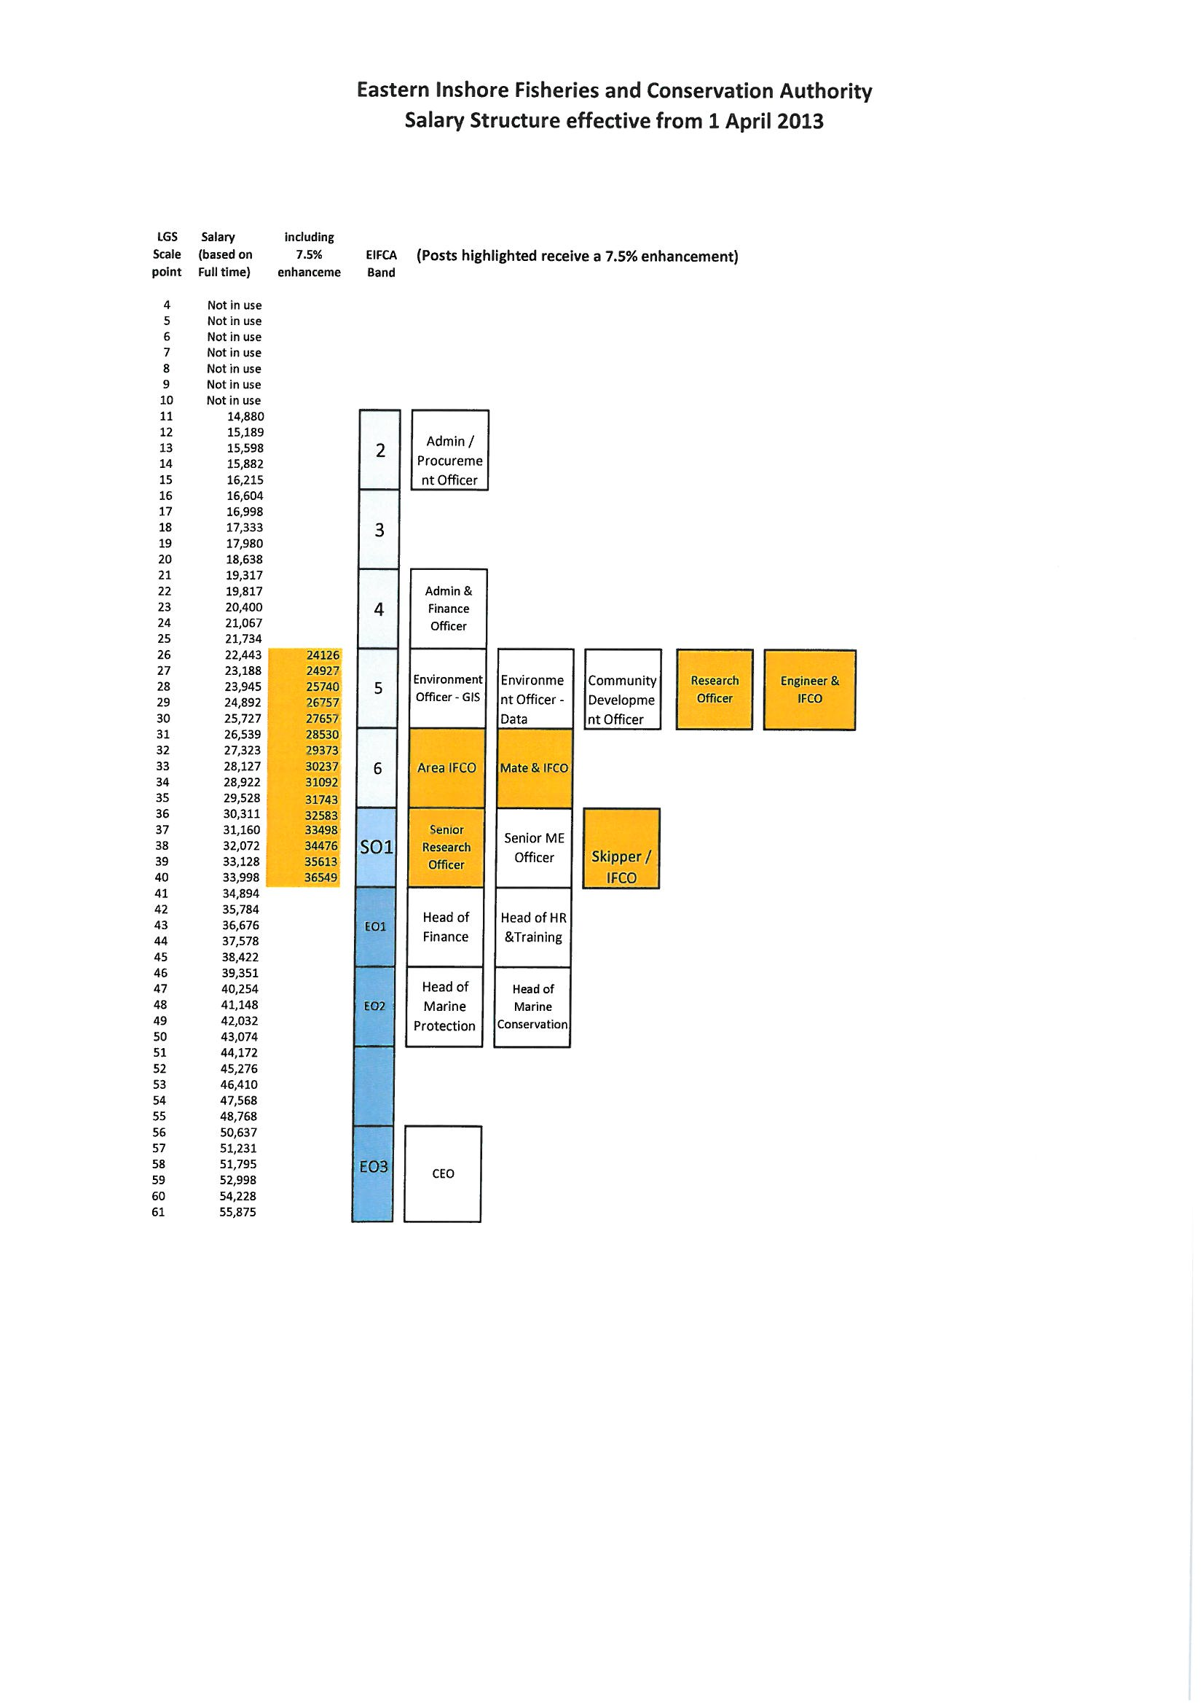

**Vision**

**The Eastern Inshore Fisheries and Conservation Authority will lead, champion and manage a sustainable marine environment and inshore fisheries, by successfully securing the right balance between social, environmental and economic benefits to ensure healthy seas, sustainable fisheries and a viable industry**

**Information Item 14**

**Finance & Personnel Sub-Committee meeting**

15 January 2014

**Report by:** Nichola Freer, Head of HR

**Purpose of report**

To inform members of the progress of the HR plan to 2015 and specifically an update of the HR activity planned to be completed during this financial year.

**Recommendations**

**It is recommended that members:**

* **Note the contents of the report**

**Report**

Background

The key activities within the 2013 HR plan are:

* Training & development
* Recruitment & new starters
* Performance review process
* Creation of an employee handbook
* Investors in People (IIP) review & re-accreditation

Progress

**Training & Development:**

From the last update, the following activity has been completed:

* Job training has been fully embedded and the plans created are being worked through and are on target

**Recruitment:**

A review of the current recruitment process has been completed and revised process and documentation was rolled out during September for future use.

**Performance review process:**

From the last update, the following activity has been completed:

* An interim review of progress towards achievement of objectives has taken place throughout November
* All Officers have participated in personal development planning discussions as part of their interim reviews during November. All Officers now have a basic form of personal development plan, which will be developed over the next year

The basic process introduced during year will be reviewed and developed to progress the quality and robustness of the process into 2014.

**Employee handbook:**

The review and update of the employee handbook has been completed. The Executive Team will roll this out to all Officers in the New Year.

**IIP review and re-accreditation:**

We were assessed by Investors in People on 28 November 2013. Initial feedback from the assessment shows that whilst there are some positive strength’s in terms of employee perception, it is recognised that we are on a journey and are seen as currently working towards the IIP standard. During this coming year we will be working with the IIP to develop engagement plans so that we are able to be re-assessed on our development areas and secure on-going accreditation.

**2014**

The 2014 HR plan is currently being developed as part of the wider corporate planning and will be shared with the members as an information item at the next meeting.

1. B1 Business – Offices, research and development of products and processes, light industry appropriate in a residential area.

   B8 Storage or distribution - including open air storage.
2. Calculated at £80 per ft² as advised by Calvert Brain & Fraulo architects
3. Indicative fees as advised by Hayes and Storr Solicitors
4. Indicative fees as advised by Calvert Brain & Fraulo architects
5. Indicative fees as advised by Calvert Brain & Fraulo architects
6. Indicative fees as advised by Calvert Brain & Fraulo architects