

© Eastern IFCA 2014

L Ritchie (2014) Eastern Inshore Fisheries and Conservation Authority Communication & Engagement Plan 2014-15. 21 pp.

This document is available in electronic form from Eastern Inshore Fisheries and Conservation Authority:

[www.eastern-ifca.gov.uk](http://www.eastern-ifca.gov.uk)

Alternatively a hard copy can be requested from:

Eastern Inshore Fisheries and Conservation Authority

6 North Lynn Business Village

Bergen Way

King’s Lynn

Norfolk

PE30 2JG

Published online on 21 March 2014

Eastern IFCA is funded by Lincolnshire County Council, Norfolk County Council and Suffolk County Council.

# 

# Foreword

This plan details how Eastern Inshore Fisheries and Conservation Authority will deliver against its remit to ‘engage with stakeholders’ and ‘be recognised and heard’ in 2014-15. Building on the significant successes and learning from the experiences of 2013-14 we have refined our plans to ensure that we remain connected and influential throughout our district. In a period where marine environmental management is firmly on the national agenda, we seek to ensure that all, from local taxpayers to elected officials, from commercial fishermen to the occasional angler and from national conservation bodies to environmentally conscious individuals, are aware of and informed about our work within the district.

Communications is a two-way process and in order to create an ongoing conversation rather than a functional exchange of information we actively seek opportunities to attend a breadth of events in order to ensure our messages are delivered. To that end, this plan is a starting point and can be amended as required to deliver our intent. Please do speak with us should you have ideas or initiatives that you would wish to share.

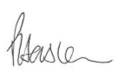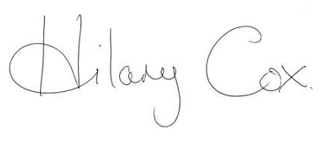

**P J Haslam Councillor Hilary Cox**

**Chief Executive Officer Chairman**

Contents

Foreword 3

1. Introduction 5

2. Guiding the plan 6

2.1 IFCA vision 6

2.2 IFCA Success Criteria 6

2.3 Benchmarking Survey 7

2.4 Sea Angling 2012 8

3. Communication and Engagement 9

3.1 Our stakeholders 11

3.2 The challenge 11

3.3 Key messages 11

4. Resources 12

5. Communication & Engagement Activities FY 2014-15 13

5.1 Communication and Engagement Activities 14

E Newsletters 14

CE2014A 14

Stakeholder database 14

CE2014B 14

Social media 15

CE2014C 15

Meaningful community engagement 15

CE2014D 15

Good news stories 16

CE2014E 16

Engage hard to reach stakeholder groups 16

CE2014F 16

Attend relevant public events 17

CE2014G 17

Information signs placed around the district 17

CE2014H 17

Partnership working encouraged 18

CE2014I 18

Communication and Engagement Strategy 18

CE2014J 18

Communication and Engagement Plan 2015-16 19

CE2014K 19

Communication and Engagement Report 2014-15 19

CE2014L 19

Feedback is routinely sought from stakeholders 19

CE2014M 19

Website 20

CE2014N 20

Create photo library 20

CE2014O 20

5.3 Summary of Communication & Engagement Activities: Financial Year 2014-15 21

# 1. Introduction

The Eastern Inshore Fisheries and Conservation Authority (Eastern IFCA) is one of ten regional authorities in England providing inshore fisheries and conservation management. Its district covers the three counties of Lincolnshire, Norfolk and Suffolk from Haile Sand Fort in Lincolnshire to Felixstowe in Suffolk and extends six nautical miles seawards.

At the heart of Eastern IFCA lies more than 100 years of marine protection and management in the form of its predecessor Eastern Sea Fisheries Joint Committee. And, since its creation in 2011 under the Marine and Coastal Access Act (2009), the Authority has sought to build on the success of its forbear by embracing the widened remit guided by the overarching success criteria set by Defra.

The widened remit required a staff restructuring exercise to balance an established Protection team with increased capacity in the Environment and Research teams. To synergize these varied work streams and to create an informed community of stakeholders; a clear and cohesive Communications & Engagement Plan is to be published, executed and evaluated by the Authority each year with stakeholders at its core.

Financial Year 2013-14 saw the Authority put in place the infrastructure to facilitate meaningful engagement and great strides were made in boosting the reach and reputation of Eastern IFCA. That said, there is more to be done in 2014-15. For example, a number of ‘hard to reach’ and potentially disengaged stakeholders have been identified (see section 2) and every effort will be made to engage with these groups at the same time as maintaining the momentum generated in 2013-14. We will continue to listen to all of our stakeholders to ensure their views are aired and considered as we make decisions to deliver our duties as set out in the Marine and coastal Access Act 2009.

This document is a comprehensive guide to the communication and engagement work streams for the 2014-15 financial year. It shows where and how public money is being expended to ensure the Authority is recognised and heard and engaged with stakeholders by the most cost effective means.

# 2. Guiding the plan

The Communication & Engagement Plan for FY 2014-15, as in previous years, is guided primarily by the IFCA Vision and Success Criteria handed down by Defra at the creation of the IFCAs in 2011. However, the results of 2 important pieces of work published in FY 2013-14 – the Eastern IFCA communications benchmarking survey and Sea Angling 2012- have brought to light a number of ‘hard to reach’ stakeholder groups who are not yet fully engaged with the work of the IFCA. Chapter 2 discusses the 4 different elements guiding the Communication & Engagement Plan for FY2014-15.

## 2.1 IFCA vision

*“Inshore Fisheries and Conservation Authorities will lead, champion and manage a sustainable marine environment and inshore fisheries, by successfully securing the right balance between social, environmental and economic benefits to ensure healthy seas, sustainable fisheries and a viable industry.”*

This vision presents a considerable challenge for all IFCAs in requiring them to balance the needs and expectations of all those with a stake in the inshore marine environment. The creation of IFCAs presented an opportunity to focus on the sustainable exploitation of sea fisheries resources through collaborative, local decision making.

Eastern IFCA has an additional responsibility inherited from its predecessor organisation, Eastern Sea Fisheries Joint Committee: ‘the Authority must seek to manage the Wash Fishery Order 1992 in a manner that supports the local fishing industry without having a detrimental impact on the site’s conservation features’. As a result of this responsibility, a great deal of the work of the Eastern IFCA and its predecessor has traditionally focused around the Wash and therefore, those affected by the Wash Fishery Order 1992 are most likely to be aware of the Eastern IFCA. One of the main challenges of the communications function continues to be a need to engage with a wider range of stakeholders throughout a large district at the same time as managing the expectations of those affected by the Wash Fishery Order 1992.

## 2.2 IFCA Success Criteria

To support the IFCAs in delivering their new duties Defra established clear guidelines in the form of seven Success Criteria. These are:

|  |  |
| --- | --- |
| 1 | IFCAs have sound governance and staff are motivated and respected. |
| 2 | Evidence-based, appropriate and timely byelaws are used to manage the sustainable exploitation of sea fisheries resources within the district. |
| 3 | A fair, effective and proportionate enforcement regime is in place. |
| 4 | IFCAs work in partnership and are engaged with their stakeholders. |
| 5 | IFCAs make the best use of evidence to deliver their objectives. |
| 6 | IFCAs support and promote the sustainable management of the marine environment. |
| 7 | IFCAs are recognised and heard. |

Whilst each of the success criteria must be embraced by all Eastern IFCA staff, the three highlighted have high priority in guiding the Authority’s communications and engagement streams.

## 2.3 Benchmarking Survey

In FY 2012-13 Eastern IFCA commissioned a benchmarking survey. The purpose of the survey was to assess awareness/engagement of key stakeholders across Eastern IFCA’s three counties. In particular, assessing the role that Eastern IFCA has in the coastal community and measuring the level of understanding for Eastern IFCA’s change of emphasis towards sustainability as well as its requirement to balance social and economic benefits of sea fisheries against exploitation.

The research was used to inform Eastern IFCA how well it is doing to meet its objectives and to make clear where it needs to target its engagement activities looking ahead. Awareness of Eastern IFCA was found to be surprisingly high however this figure did vary across stakeholder groups for example;

* Commercial fishermen – 87% of respondents aware of Eastern IFCA
* Community – 44% of respondents aware of Eastern IFCA
* Conservation groups and NGOs – 54% of respondents aware of Eastern IFCA
* Recreational coast users – 54% of respondents aware of Eastern IFCA
* In counties awareness of Eastern IFCA varied greatly – Suffolk - 55%, Norfolk – 66% and Lincolnshire – only 37%

When further analysed by sub-stratum some interesting results emerged such as 0% of respondents from schools were aware of Eastern IFCA (compared to 44% of community group as a whole), whilst the Wildlife Trust were aware of us nobody from the RSPB was, only 38% of boat owners were and a lack of understanding about the work of Eastern IFCA was highlighted amongst recreational anglers. It was also found that whilst many respondents were aware of Eastern IFCA, they were unsure of what it actually did.

This survey highlighted some ‘holes’ in Eastern IFCA’s previous engagement activities that harder to reach stakeholders had fallen through. The results of this survey will therefore be used to guide the Communications & Engagement Plan for FY 2014-15 and ensure value for money is delivered across all stakeholder groups throughout the 3 counties.

## 2.4 Sea Angling 2012

Eastern IFCA, in collaboration with the other 9 IFCAs and a steering group comprised of policy makers, government scientists, academic scientists, and the angling community collected data throughout 2012 to compile Sea Angling 2012 – a survey of recreational sea angling activity and economic value in England. The report, published in December 2013, was developed to estimate the extent and contribution of sea angling. The report emphasises the importance of sea angling to the local economy and its effect on fish stocks. Highlights of the report suggest;

* 884,000 individuals were found to go angling in England with a direct spend of £831 million on various associated items (see charts below). As a comparison, MMO figures suggest that the total value of commercial landings in England in 2010 was £719 million.

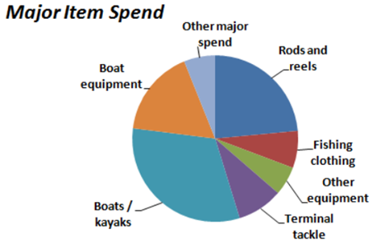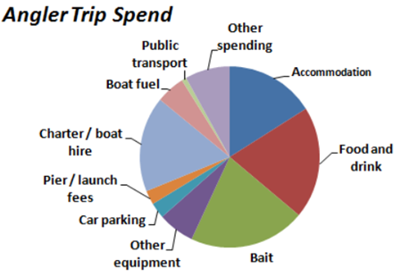

What recreational anglers spend their money on.

Source: Sea Angling 2012 <http://www.marinemanagement.org.uk/seaangling/documents/finalreport.pdf>

* There are 82 charter boats found to be operating in the district compared to 233 commercial fishing vessels and many more privately owned boats
* Almost 4 million days of sea angling were recorded in England over the year. Shore fishing was the most common type of sea angling – almost 3 million angler-days compared with 1 million for private or rented boats and 0.1 million on charter boats. Anglers had most success on charter boats, catching 10 fish per day on average compared with around 5 from private boats and only 2 from the shore

The results of Sea Angling 2012 demonstrate the breadth of sea angling and its contribution to the local economy. However, as discussed in section 2.3, there continues to be confusion amongst the angling community about what Eastern IFCA does and how the Authority affects them as well as a low level of awareness amongst associated parties such as charter boat owners. There is a demand that Eastern IFCA concentrate engagement efforts on recreational anglers and associated parties.

Chapter 3 will now go on to discuss the progress Eastern IFCA is making, the stakeholders we wish to engage with along with the Authority’s core values and key messages that we wish to disseminate.

# 

# 3. Communication and Engagement

At the national level our goal is to participate fully in the national marine communications initiative to ensure that IFCA efforts to protect the inshore marine environment and to support and enable activity within it are recognised and understood. At the local level our goal is to create a stakeholder community that is well informed about the work of the Eastern IFCA and stakeholders confident that we represent value for money in delivering our core values of healthy seas, sustainable fisheries and a viable industry. Our stakeholders are identified in section 3.1.

## 3.1 Our stakeholders

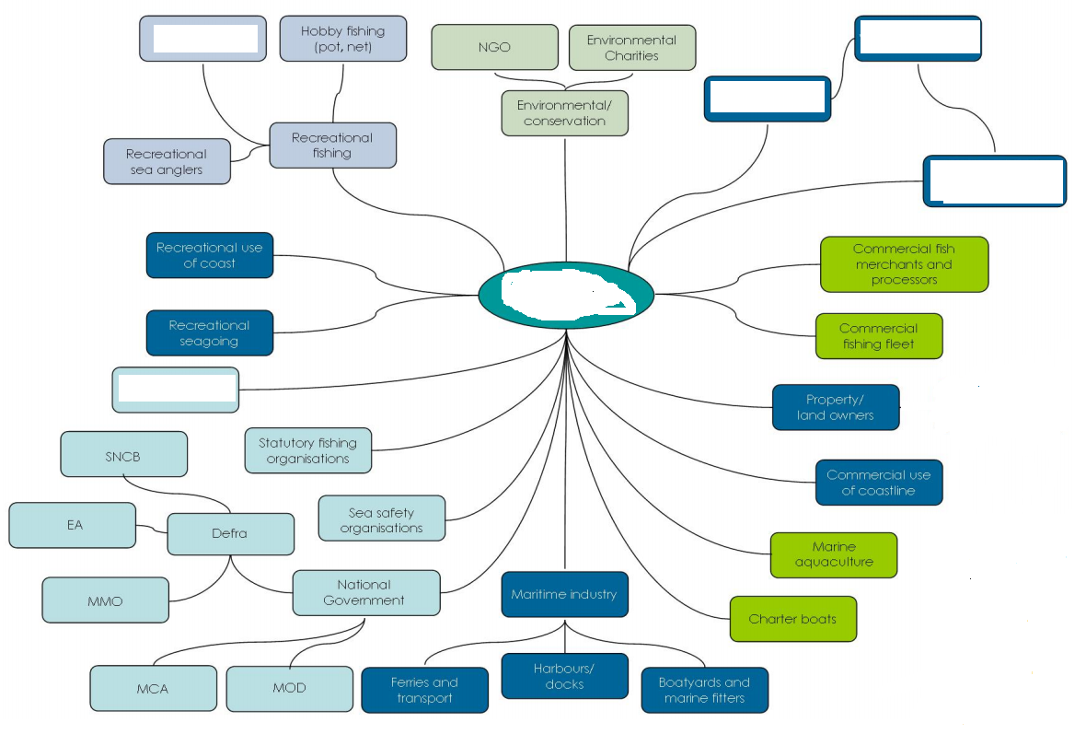

Norfolk County Council

Suffolk County Council

Lincolnshire County Council

Recreational divers

Coastal residents

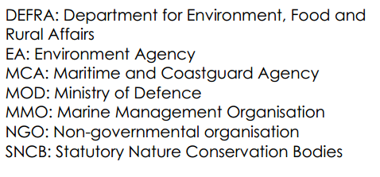

Divers

Bait diggers

Sea anglers

Recreational sea users

Recreational potting/netting etc.

## 3.2 The challenge

Our challenge is to engage people to break down some of the barriers that exist and to connect people to Eastern IFCA and ultimately to earn the recognition and respect of our stakeholders. The table below shows the journey Eastern IFCA is on and highlights the shifts that have been made and those that still need to be made to achieve our aims.

|  |  |  |  |  |
| --- | --- | --- | --- | --- |
| Where We Were in 2011/12 |  | Where We’re At  2014 |  | Where We Want to Be  2015 |
| People weren’t aware of our existence |  | Many stakeholders have heard of us following concerted engagement efforts in FY 2013/14 but more effort needs to be focussed on harder to reach stakeholder |  | Eastern IFCA is ‘recognised and heard’. All stakeholders, including those that are harder to reach, have a full understanding of the work of the Authority |
| People didn’t think our work affected them |  | Our presence at local events in FY 2013/14 means that more tax payers are aware of the relevance of our work. |  | Taxpayers are confident that Eastern IFCA delivers value for money |
| We were not fully engaged with all our stakeholders |  | We have identified partnership working opportunities and have built these into our 2014/15 plans |  | Partnership working is at the core of Eastern IFCA’s work. |

## 3.3 Key messages

There has never been a more exciting time in marine management. Momentum is gathering for the concept of managing the marine environment for the benefit of multiple users along with a shift towards the ecosystem approach. As local managers, Eastern IFCA is at the vanguard of these changes and has developed a number of key messages to reflect our approach.

# 

# 4. Resources

The budget for financial year 2014-15 has been set at £16,320. This represents a reduction of a little over 20% on the 2013-14 budget which was itself greatly reduced from financial year 2012-13 budget which was set at £50,000.

Some of the reduction in budget is due to the entire infrastructure being put in place by the end of financial year 2013-14 thus allowing Eastern IFCA to continue its successful stakeholder engagement program. However, the reduction is also the result of austerity savings. For example, following an assessment of the value of events attended in FY 2013-14, a cut back programme has been planned for 2014-15 to deliver maximum value for money to stakeholders at the same time as making significant saving in areas such as entrance fees and vehicle hire costs.

Another vital resource is the staff. The Authority employs a close team of multi-disciplined professionals to undertake its work. Individually, they have extensive skills, knowledge and experience in their respective roles. The organisation comprises enforcement, research, environment and administrative functions overseen by a Chief Executive Officer who in turn reports to the Authority. However, although roles are clearly defined, Eastern IFCA management encourages a shared understanding of roles and interchangeable capacity to carry out certain roles such as those involved in stakeholder engagement.

# 5. Communication & Engagement Activities FY 2014-15

As well as aligning with the High Level Objectives set for IFCAs by Defra, the communication and engagement activities described in this section have been designed to complement the Authority’s organisational priorities for the year (as set out in the Annual Plan available on the Authority Website <http://www.eastern-ifca.gov.uk> ).

The Authority’s key communication and engagement activities for FY 2014-15 are shown in the table below. Further details of each activity are provided in the subsequent tables. These tables include a brief description of each project, the expected outputs and resources required.

Whilst this document sets out the key communication and engagement activities that the Authority plans to undertake during FY 2014-15, it is acknowledged that additional unplanned activities are likely to be identified during the period. As and when these arise, a risk assessment will be applied to prioritise between planned and unplanned activities and to identify when external resources might need to be commissioned or planned activities postponed. The Authority recognises that whilst following an agreed annual plan helps ensure it meets its organisational targets, a degree of flexibility is essential in order to maximise efficiencies in communication and engagement.

This section will be reviewed in the Annual Report 2014-15 and a new document created to detail the work plan for the 2015-16 financial year.

**Communication & Engagement Plan – Financial Year 2014-15**

|  |  |
| --- | --- |
| **Ref** | **Project** |
| CE2014A | E Newsletters |
| CE2014B | Stakeholder database |
| CE2014C | Social media |
| CE2014D | Meaningful community engagement |
| CE2014E | Good news stories |
| CE2014F | Engage harder to reach stakeholder groups |
| CE2014G | Attend relevant public events |
| CE2014H | Information signs placed around the district |
| CE2014I | Signing of MoUs and SLAs and partnership working encouraged |
| CE2014J | Communication and Engagement Strategy |
| CE2014K | Communication & Engagement Plan 2015-16 |
| CE2014L | Communication & Engagement Report 2014-15 |
| CE2014M | Feedback is routinely sought from stakeholders |
| CE2014N | Website content |
| CE2014O | Create photo library |

## 

## 5.1 Communication and Engagement Activities

The following tables set out the primary activities that the Authority will conduct in financial year 2014-15.

|  |  |  |  |  |  |  |  |
| --- | --- | --- | --- | --- | --- | --- | --- |
| **E Newsletters** | | **Ref** | | **CE2014A** | | | |
| **Output** | | | **Q1 (2014)** | | **Q2**  **(2014)** | **Q3**  **(2014)** | **Q4**  **(2015)** |
| E newsletter sent to stakeholders on a quarterly basis | | | • | | • | • | • |
| **Project Description** | In the month following the quarterly Statutory Authority Meetings an e newsletter will be developed and sent out to stakeholders. The newsletter is intended to keep stakeholders informed of our work and will include the following;   * Updates on Statutory Authority Meetings and a link to the papers online * Information about community engagement meetings * Staff profiles * Research & Environment team updates * Enforcement team updates * Hyperlinks to relevant documents * Any other news   The benchmarking survey detailed in section 2.3 suggested that stakeholders’ preferred method of communication was by e newsletter making this an especially important activity for 2014-15. | | | | | | |
| **Resources Required** | The newsletter is free to produce online using Mail Chimp. It will take around 20 staff hours to collect the information, design the newsletter and mail it to stakeholders each quarter. | | | | | | |

|  |  |  |  |  |  |  |  |
| --- | --- | --- | --- | --- | --- | --- | --- |
| **Stakeholder database** | | **Ref** | | **CE2014B** | | | |
| **Output** | | | **Q1 (2014)** | | **Q2**  **(2014)** | **Q3**  **(2014)** | **Q4**  **(2015)** |
| In accordance with High Level Objective 4.2a, an easily accessible and up-to-date database of stakeholder contact details will be maintained | | |  | | • |  | • |
| **Project Description** | High Level Objective 4.2a stipulates the need for a database of stakeholders which is to be updated every six months to allow the Eastern IFCA to communicate and engage with its stakeholders in a more meaningful way.  An Access database was created in FY 2013-14. This will need to be maintained, developed and updated in FY 2014-15.  Efforts should also be made to increase the mailing list for e newsletters in accordance with activity CE2014A. | | | | | | |
| **Resources Required** | It will take around 10 hours every other quarter to maintain and update the database. New contacts should be added as and when necessary. | | | | | | |

|  |  |  |  |  |  |  |  |
| --- | --- | --- | --- | --- | --- | --- | --- |
| **Social media** | | **Ref** | | **CE2014C** | | | |
| **Output** | | | **Q1 (2014)** | | **Q2**  **(2014)** | **Q3**  **(2014)** | **Q4**  **(2015)** |
| 1. Regular Twitter updates 2. A regularly updated Facebook profile 3. You Tube channel | | | • | | • | • | • |
| **Project Description** | Social media is free to use and can be updated regularly. Twitter, Facebook and You Tube will be used in combination to keep followers informed of;   * Career opportunities * Fisheries news * Attendance at events * Community engagement meetings * Staff appointments * The work of the Research & Environment team * Any other news   The following work is required in FY 2014-15  Twitter   * Account is active – this needs to be used regularly * Increase followers from current 432 to 1000 by end FY 2014-15   Facebook   * Account is active but not used in FY 2013-14 * Develop a strategy for use * Ask IFCA staff for regular contributions * Create engaging and meaningful posts * Increase friends and followers   You Tube   * Account is active but not used in FY 2013-14 * Investigate potential for You Tube channel * Post DVD to You Tube and link to Eastern IFCA website | | | | | | |
| **Resources Required** | CDO should be in charge of co-ordinating all social media with support from other relevant staff. It is anticipated that this may consume 5 staff hours a week. | | | | | | |

|  |  |  |  |  |  |  |  |
| --- | --- | --- | --- | --- | --- | --- | --- |
| **Meaningful community engagement** | | **Ref** | | **CE2014D** | | | |
| **Output** | | | **Q1 (2014)** | | **Q2**  **(2014)** | **Q3**  **(2014)** | **Q4**  **(2015)** |
| An appropriate mechanism to engage with the widest possible cross section of stakeholders face to face | | | • | | • | • | • |
| **Project Description** | A 1 year trial to use a trailer based office to conduct ‘clinic’ style engagement at locations and situations to suit stakeholders. | | | | | | |
| **Resources Required** | Officer time to position and populate the trailer. Accommodation may be required on occasion if return travel to King’s Lynn precludes effective use of the trailer. | | | | | | |

|  |  |  |  |  |  |  |  |
| --- | --- | --- | --- | --- | --- | --- | --- |
| **Good news stories** | | **Ref** | | **CE2014E** | | | |
| **Output** | | | **Q1 (2014)** | | **Q2**  **(2014)** | **Q3**  **(2014)** | **Q4**  **(2015)** |
| Monthly press releases | | | • | | • | • | • |
| **Project Description** | In FY2013-14 press releases were sent out in an ad hoc manner. To better raise the profile of Eastern IFCA “good news stories” should be sent out to the media on a monthly basis. They should be sent to a range of media including TV, online, radio, local & national newspapers, industry press and magazines. Closer ties should also be made with media professionals who should be encouraged to approach Eastern IFCA for stories. Suggestions include (but are not limited to);   * Journalist trips on John Allen and Three Counties * EMS byelaw * The importance of the industry to the local economy and Eastern IFCA’s role in managing it * The work of the research, enforcement and environment teams | | | | | | |
| **Resources Required** | It will take around 8 staff hours a month to write and send press releases. More time may be required to accompany journalists on boat trips for example. | | | | | | |

|  |  |  |  |  |  |  |  |
| --- | --- | --- | --- | --- | --- | --- | --- |
| **Engage ‘hard to reach’ stakeholder groups** | | **Ref** | | **CE2014F** | | | |
| **Output** | | | **Q1 (2014)** | | **Q2**  **(2014)** | **Q3**  **(2014)** | **Q4**  **(2015)** |
| Key stakeholder groups will be engaged through visits from relevant staff members. | | | • | | • | • | • |
| **Project Description** | The benchmarking survey commissioned in 2012 showed low levels of awareness amongst certain key stakeholder groups. For example;   * Residents of Lincolnshire when compared to other counties * Recreational coastal users * Parish and community groups including schools * Certain NGOs   Furthermore, Sea Angling 2012 highlighted the extent and importance of recreational angling. More effort will be made to engage fishing clubs and individuals with Eastern IFCA’s work.  In FY 2014-15 it is essential to redress this balance by identifying and contacting groups mentioned above and raising awareness of the work of Eastern IFCA by appropriate means such as;   * Giving presentations * Sending copies of the DVD * Involving schools in competitions | | | | | | |
| **Resources Required** | CDO core output. Additional time will be required once contact is established in order to promote the work of Eastern IFCA amongst hard to reach stakeholder groups. | | | | | | |

|  |  |  |  |  |  |  |  |
| --- | --- | --- | --- | --- | --- | --- | --- |
| **Attend relevant public events** | | **Ref** | | **CE2014G** | | | |
| **Output** | | | **Q1 (2014)** | | **Q2**  **(2014)** | **Q3**  **(2014)** | **Q4**  **(2015)** |
| The Eastern IFCA will be recognised and heard by the local community through our attendance at various regional events. | | | • | | • | • | • |
| **Project Description** | Country shows, game fairs and carnivals take place throughout the 3 counties during the summer months. Many of these events have marine, fishing or coastal themes/areas and are suitable occasions to engage with local tax payers and users of the coast. Events to attend in 2014-15 will include;   * Cromer & Sheringham Crab & Lobster Festival * Friskney Show * Ipswich Maritime Festival * Great Yarmouth Maritime Festival * Wild About Norfolk   Infrastructure purchased in the previous financial year including a mobile aquarium and branded gazebo will create a buzz at these events and help raise the profile of Eastern IFCA throughout its district. | | | | | | |
| **Resources Required** | Hire costs vary according to event but are generally around £50 - £100. It is hoped that attendance at these events will cost no more than £1000 in total. Man hours required will also vary according to duration of the event and our involvement. | | | | | | |

|  |  |  |  |  |  |  |  |
| --- | --- | --- | --- | --- | --- | --- | --- |
| **Information signs placed around the district** | | **Ref** | | **CE2014H** | | | |
| **Output** | | | **Q1 (2014)** | | **Q2**  **(2014)** | **Q3**  **(2014)** | **Q4**  **(2015)** |
| To meet High Level Objective 4.2d, Eastern IFCA information signs will be located along the coast. | | | • | | • |  |  |
| **Project Description** | 8 signs containing information such as minimum landing sizes were made in 2011 and are ready to be placed around the coast to provide information to coastal users. Negotiations have been on-going but a great deal of consultation to resolve issues such as planning permission has been required. One sign was placed at Levington Marina in 2013 and further positive steps have been made to place the other 7. It is hoped that all 8 signs will be in place for the start of the summer season 2014.  It is hoped that further signs relating to other Eastern IFCA projects will be placed around the coast throughout the period. | | | | | | |
| **Resources Required** | The signs cost £11,200 for design and manufacture in FY 2011-12. Installation costs in FY 2014-15 will cost around £1000. Liaison time is around 15 hours per month. | | | | | | |

|  |  |  |  |  |  |  |  |
| --- | --- | --- | --- | --- | --- | --- | --- |
| **Partnership working encouraged** | | **Ref** | | **CE2014I** | | | |
| **Output** | | | **Q1 (2014)** | | **Q2**  **(2014)** | **Q3**  **(2014)** | **Q4**  **(2015)** |
| To meet Success Criterion 6 – ‘IFCAs support and promote the sustainable management of the marine environment’ – Eastern IFCA will work in partnership with a number of organisations. | | | • | | • | • | • |
| **Project Description** | Further partnership working planned for FY 2014-15 include;   * A joint event with the RSPB * Participation in the Wildlife Trust’s Marine Week * Co-operation with Hunstanton Sea Life Sanctuary * Joint communications with Defra family * Continued engagement with Offshore renewable developers | | | | | | |
| **Resources Required** | Time, and possibly financial resources, will be required for partnership working events. | | | | | | |

|  |  |  |  |  |  |  |  |
| --- | --- | --- | --- | --- | --- | --- | --- |
| **Communication Strategy** | | **Ref** | | **CE2014J** | | | |
| **Output** | | | **Q1 (2014)** | | **Q2**  **(2014)** | **Q3**  **(2014)** | **Q4**  **(2015)** |
| A finalised communication strategy taking Eastern IFCA forwards from 2015 | | |  | |  |  | • |
| **Project Description** | A joint Communication & Engagement Strategy and Plan was written to guide Eastern IFCA up to the end of FY 2014/15. Following assessment of stakeholder engagement and communication activities from 2012-15, it will be necessary to re-write the Authority’s strategy to detail the overall direction the Authority will take to ensure continued meaningful engagement with stakeholders. | | | | | | |
| **Resources Required** | Following a meeting with the Planning & Communication Sub-Committee to discuss the direction of the Authority, the strategy will take around 80 hours to write and will require additional time for amendments and agreement with Planning & Communication sub-committee members. | | | | | | |

|  |  |  |  |  |  |  |  |
| --- | --- | --- | --- | --- | --- | --- | --- |
| **Communication and Engagement Plan 2015-16** | | **Ref** | | **CE2014K** | | | |
| **Output** | | | **Q1 (2014)** | | **Q2**  **(2014)** | **Q3**  **(2014)** | **Q4**  **(2015)** |
| A Communication & Engagement plan for FY 2015-16. | | |  | |  |  | • |
| **Project Description** | This document details communication & engagement activities for FY 2014-15. A similar document needs to be produced to detail communication & engagement activities for FY 2015-16. | | | | | | |
| **Resources Required** | The Communication & Engagement Plan for FY 2015-16 will take around 60 hours to plan and write. | | | | | | |

|  |  |  |  |  |  |  |  |
| --- | --- | --- | --- | --- | --- | --- | --- |
| **Communication and Engagement Report 2014-15** | | **Ref** | | **CE2014L** | | | |
| **Output** | | | **Q1 (2014)** | | **Q2**  **(2014)** | **Q3**  **(2014)** | **Q4**  **(2015)** |
| A Communication & Engagement report detailing progress made in that financial year. | | |  | |  |  | • |
| **Project Description** | A Communication & Engagement report works in tandem with the Communication & Engagement Plan. It details progress made against the plan and critiques the work of the previous financial year. It is intended that a report will be completed in Q4 of 2015. | | | | | | |
| **Resources Required** | The report will take around 40 hours to write and will require additional time for amendments and agreement with Planning & Communication sub-committee members. | | | | | | |

|  |  |  |  |  |  |  |  |
| --- | --- | --- | --- | --- | --- | --- | --- |
| **Feedback is routinely sought from stakeholders** | | **Ref** | | **CE2014M** | | | |
| **Output** | | | **Q1 (2014)** | | **Q2**  **(2014)** | **Q3**  **(2014)** | **Q4**  **(2015)** |
| Feedback is routinely sought from stakeholders in accordance with High Level Objective 6.2c and there are clear channels for stakeholders to comment and make complaints. | | | • | | • | • | • |
| **Project Description** | Bright ideas forms developed and distributed  Website to include an ‘Ask the Chief’ section to allow stakeholders to contact the CEO directly. | | | | | | |
| **Resources Required** | Core output of CDO. | | | | | | |

|  |  |  |  |  |  |  |  |
| --- | --- | --- | --- | --- | --- | --- | --- |
| **Website** | | **Ref** | | **CE2014N** | | | |
| **Output** | | | **Q1 (2014)** | | **Q2**  **(2014)** | **Q3**  **(2014)** | **Q4**  **(2015)** |
| In accordance with High Level Objective 4.2c, Eastern IFCA will deliver increased traffic to an up-to-date, engaging and user-friendly website. | | | • | | • | • | • |
| **Project Description** | The Administrative Officer is responsible for updating the website with meeting papers and dates etc. along with the ‘Latest News’ section. This should be maintained.  It would also be useful to monitor traffic to the website by including a web counter.  Website content should be reinvigorated in FY 2014 – 15. Eastern IFCA staff and stakeholders should be consulted however, at present, ideas include;   * An ‘ask the Chief’ section to facilitate stakeholder feedback * A Twitter feed * A re-invigorated ‘environment’ section containing information about the species and habitats in our district * Information for schools | | | | | | |
| **Resources Required** | Core output of CDO. | | | | | | |

|  |  |  |  |  |  |  |  |
| --- | --- | --- | --- | --- | --- | --- | --- |
| **Create photo library** | | **Ref** | | **CE2014O** | | | |
| **Output** | | | **Q1 (2014)** | | **Q2**  **(2014)** | **Q3**  **(2014)** | **Q4**  **(2015)** |
| A user-friendly data base of photos and videos detailing the work of the Authority. | | | • | | • | • | • |
| **Project Description** | At present photos are taken in an ad hoc manner and are stored in various places on the system making it difficult to find new, interesting photos for use in reports, newsletters, social media etc. To achieve this the following will be required;   * Buy-in from all Eastern IFCA staff and key stakeholders * A commitment to take and share photos and videos * An agreed place on the system to store and log photos | | | | | | |
| **Resources Required** | Time will be required to develop a film for this along with time to co-ordinate and store photos. | | | | | | |

## 5.3 Summary of Communication & Engagement Activities: Financial Year 2014-15

**Table 5.3 Communication & Engagement activities**

|  |  |  |  |  |  |  |  |  |  |  |  |  |  |
| --- | --- | --- | --- | --- | --- | --- | --- | --- | --- | --- | --- | --- | --- |
| **Ref** | **Project** | **A** | **M** | **J** | **J** | **A** | **S** | **O** | **N** | **D** | **J** | **F** | **M** |
| CE2014A | E Newsletters |  |  |  |  |  |  |  |  |  |  |  |  |
| CE2014B | Stakeholder database |  |  |  |  |  |  |  |  |  |  |  |  |
| CE2014C | Social media |  |  |  |  |  |  |  |  |  |  |  |  |
| CE2014D | Meaningful community engagement |  |  |  |  |  |  |  |  |  |  |  |  |
| CE2014E | Good news stories |  |  |  |  |  |  |  |  |  |  |  |  |
| CE2014F | Give presentations to different stakeholder groups |  |  |  |  |  |  |  |  |  |  |  |  |
| CE2014G | Attend relevant public events |  |  |  |  |  |  |  |  |  |  |  |  |
| CE2014H | Information signs placed around the district |  |  |  |  |  |  |  |  |  |  |  |  |
| CE2014I | Signing of MoUs and SLAs and partnership working encouraged |  |  |  |  |  |  |  |  |  |  |  |  |
| CE2014J | Communication and Engagement Strategy |  |  |  |  |  |  |  |  |  |  |  |  |
| CE2014K | Communication & Engagement Plan 2015-16 |  |  |  |  |  |  |  |  |  |  |  |  |
| CE2014L | Communication & Engagement Report 2014-15 |  |  |  |  |  |  |  |  |  |  |  |  |
| CE2014M | Feedback is routinely sought from stakeholders |  |  |  |  |  |  |  |  |  |  |  |  |
| CE2014N | Website content |  |  |  |  |  |  |  |  |  |  |  |  |
| CE2014O | Create photo library |  |  |  |  |  |  |  |  |  |  |  |  |