Eastern IFCA Application and Exemptions Byelaw
Information for stakeholders
Eastern IFCA has launched formal consultation for the proposed Application and Exemptions Byelaw.
The deadline for your feedback is the 4th January 2016 – these should be written responses in the form of a letter or by completing a questionnaire (which can be found by clicking here) sent either by post or via email to the addresses below:
Email: mail@eastern-ifca.gcsx.gov.uk

If you have any questions regarding the byelaws or the formal consultation please feel free to contact the office on:
Tel: 01553 775321

Postal address
Eastern IFCA
6 North Lynn Business Village
Bergen Way
King’s Lynn
PE30 2JG

Please also forward any comments or completed questionnaires to the Marine Management Organisation at either of the following:
Postal Address
Marine Conservation and Enforcement Team
Marine Management Organisation
Lancaster House
Hampshire Court
Newcastle-Upon-Tyne
NE4 7HY
Or
Email: IFCAbyelaws@marinemanagement.org

Key links (click the link to open):
Eastern IFCA Application and Exemptions Byelaw
Associated Impact Assessment
Why is a byelaw necessary?
Eastern IFCA inherited a small part of North Eastern Sea Fisheries Committee’s district and all of their byelaws in 2011. As a result, Eastern IFCA has two sets of byelaws – one set which only apply within the ‘inherited area’ and one set which apply in the rest of the district.
The inherited area is shown in the chart below.

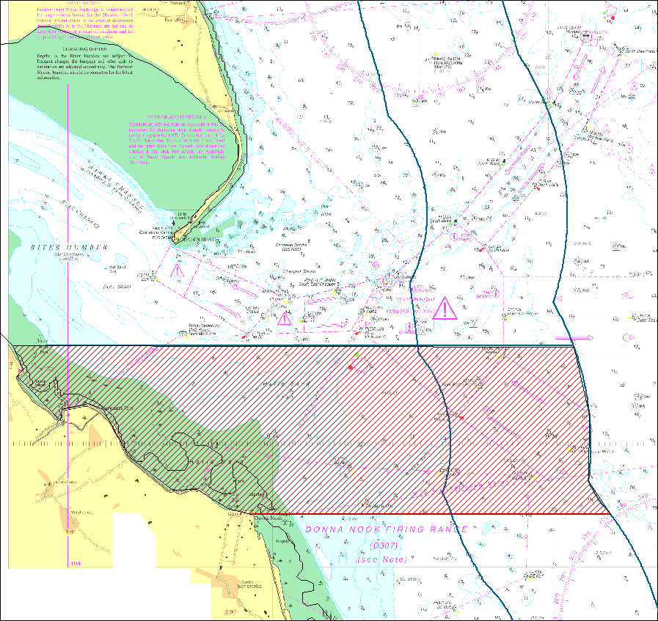
Figure 1. Chart showing the location of the ‘inherited area’. Within this area – Only those byelaws inherited from North Eastern Sea Fisheries Committee apply.
The ‘inherited area’ (coloured in with red shading on the chart) consist of the sea out to six nautical miles between:
- The control tower at the Royal Air Force Gunnery and Bombing Range at Donna Nook in Lincolnshire – (Latitude 53 28.22’N Longitude 0 09.24’E); and
- Haile Sand Fort in Lincolnshire (Latitude 53 32.09’ N Longitude 0 01.82E).
The two blue lines on the chart running south to north indicate the 3 and 6 nautical mile boundaries.
This chart is not to be used for navigational purposes
(c) British Crown and SeaZone Solutions Limited. All rights reserved. Licence No. 092009.021. This product has been derived in part from material obtained from the UK Hydrographic Office with the permission of the Controller of Her Majesty’s Statutory Office and UK Hydrographic Office.

To remedy this situation such that there is consistency across the whole Eastern IFCA district, Byelaw 2 (Application and Saving for Scientific Purposes) of Eastern IFCA’s byelaws needs to be revoked and remade.
Byelaw 2 (Application and Saving for Scientific Purposes) sets out where Eastern IFCA’s byelaws apply – it currently refers to the Eastern Sea Fisheries Committee’s district which does not include the inherited area.
What is the proposed Application and Exemptions Byelaw?
The proposed byelaw will have the effect of redefining the spatial application of Eastern IFCA byelaw to include the inherited area by revoking Byelaw 2 (Application and Saving for Scientific Purposes) and replacing it with the proposed byelaw.
It will mirror the provisions of Byelaw 2 (Application and Saving for Scientific Purposes) to allow Eastern IFCA to grant exemptions form byelaws for scientific surveys and breeding and stocking purposes. The byelaw will also include the provision to allow Eastern IFCA to grant exemptions for reasons of ‘fisheries management’.
The proposed byelaw will also revoke 15 North Eastern Sea Fisheries Committee byelaws which were inherited by Eastern IFCA. In doing so, the byelaws will effectively be replaced by Eastern IFCA byelaws.
What will the impacts of the byelaw be?
The fishing activity which could be impacted by these changes is potting for crabs and lobster within the inherited area. The differences between the inherited regulation and the proposed regulation are as follows:
Removal of parts of shellfish
Several IFCAs have byelaws which prohibit the landing of crabs and lobsters unless they are landed whole – i.e. it is prohibited to land a crab claw detached from the rest of the crab. Under the current regulation in the inherited area, it is permitted to land parts of edible crab (Cancer pagurus) and velvet crabs (Necora puber) if:
• The parts of crab do not make up more than 10% by weight, the total landed catch on one occasion; or
• The crab was caught in a trammel, gill or other enmeshing net and the claw became detached from the crab in clearing the net.
Please refer to the full byelaw on our website for more details
Under the proposed regulations it would be prohibited to land any parts of crabs (edible crabs or velvet crabs) regardless of how it was caught or its percentage with regards to total catch.
Using edible crab for bait
Under the current regulations it is permitted to use edible crab (Cancer pagurus) within the inherited area if that crab is cooked offal.
Under the proposed regulations it would be prohibited to use any edible crab as bait even if cooked offal.
Four inherited byelaws will not be revoked. These byelaws have been identified as requiring further review.
A full list of the byelaws which will be revoked can be found in Annex 1 – which also includes rationale for why they are to be revoked.
Have your say
If you have any comments or objections to the measures please use the information at the top of this information to respond by the 4th January 2016. Please also forward representations to the MMO.

North Eastern IFCA BYELAW | Summary of Offence / Byelaw | EIFCA Equivalent (Y/N) | Recommended Action | Explanation | Economic Impacts (Including the impact of replacing with Eastern Byelaw) | Environmental Impacts (Including the impact of replacing with Eastern Byelaw)
II. Application & Saving for scientific purposes |  | Y - Byelaw 2 : EIFCA refers to sec 6 Sea Fisheries Regulation Act 1966, NEIFCA refers to Section 13 Sea Fisheries Regulation Act 1888 | Revoke | ESFJC equivalent includes more up-to-date legislation | N/A | N/A
III. Trawling Prohibition : Exceptions | Trawling without a Permit | N - eastern IFCA only has trawling restrictions in specified areas | Retain - further review | The NESFC byelaw prohibits fishing within the inherited area. Removal of this byelaw would allow trawling in the inherited area - Options for removal include extending EIFCA byelaw 12 (which would restrict the length of vessels which can trawl) or amending our byelaw 12 to include a prohibition in this area. There are important sole nursery/spawning grounds around the Humber Estuary. There is a case to keep it until EIFCA byelaw 12 is reviewed. | N/A | N/A
IV. Seine Net, Draw Net Prohibition | Use of a Seine net, or any drawn net of the kind known as the Danish seine or 'snurrevaad' | N | Revoke | The NESFC byelaw prohibits the use of siene nets (and snurrevaad) in this area. The byelaw is generic and doesn’t specify this area. Need to consider the impact of allowing seine netting in this area (i.e. sole grounds) and the current level of activity - would seine netting have an impact on the sole grounds? | N/A | Potential conflict with the sole spawning grounds - need to consider the likelihood of this activity actually taking place should the byelaw be revoked
V. Push Net | Push nets must be raised and cleared at least once in every half hour | N | Revoke | The NESFC byelaws prohibits the use of shrimp push nets in this area. This byelaw is generic and doesn’t specify this area. Need to consider impact of allowing push netting in this area (i.e. sole grounds) and the current level of activity. | N/A | Potential conflict with the sole spawning grounds - need to consider the likelihood of this activity actually taking place should the byelaw be revoked
VIII. Mussels : Minimum Size | removal from a fishery of mussels less than 51mm in length | Y - Byelaw 4 : Minimum sizes differ between the two byelaws | Revoke | There are currently no known mussel beds within inherited part of Eastern IFCA district - Eastern IFCA has no reason to believe an increase in the MLS of mussel is required within its district. Removal of this byelaw will make regulation across district consistent. | N/A - Positive | Potential impact on mussels if taking smaller size
X. Re-Deposit of Shellfish | Removal of prohibited shellfish - must be redeposit as close as possible to the place from which it was taken. | Y - Byelaw 9 | Revoke | This byelaw represents a duplication of the EIFCA byelaw and can be removed with no effect. | N/A | N/A
XI. Regulations of Shellfish Beds | Removal of shellfish from a closed area | Y - Byelaw 8 | Revoke | EIFCA has an equivalent byelaw - Byelaw 8 includes the ability to temporarily close a bed for 'protection of the fishery' which may include more metrics than juvenile density and stock levels. EIFCA byelaw is more appropriate. | N/A | N/A
XII. Shrimp & Prawn Fishing | Failure to raise or clear nets when fishing for shrimp or prawn, at least once in every hour | N | Retain - further review | The byelaw requires fishers to lift and clear gear every hour - presumably to prevent the death of by-catch. Given that the area is a sole nursery area this is likely to be important. EIFCA are currently reviewing shrimp measures with a view to implement new measures. There is a case to keep this byelaw and look to revoke it at conclusion of our shrimp measures. | N/A | N/A
XIV. Prohibition of Removal of parts of lobsters from any fishery | Removal of lobsters below MLS, or tail, claw or any other detached part of a lobster | Y - Byelaw 7 - refers to edible crab, velvet crab and lobsters | Revoke | This byelaw duplicates the Eastern IFCA byelaw 7 but includes more species - includes edible crab and velvet crab | Potential impact if current fishing practices include landing parts of velvet crab or edible crab | N/A - positive
XV. Application of Byelaws | Byelaws in force prior to 22nd Dec 1992 apply only to inside three nautical miles from baselines | N - Reference is made to where byelaws are applied in the paragraph prior to Byelaw 1. | Revoke | Not relevant | N/A | N/A
XVIII. Fixed Engine (Authorisation) Byelaw | Use of fixed engines only in specified areas, for specified species and for a period of 5 years after the date the byelaw was made. | Y - BYELAW 13 - this prohibits the use of fixed engines in waters inland of the ESFJC District except where historical rights of several fisheries make the prohibition exempt | Retain - further review | Removal of this byelaw would allow the targeting of sole, cod and all sea fish within 'Box B'. The byelaw specifically names an area within Eastern IFCA's district which is also a known sole spawning/nursery area. Revoking this byelaw would potentially have impacts on the sustainability of sole fisheries. Recommendation is to keep this byelaw and remake at a later stage in line with up-to-date byelaw guidance. | N/A | N/A
XIX. Parts of a Crab | prevents the landing of parts of a crab which cannot be measured to ensure compliance with the MLS, with the exceptions stated as (a) and (b) | Y - Byelaw 7 - refers to edible crab, velvet crab and lobsters | Revoke | Eastern IFCA byelaw is more restrictive - i.e. NESFC byelaw has exemptions where it is permitted to remove parts of (edible crab) - if removed the increased regulation would need to be reflected in an Impact Assessment | Potential impact if parts of crab is caught as by-catch (not more than 10%) or by a trammel, gill, entangling etc. Should consider potential loss of earnings if this is prohibited. | N/A - positive
XX. Prohibition on use of Crab(Cancer Pagurus) for Bait | use of edible crab for bait with the exception of cooked crab offal | Y - Byelaw 5 - no reference is made to cooked crab offal being an exception | Revoke | Eastern IFCA byelaw is more restrictive - i.e. has no exception for cooked crab offal. This increase in regulation will need to be reflected in an IA | Potential impact on cost of bait if cooked offal is currently being used as bait. | Potential impact if fishers start capturing other bait sources
XXI. Protection of 'V' notched lobsters | fishing for or taking lobster which have a v-notch in any of their tail fan flaps, or which have any form of mutilation to any of the tail fan flaps | N - SI (2000 No.874) prohibits the landing of v-notched lobsters | Revoke | The Lobsters and Crawfish (Prohibition of Fishing and Landing) Order 2000 (SI 874) prohibits the fishing of v notched or mutilated lobsters however the byelaw would allow for fishers not associated with a relevant vessel (i.e. recreational fishers). There is unlikely to be a significant impact on the lobster fishery from recreational fishers taking lobster in this area - should be considered in IA. | N/A | Potential for v-notched lobsters to be caught by recreational fishers
XXII. Permit to fish for lobster, crab, velvet crab and whelk | fishing for or removing lobster, crab, velvet crab or whelk without a specified permit | N | Revoke | Removal of this byelaw will allow fishing for the species prescribed in the byelaw to occur as in the rest of Eastern IFCA district - as we do not currently issue any permits for this area fishing for these species is currently banned in the inherited area. Removal would bring fisheries management in line with rest of district and will potentially be considered during Whelk byelaw/potting byelaw. It currently contradicts the whelk potting byelaw. | N/A - Positive (technically potting is prohibited din this area as we have not issued any permits) | Lobster, edible crab and velvet crab fishing could take place without any conditions on gear which could have an impact. Whelk effort is controlled under the EIFCA whelk byelaw.
XXIII. Method and area of fishing (Dredges) byelaw | Use of a dredge other than between 1st July and 30th September, dredges must be limited to max of 10 and of specified construction. Dredging is not permitted inside 3nm from baselines | Y - Byelaw 3, byelaw 15 | Revoke | Byelaw relevant to scallop dredging which is prohibited under the byelaw. Fishers will not be able to use any gear to take scallops (or any shellfish prescribed in Byelaw 3) without authorisation from Eastern IFCA under byelaw 3. As such we have a byelaw which has the same protective effect at the moment. | N/A | N/A
XXIV. Humber Estuary Cockle Fishery Byelaw | Removal or disturbance of cockle without a permit | Y/N - Byelaw 3 - prevents the removal of cockles except by hand, hand-rake or gear approved by the Authority. Byelaw 8 allows us to close a shellfish bed. Byelaw 11 allows us to ask for returns. | Retain - further review | Permits will be provided to anyone on demand who accurately completes an application form - we can only refuse a permit on the grounds that the application form is not complete. i.e. there would be no real way to limit the number of permits under this byelaw. use of byelaw 8 and 11 of our byelaws could be used in its stead however we would still have same issue. Recommended that the byelaw remains in place until further review can be completed. | N/A | N/A
XXV. Prohibition on removal of tope or parts thereof | Removal of tope or the species (Galeorhinus galeus) of parts thereof. | Y - Byelaw 14 | Revoke | Eastern IFCA equivalent | N/A | N/A
XXVIII. Crustacea Conservation Byelaw | Use of pots, creel or traps which do not meet the guidelines set out in the byelaw | N | Revoke | This byelaw does not apply in the inherited part of Eastern IFCA's district | N/A | N/A

