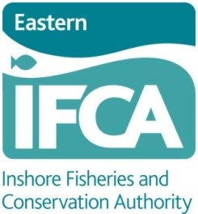
Bright Ideas template
Our aim is to deliver responsive and flexible management of sea fisheries resources, to meet local needs.
To do this we need your help… we want to hear your ideas about projects that the Eastern IFCA Research and Environment team could undertake, for the benefit of our local seas.
1. What is the idea? (please feel free to use additional paper)

2. Where would the work need to be carried out? Please specify county and approximate location, e.g. Suffolk, Aldeburgh to Orfordness
County Location
Norfolk …………………………………………………
Suffolk …………………………………………………
Lincolnshire …………………………………………………

3. Which of the following categories does the work relate to? You may tick more than one box
Eastern Region Marine Plan Offshore Wind Farms
Wash Fishery Order Marine Aggregates/dredging
Other Commercial Fishery Marine Conservation Zones
European Marine Sites ‘Non-fish’ Wildlife
Recreational fishery Cultural/Social value
Enforcement Fish Sustainability/MSC
Other …………………………………………………
4. What other organisations will we need to work with?

5. Does the work fit in with any existing projects that you are aware of? (e.g. Cefas juvenile crab and lobster studies, Shark Trust skate and ray project, Cefas Marine Protected Area evidence project, etc.)

6. What practical work do you envisage being required? (e.g. vessel or shore based surveys) Please include approximate timings for the project, if known.

Any other comments?

Thank you for taking the time to send us your thoughts.
The next step for us will be to compare all the suggestions and present the findings to our Regulatory and Compliance Sub-Committee. They will make the final decision as to what is included in the final Research & Environment plan for the 2014/15 financial year.
You are welcome to attend any of the Authority public meetings (details on our website).
If you would like us to confirm receipt of your suggestion and/or to keep you informed of our planning processes and the work of the Eastern IFCA, please provide your contact details:
Name :
Address:
Email:

