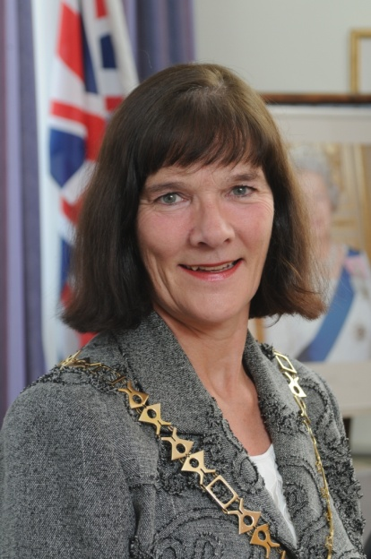
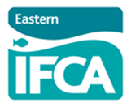
Contact: Lucy Ritchie
Tel: 01553 775321
lucyritchie@eastern-ifca.gcsx.gov.uk

PRESS RELEASE

EASTERN IFCA PLEASED TO ANNOUNCE ELECTION OF NEW CHAIR

At the 10th Statutory Authority Meeting of the Eastern Inshore Fisheries and Conservation Authority (Eastern IFCA) a new chair was elected following the retirement of Councillor Ken Sale from Suffolk County Council. Councillor Hilary Cox was elected unanimously by the Authority comprising representatives from Lincolnshire, Norfolk and Suffolk County Councils along with Marine Management Organisation appointees representing various marine stakeholders.

Councillor Cox was also appointed as Chairman of Norfolk County Council on 13 May 2013 having been a councillor since 2002. Hilary is very committed to local issues and values as reflected in her work for Eastern IFCA.
Hilary is married to a retired Cromer crab fisherman of 50 years and has witnessed the changes that have taken place both in the fishing industry and in the attitude of care for the environment. Her concern for the continuation of local fisheries all along the coastline of the Eastern IFCA alongside the need to protect the environment to benefit both community and sustainability of the industry is high on her agenda.
She is determined to enable the Authority to ensure that any marine development and or exploitation is carried out with the preservation of local traditions, acknowledging ongoing changes of nature and balancing natural phenomena with the need for human resources.
Eastern IFCA was created in 2011 by ministerial order following the passage of the Marine and Coastal Access Act (2009). It builds on the work of the Eastern Sea Fisheries Joint Committee (1894) with an expanded vision to ‘lead, champion and manage a sustainable marine environment and inshore fisheries, by successfully securing the right balance between social, environmental and economic benefits to ensure healthy seas, sustainable fisheries and a viable industry’.
If you would like to speak to Councillor Cox please contact the Eastern IFCA office on 01553 775321 or via E mail to lucyritchie@eastern-ifca.gov.uk

