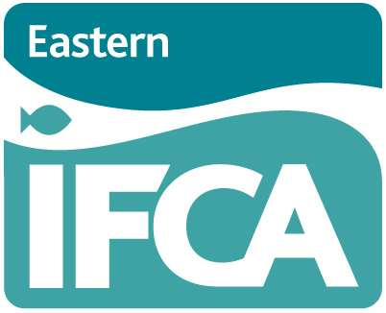
Eastern IFCA – Marine Protected Areas Byelaw 2019: Informal consultation

March 2019

Eastern IFCA is undertaking an informal consultation regarding additional closures to bottom-towed gear. This questionnaire is designed to capture information to inform the development of the proposed closures.
By providing a response, your information is captured and helps to improve the evidence base Eastern IFCA is using to shape management proposals.
We recognise the sensitivity of your data and individual responses will be treated as confidential. However, we will create a summary of the responses which may be published.

The data collected on this questionnaire will be processed in accordance with an associated privacy notice which can be found on the Eastern IFCA website here.

Completed questionnaires should be sent by 12 noon on 24th April 2019 to:
CEO, Eastern Inshore Fisheries & Conservation Authority, Unit 6 North Lynn Business Village, Bergen Way, King’s Lynn, Norfolk, PE30 2JG.

Email: mail@eastern-ifca.gov.uk

If you have any queries about this consultation or the form, please contact the office. If you would like some assistance completing the form, please contact the office to arrange some time with an Officer who will go through the questionnaire with you.

Please note, there are four sections in this questionnaire:

- Section 1: About you
- Section 2: Fishing activity: North Norfolk Coast
- Section 3: Fishing activity: East Norfolk Coast
- Section 4: Any other observations/comments

Section 1. About you

- Personal details

Full Name
Contact Address
Email
Tel / mob
Vessel Name
Vessel PLN
Port / beach of vessel launch
Do you have a commercial fishing Licence? (please select) | Yes/No

Section 2. Fishing activity in management focus areas: North Norfolk Coast
Do you fish using bottom-towed gear in any of the areas numbered on the chart titled ‘North Norfolk Coast’? (please tick as appropriate) Please mark onto the chart any important fishing areas / trawl lines.

- Area 1
- Area 2
- Area 3

For each area that you fish in, please provide the following information:
Area | Type of bottom-towed gear used | Species targeted (using bottom towed gear) | Number of trips fishing in this area per year (using bottom towed gear) | Proportion / percentage of income generated from catch from this area (using bottom towed gear)
1
2
3

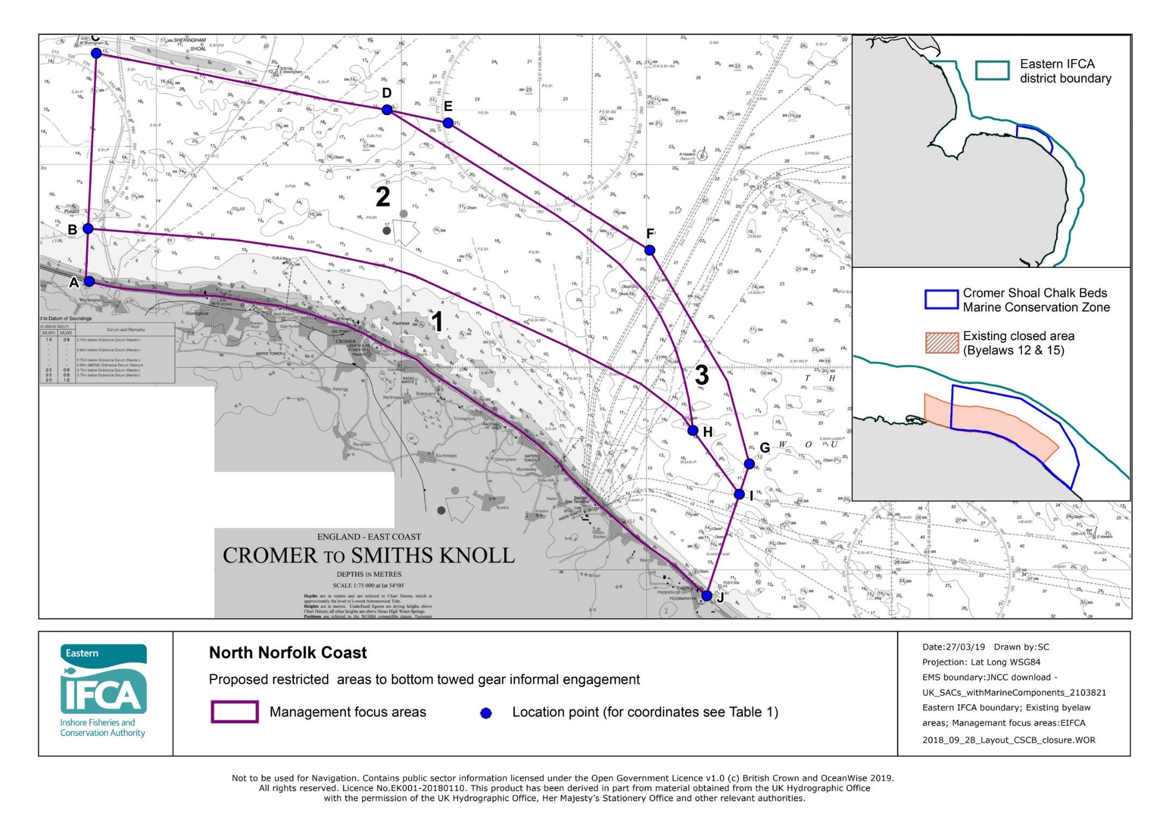

Section 3. Fishing activity in management focus areas: East Norfolk Coast
Do you fish using bottom towed gear in any of the areas numbered on the chart titled ‘East Norfolk Coast’? (please tick as appropriate) Please mark onto the chart any important fishing areas / trawl lines .

- Area 1
- Area 2
- Area 3

For each area that you fish in, please provide the following information:
Area | Type of bottom towed gear used | Species targeted (using bottom towed gear) | Number of trips fishing in this area per year(using bottom towed gear) | Proportion / percentage of income generated from catch from this area (using bottom towed gear)
1
2
3

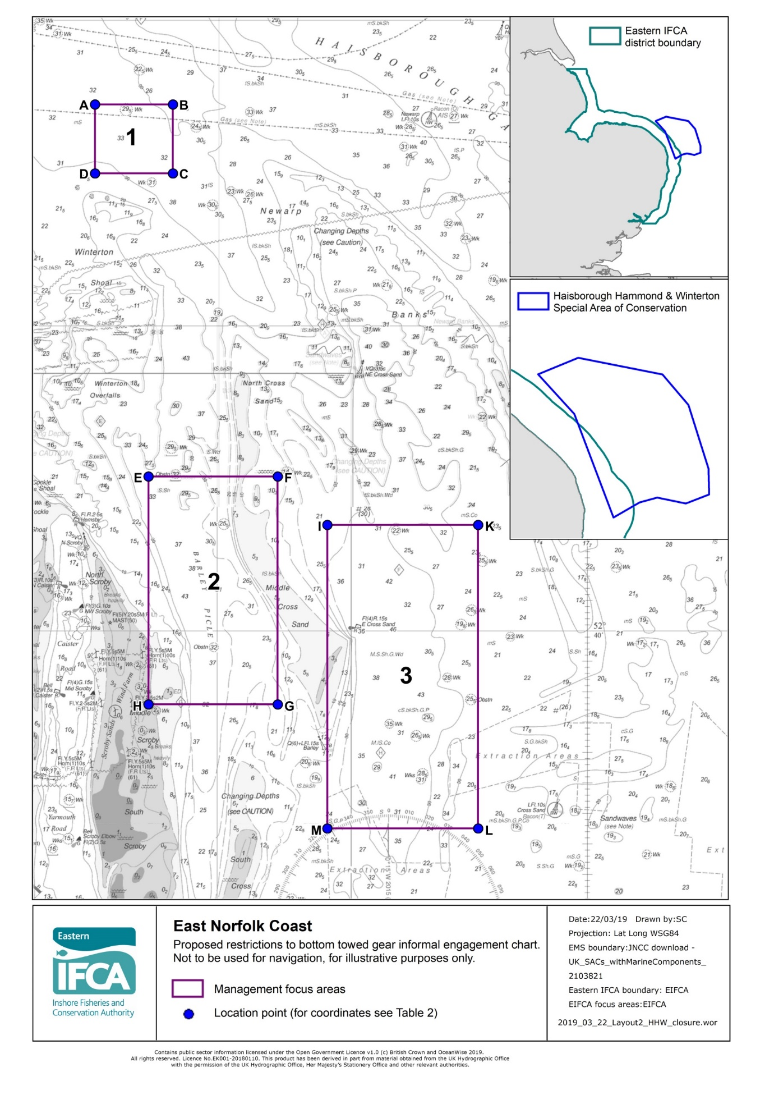

Section 4: Additional comments
Please use the space below to make any other observations / comments about the areas being considered for management.

Thank you for taking time to provide your feedback.
Please send completed questionnaires by 12 noon on 24th April 2019 to:
CEO, Eastern Inshore Fisheries & Conservation Authority, Unit 6 North Lynn Business Village, Bergen Way, King’s Lynn, Norfolk, PE30 2JG

Or by email to: mail@eastern-ifca.gov.uk

