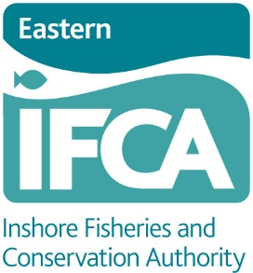
Eastern IFCA crab and lobster fisheries management – Questionnaire

Eastern IFCA is undertaking an informal consultation regarding crab and lobster fisheries management throughout the district. We are aiming to gain more information regarding activity levels, fishing areas and business models and are seeking your views on what management would be beneficial to the fishery. This will inform the development of new management measures.
By providing a response, your information is captured and helps to improve the evidence base EIFCA is using to shape management proposals.
We recognise the sensitivity of your data and individual responses will be treated as confidential. However, we will create a summary of the responses which may be published. Eastern IFCA has a privacy notice which sets out how your personal data will be used and your rights in relation to that data. This is available on request from the Eastern IFCA Office or from the Eastern IFCA website (www.eastern-ifca.gov.uk).

If you have any queries about this consultation or the form, please contact the office. We recognise that this is a long questionnaire and will be time consuming for you to complete. If you would like some assistance completing the form, please contact the office to arrange some time with an Officer who will go through the questionnaire with you over the phone or in person, completing the form based on your verbal answers.

Section 1. About you.
- Personal details
Full Name
Contact Address
Email
Tel / mob
Vessel Name
Vessel PLN
Port / beach of vessel launch
Do you have a commercial fishing licence? (if no please skip section 2) | Yes/No

Section 2. Your Business (Commercial fishers only)
To inform any impact assessments Eastern IFCA must understand various business models.
- Business model
Please circle the business model which best fits your situation: | - Small independent (1 vessel, 1-2 crew, no association with or assets in the name of a company)  - Small / family business (less than 5 vessels, associated with or assets in the name of a company)  - Medium / large business (more than 5 vessels, association with or assets in the name of a company)
What is the focus of your business model? Please circle the most relevant | - Fishing to sell to market  - Fishing to sell to processor  - Fishing to sell direct to the public
Do you intend to grow your business model (e.g. purchase additional vessels, employ additional crew, buy more pots)? | Yes / No
If yes to above, please provide an explanation below:

What are the overhead costs of your fishing activity? Please estimate as far as possible the costs for each of the sections below. Please also specify the associated time period (e.g. per year, per month, per trip etc.);
 | Cost | Time Period
- Fuel costs
- Vessel maintenance
- Gear maintenance
- Bait costs
- Crew costs / expenses
- Other (please specify)
Please indicate the ‘range’ of your vessel in terms of miles from the shore that you typically fish.
Please indicate the ‘range’ of your vessel in terms of miles along the shore from launch point that you travel to fish.

Section 3. Fishing activity
What type of pots do you fish with? (circle those that apply) | Inkwell/Creel, Parlour, Other (please specify) ……………………
How many pots do you typically have set at sea at any one time?
How many days per year do you typically spend at sea fishing for crabs and lobsters?
How long do you typically soak your pots for?
How many pots do you set within the Eastern IFCA District? | Please indicate the number of pots on chart 1 (Eastern IFCA district)
Do you fish inside Cromer Marine Conservation Zone (MCZ)? (see Appendix 2) for chart. | Yes/No
If you answered yes to the above please answer the following:  - How many days a year do you typically spend fishing for crab and lobster within the MCZ?  - How many pots do you typically have set within the MCZ at any one time? | a)  b)
Please mark on the chart provided fishing locations within the Cromer Shoal MCZ

Which months do you fish your pots? (tick more than one box if applicable)
Months | Tick box | Months | Tick box
January |  | July
February |  | August
March |  | September
April |  | October
May |  | November
June |  | December
All Year

Section 4. Vision for the fishery
To develop the most appropriate approach to managing crab and lobster fisheries, Eastern IFCA would like to know more about how you perceive the fishery as it is.
What are the main risks associated with the fishery?
Please consider the list below and rank the risks you think pose the highest risk to the fishery. Please rank these from 1 (highest risk) to 9 (lowest risk). Please also add additional risks you think Eastern IFCA should be aware of.
Risks and threats to the fishery | Rank
Too few crab and lobster being caught
Too many small crab and lobster being caught and retained
Damage to the environment
Lack of understanding/knowledge of the fishery by managers/policy makers
Boats fishing outside the district fishing unsustainably
Effort increases (number of pots, days at sea, types of vessels, new vessels)
Minimum landing size set too small (Crab)
Minimum landing size set too small (Lobster)
Difficulty of entering the fishery (new entrants)
Other (please specify)

Comments – please use this section to comment on what you believe to be the key risks and threats to the crab and lobster fisheries

Longevity of the fishery
How long have you been fishing for?
How did you enter the fishing industry? (e.g. family trade?).
How long do you intend to continue fishing for crab and lobster?
What would be the main reason(s) for your stopping fishing?
Do you have an apprentice / successor? If yes – are they a relative?

Strengths and weaknesses
Please use the space below to set out what you believe are the strengths and weaknesses of the crab and lobster fisheries.
Strengths | Weaknesses

Fishing Trends
Please consider each element below and indicate whether you think there has been an ‘increase’ or a ‘decrease’.
Element of the fishery | Increase | Decrease
Number of crab / lobster pots at sea
Number of Crab / Lobster fishers
Number of crab / lobster fishing vessels
Size / capacity of crab and lobster fishing vessels
Amount of crab and lobster landed
Size / area of crab and lobster fishing grounds

Section 5. management measures
Eastern IFCA intends to develop management measures for the crab and lobster fisheries to achieve the following:
- Ensure fishing is sustainable and produces high long-term yields;
- Ensure that the stocks can replace crab and lobster lost through fishing and natural mortality to maintain the total size (biomass) of stocks; and
- To maintain or increase the amount of larger and older crab and lobsters within the stock.
There are many different ways to achieve the above and Eastern IFCA intends to choose the most appropriate measures as informed by industry dialogue. Please take the time to consider the possible management measures below. More information on each potential management measure is set out in the supporting document ‘crab and lobster measure development – summary of the investigation into different management measures (strengths and weaknesses)’ which should accompany this questionnaire but is also available on the Eastern IFCA website.
To what extent do you agree that the following measures will have a positive effect on the fishery?
Each management measure is explored in more detail in the summary document attached. Pleas reefer to the summary document when considering these measures. Feel free to discuss these in more detail with officers to help inform you consideration.
Management measure | Strongly agree | Agree | Neither agree/disagree | Disagree | Strongly disagree
Minimum size increase (Edible Crab)
Minimum size increase (Lobster)

Gradual increase in minimum size (either species)
Maximum Landing Size (Edible Crab)

Maximum Landing Size (Lobster)

Escape Gaps (in pots)

Cap the number of pots and days at sea to current levels
Management measure | Strongly agree | Agree | Neither agree/disagree | Disagree | Strongly disagree
Pot limitation – limit the number of pots a fisher can use, single pot limitation for whole industry
Limit the number of pots based on criteria for example; number of crew, size of vessel etc.
V-notching Lobster – enhancement or voluntary scheme
Spatial Closures
Closed Seasons (closures during winter)
EIFCA Activity Returns
Quota based landing restrictions (transferable quota)
Quota based landing restrictions (non-transferable quota)

Voluntary management measures
Do you currently use escape gaps in your pots? | Yes / No
If yes – what size escape gap to you use?
Please use the space below to set out any other voluntary measures you fish in accordance with (e.g. increased minimum landing size?)

Do you have any further ideas that could be included in management measures that would help meet the management objectives or have other positive effects on the fishery?

Review of current byelaws
We are reviewing our current byelaws. We want to know how effective you think they are. Please indicate if you think the byelaws are effective.
 | Strongly agree | Agree | Neither agree/disagree | Disagree | Strongly disagree
EIFCA Byelaw 5: - Prohibition on the use of edible crab (C. pagurus) for bait.
EIFCA Byelaw 6: - Berried (egg-bearing) or soft shelled crab (C. pagurus) or lobster (H. gammarus)
EIFCA Byelaw 7: - Parts of shellfish
EIFCA Byelaw 9: - Redeposition of shellfish
EIFCA Byelaw 10: - Whitefooted edible crab

What changes would you like to see to the above byelaws?

Other comments
Please use the space provided below to add any other comments regarding management of crab and lobster fisheries. (Please continue on a separate sheet as required)

Eastern IFCA - crab and lobster measure development: fishing areas
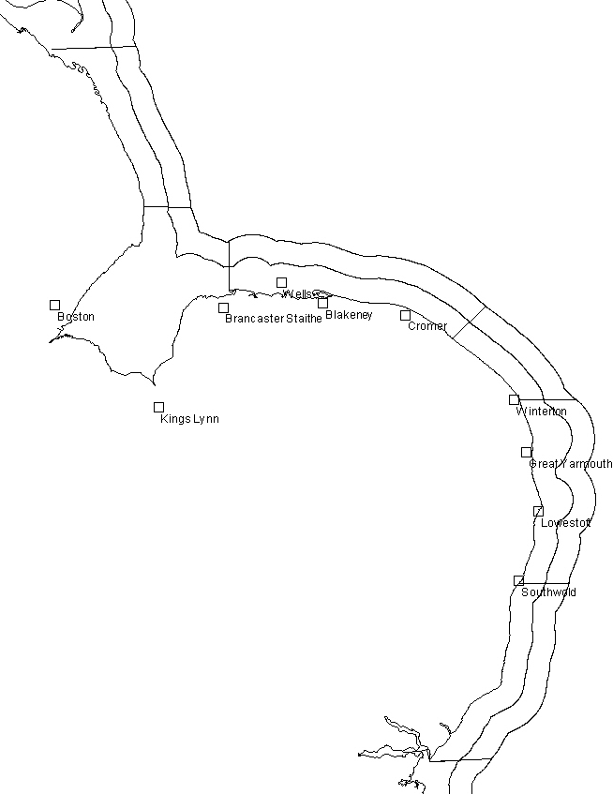
Please mark on the chart with an ‘x’ the areas you most commonly fish for crab and lobsters.
1
2
3
4
5
6
7
8
9
10
11
12
Port of Landing:………………………………….
Vessel Name:………………………………………. | Vessel Reg:………………………………

