Galloper Offshore Wind Farm
Local Notice To Mariners

Issued by: Galloper Marine Coordination Centre | Date of Issue:22.09.2020
NTM: GWF-O&M 01/09-2020 v2
For general enquiries please contact via email:  srv_galmcc.service@innogy.com  www.galloperwindfarm.com  For fisheries enquiries please contact via email: jonathan@brownmay.com  courtney@brownmay.com | 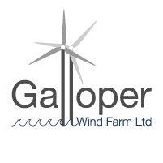
Dear Owners, Ships Agents, Masters, Pilots and Fishermen,

Re: Galloper Windfarm – RWE NTM: GWF-O&M 01/09-2020 - 250m Exclusion zone around location GN-F5F

Please be advised that Galloper Windfarm have placed a temporary exclusion zone of 250m around location F5F. There appears to be lightning damage to one of the blades which requires further investigation.

Asset location : Galloper north field

Asset Name | LAT_DM_WGS84 | LON_DM_WGS84
GN-F5F | 51° 55,991' N | 2° 3,413' E

Positional data found in Kingfisher Wind farms chart “Galloper offshore wind farm January 2020” - Link
https://kis-orca.eu/wp-content/uploads/2020/01/Chart-32-Galloper.pdf
https://kis-orca.eu/
https://kis-orca.eu/wp-content/uploads/2020/01/Chart-32-Galloper.pdf
https://www.seafish.org/article/kingfisher-bulletins

Galloper Marine Coordination Centre – Tel: 07867 371 331

