Eastern Inshore Fisheries and Conservation Authority
Local Notice to Mariners EIFCA 08-2021
Issued – 23 June 2021
East Coast of England – Lincolnshire Coast

Mariners are advised subject to weather RV “Three Counties” will be carrying out survey work on Thursday 24 June 2021 between 05:30hrs - 20.00hrs in the inshore area up to 5 nautical miles offshore between Skegness and Mablethorpe.
Vessels are requested to keep clear as underwater scientific equipment will be deployed during the survey.
Vessels will maintain a listening watch on VHF channel 16.
This LNTM EIFCA 08-2021 will be self-cancelling as of midnight on the 25 June 2021 and cancels LNTM EIFCA 07-2021
Three Counties
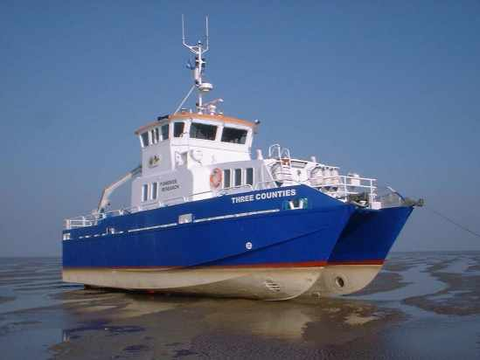

Jon Butler
Operations Manager
Eastern Inshore Fisheries and Conservation Authority
6 North Lynn Business Village
Bergan Way
Kings Lynn
PE30 2JG
01553 775321

