Ørsted - East Coast Operational Assets

Notice to Mariners

  - Period of Notice: June 2021

  - Version: Issue 1

Table of Contents

1 Introduction 3
1.1 Subsea Cables 3
1.2 Wind Farm Positional Data 4
2 Key Contacts 4
3 Notice to Mariners Summary: 5
4 Race Bank – Notice to Mariners 6
4.1 Lighting and Marking Status 6
4.2 Other Operations 6
5 Westermost Rough – Notice to Mariners 7
5.1 Lighting and Marking Status 7
5.2 Other Operations 7
6 Lincs – Notice to Mariners 8
6.1 Lighting and Marking Status 8
6.2 Other Operations 8
6.2.1 LS51 & LS75 Gearbox Exchange 8
7 Gunfleet Sands – Notice to Mariners 11
7.1 Lighting and Marking Status 11
7.2 Other Operations 11
7.2.1 Transition Piece Maintenance (paint campaign). 11
8 Hornsea One – Notice to Mariners 12
8.1 Lighting and Marking Status 12
8.2 Other Operations 12
8.2.1 Post construction Survey 12

Introduction

Ørsted is an offshore wind farm owner and operator with ten operational wind farms in UK waters. Of these ten, the following offshore wind farms are located off the East Coast of England:

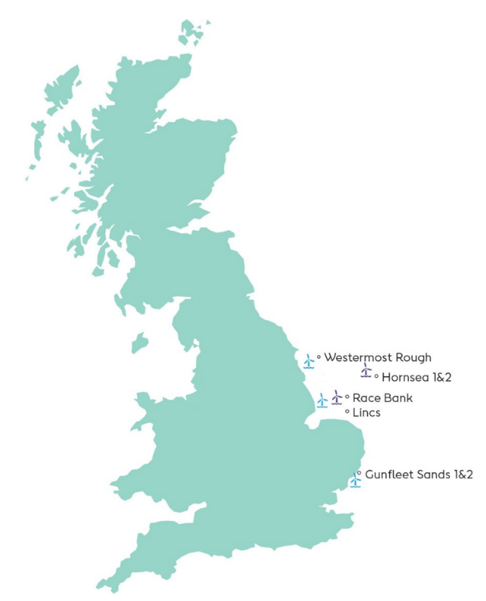
- Gunfleet Sands
- Westermost Rough
- Race Bank
- Lincs
- Hornsea One

The purpose of this monthly Notice to Mariners (NtM) is to ensure that mariners are aware of any non-routine operations across the East Coast assets that could pose a risk to other sea users. Safety is paramount to Ørsted and this notice should assist in ensuring that both mariners and the Ørsted operational team can operate safely offshore. This NtM will provide:

- A regular, clear and consistent overview of non-routine operations
- Updates relating to lighting and marking
- Key contact details
- Access to detailed site information and figures
- Clarity on when Safety Zones and recommended safe separation distances are in force or requested

This Notice to Mariners will not provide:

- Information relating to routine maintenance carried out by Crew Transfer Vessels (CTV) or Service Operation Vessels (SOV).
- Any information relating to export cables
- Any information relating to offshore wind farms currently in development, construction or not operated by Ørsted

Subsea Cables
Subsea cables are installed across each offshore wind farm and are marked on the KIS ORCA charts referenced in Section 1.2. Please note the following advice from NP 100 The Mariners Handbook “Every care should be taken to avoid anchoring, trawling, fishing, dredging, drilling, or carrying out any other activity in the vicinity of cables which might damage them.” This warning is repeated on all admiralty charts.

Wind Farm Positional Data
KIS ORCA Awareness Charts (including the layout and coordinates) and Fishing Plotter Files of the offshore assets referenced in this NtM can be found via the KIS ORCA website: http://www.kis-orca.eu/downloads#.XWUTQUxFwjZ. Should mariners require further information or any data in a format that can be used in a plotter or other device, please contact the Company Fisheries Liaison Officer, listed in Section 2 below.

Key Contacts
For further information on any of the activities listed within this notice, please use the contact details listed below.

Site | Ørsted Mailbox/ Offshore Coordination | Fisheries Industry Representative
Race Bank | Phone: 07826 943808  Email: rowoffshorec@orsted.co.uk | Ady Woods  Phone: 07468 898948  Email: firwoods@hotmail.com
Westermost Rough | Phone: 07867 674941  Email: wmroffshorec@orsted.co.uk | Guy Pasco  Phone: 07880 362082  Email: guy@seascopefisheries.co.uk
Lincs | Phone: 07766443319  Email: lincsoffshorec@orsted.co.uk | Ady Woods  Phone: 07468 898948  Email: firwoods@hotmail.com
Gunfleet Sands |  | Merlin Jackson  Phone: 07989 520484  Email: merlinjackson@btinternet.com
Hornsea One | Phone: 07775005465  Email: HOWoffshoreC@orsted.co.uk | Nick Garside  Phone: 07538 827013  Email: nick.garside@live.co.uk

Company Fisheries Liaison Officer

The Ørsted Company Fisheries Liaison Officer can be contacted using the details below:

Courtney French
Email: CONFR@Orsted.co.uk

Notice to Mariners Summary:

Site | Lighting and Marking Status | Survey | Jack-Up Vessel | Other Works
Race Bank | D01 Foghorn inactive | Yes | None | None
Westermost Rough | OK | Yes | None | None
Lincs | OK | Yes | None | LS51 & LS75 Gearbox Exchange
Gunfleet Sands | OK | None | None | TP paint campaign°
Hornsea One | OK | None | Yes | none

* Formal 500m safety zone in place
° Licensable activity
** 500m safety distance requested
*** 200m safety distance requested

Race Bank – Notice to Mariners

Lighting and Marking Status
D01’s fog signal is currently inoperative. All other lighting and/ or navigational warning systems are currently operational. No further planned outages.

Other Operations

N/A

Westermost Rough – Notice to Mariners

Lighting and Marking Status
The lighting and/ or navigational warning systems are currently operational. No planned outages.

Other Operations

Figure 2

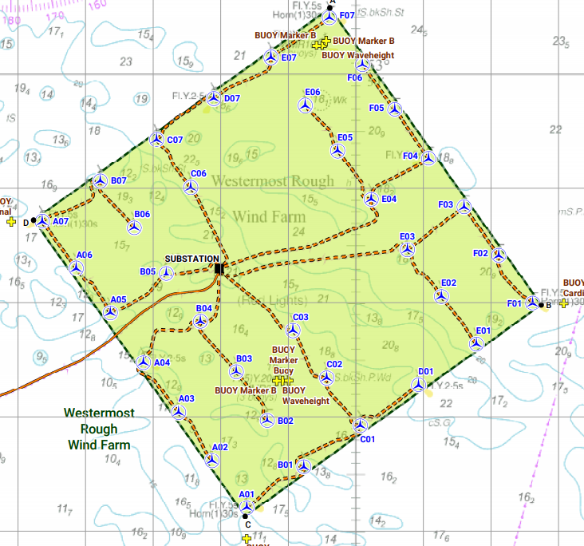

Table 2

WTG ID | Degrees, Decimal Minutes
 | Latitude | Longitude
E07 | 53°50.144’N | 00°08.744’E

Lincs – Notice to Mariners

Lighting and Marking Status
The lighting and/ or navigational warning systems are currently operational. No planned outages.

Other Operations

LS51 & LS75 Gearbox Exchange
Exchange of gearbox’s at LS51 and LS75, expected on Lincs Windfarm 11th for a duration of 10 days weather permitting. The Jack Up vessel Wind Pioneer will be operating a 500m Safety Zone for the duration of the works at LS51 and LS75.

Vessel Information

General Information |  | Vessel Picture
Name | Wind Pioneer | 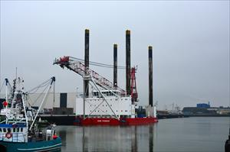
Flag | Danish
Year Built | 2010
MMSI Number | 219017684
Call Sign | OWLA2
Vessel Contact Details
Bridge | +45 21822180
Party Chief | Master on Wind Pioneer
Email | Master.windpioneer@ziton.eu

Figure 3
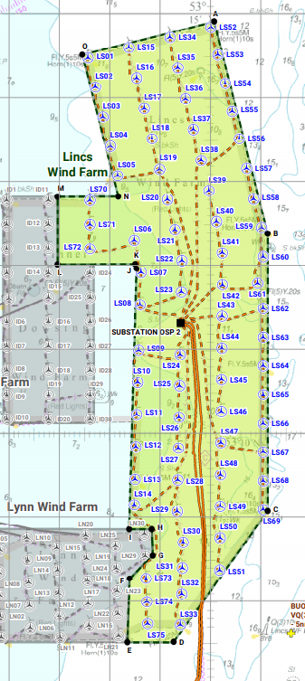

Table 2
WTG ID | Degrees, Decimal Minutes
 | Latitude | Longitude
LS51 | 53°08.365’N | 00°30.183’N
LS75 | 53°07.726’N | 00°28.754’N

Entry Points
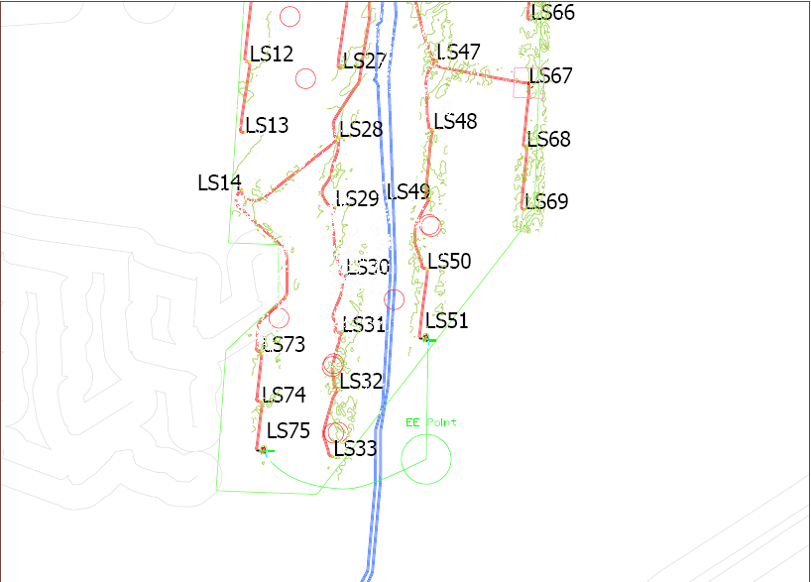

Gunfleet Sands – Notice to Mariners

Lighting and Marking Status
The lighting and/ or navigational warning systems are currently operational. No planned outages.

Other Operations

Transition Piece Maintenance (paint campaign).

Transition Piece maintenance will be undertaken on all WTG’s on GFS01 + GFS02 from the 22nd March for a provisional 3 months. Sequence of locations and dates are unavailable as works will be weather dependant and coordinated to ensure no conflict with routine maintenance operations.

We request Mariners observe a safe distance from the affected turbine(s) while works are being carried out.

The CTV “WEM 1” will act as Guard Vessels during the maintenance programme with the vessel broadcasting the Turbine ID, establishment/cancellation of the safety zones and seeking contact with marine traffic approaching or nearing the areas on VHF Channel 16 and 12.

Vessel Information

General Information |  | Vessel Picture
Name | Wem 1 | 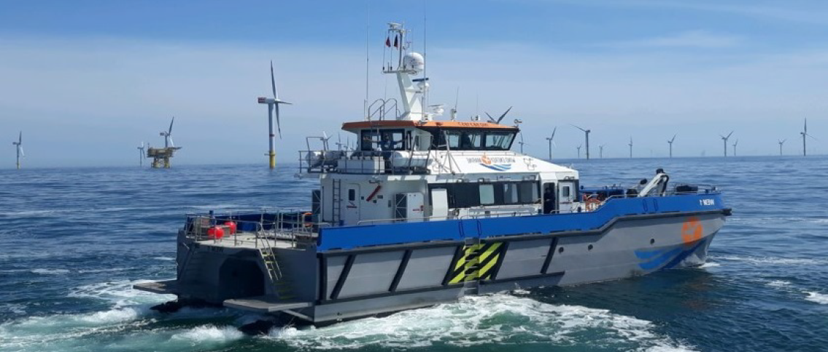
Flag | United Kingdom
Year Built | 2018
MMSI Number | 232013884
Call Sign
Vessel Contact Details
Bridge | +44 (0) 7944 886553
Party Chief
Email | wem1@windenergymarine.com

Hornsea One – Notice to Mariners

Lighting and Marking Status

The lighting and/ or navigational warning systems are currently operational. No planned outages.

Other Operations

Post construction Survey

We have ongoing Post construction surveys within the Hornsea One Offshore Windfarm and the array cable to shore. The Breaker is currently onsite conducting the survey (02/02/2021) with the Deep Seapal expected to arrive 1 week later.
Planned duration is for 14 days with surveys conducted around WTG’s and as close to shore as the vessel can go.

Vessel Information

General Information |  | Vessel Picture
Name | Breaker | 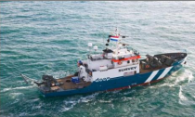
Flag | Panama
Year Built | 1956
MMSI Number | 371150000
Call Sign | HP-4641
Vessel Contact Details
Bridge | +31 61 536 7813
Party Chief | Rein Ritsema.  +31 61 515 5713
Email | Breakersurvey57@gmail.com

General Information |  | Vessel Picture
Name | Deep Seapal | 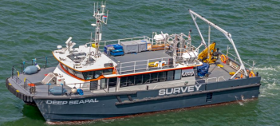
Flag | United Kingdom
Year Built
MMSI Number | 235089472
Call Sign | 2EZU7
Vessel Contact Details
Bridge | +31 61 322 1213
Party Chief | Tom Colston  +31 61 248 0212
Email | deepseapal@deepbv.nl

Survey Area
