Ørsted - East Coast Operational Assets

Notice to Mariners

  - Period of Notice: May 2021

  - Version: Issue 2

Table of Contents

1 Introduction 3
1.1 Subsea Cables 3
1.2 Wind Farm Positional Data 4
2 Key Contacts 4
3 Notice to Mariners Summary: 5
4 Race Bank – Notice to Mariners 6
4.1 Lighting and Marking Status 6
4.2 Other Operations 6
5 Westermost Rough – Notice to Mariners 6
5.1 Lighting and Marking Status 6
5.2 Other Operations 6
5.2.1 Debris clearance survey 6
6 Lincs – Notice to Mariners 8
6.1 Lighting and Marking Status 8
6.2 Other Operations 8
6.2.1 Debris clearance survey 8
7 Gunfleet Sands – Notice to Mariners 10
7.1 Lighting and Marking Status 10
7.2 Other Operations 10
7.2.1 Transition Piece Maintenance (paint campaign). 10
8 Hornsea One – Notice to Mariners 11
8.1 Lighting and Marking Status 11
8.2 Other Operations 11
8.2.1 Met mast removal 11

Introduction

Ørsted is an offshore wind farm owner and operator with ten operational wind farms in UK waters. Of these ten, the following offshore wind farms are located off the East Coast of England:

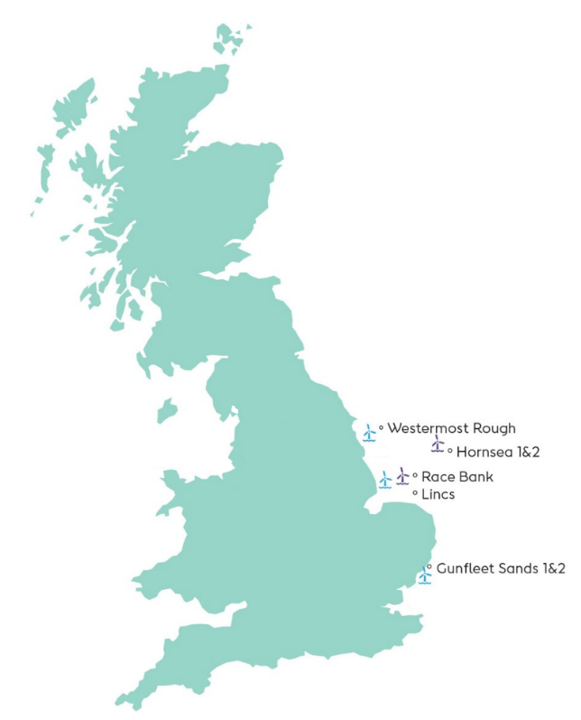
- Gunfleet Sands
- Westermost Rough
- Race Bank
- Lincs
- Hornsea One

The purpose of this monthly Notice to Mariners (NtM) is to ensure that mariners are aware of any non-routine operations across the East Coast assets that could pose a risk to other sea users. Safety is paramount to Ørsted and this notice should assist in ensuring that both mariners and the Ørsted operational team can operate safely offshore. This NtM will provide:

- A regular, clear and consistent overview of non-routine operations
- Updates relating to lighting and marking
- Key contact details
- Access to detailed site information and figures
- Clarity on when Safety Zones and recommended safe separation distances are in force or requested

This Notice to Mariners will not provide:

- Information relating to routine maintenance carried out by Crew Transfer Vessels (CTV) or Service Operation Vessels (SOV).
- Any information relating to export cables
- Any information relating to offshore wind farms currently in development, construction or not operated by Ørsted

Subsea Cables
Subsea cables are installed across each offshore wind farm and are marked on the KIS ORCA charts referenced in Section 1.2. Please note the following advice from NP 100 The Mariners Handbook “Every care should be taken to avoid anchoring, trawling, fishing, dredging, drilling, or carrying out any other activity in the vicinity of cables which might damage them.” This warning is repeated on all admiralty charts.

Wind Farm Positional Data
KIS ORCA Awareness Charts (including the layout and coordinates) and Fishing Plotter Files of the offshore assets referenced in this NtM can be found via the KIS ORCA website: http://www.kis-orca.eu/downloads#.XWUTQUxFwjZ. Should mariners require further information or any data in a format that can be used in a plotter or other device, please contact the Company Fisheries Liaison Officer, listed in Section 2 below.

Key Contacts
For further information on any of the activities listed within this notice, please use the contact details listed below.

Site | Ørsted Mailbox/ Offshore Coordination | Fisheries Industry Representative
Race Bank | Phone: 07826 943808  Email: rowoffshorec@orsted.co.uk | Ady Woods  Phone: 07468 898948  Email: firwoods@hotmail.com
Westermost Rough | Phone: 07867 674941  Email: wmroffshorec@orsted.co.uk | Guy Pasco  Phone: 07880 362082  Email: guy@seascopefisheries.co.uk
Lincs | Phone: 07766443319  Email: lincsoffshorec@orsted.co.uk | Ady Woods  Phone: 07468 898948  Email: firwoods@hotmail.com
Gunfleet Sands |  | Merlin Jackson  Phone: 07989 520484  Email: merlinjackson@btinternet.com
Hornsea One | Phone: 07775005465  Email: HOWoffshoreC@orsted.co.uk | Nick Garside  Phone: 07538 827013  Email: nick.garside@live.co.uk

Company Fisheries Liaison Officer

The Ørsted Company Fisheries Liaison Officer can be contacted using the details below:

Courtney French
Email: CONFR@Orsted.co.uk

Notice to Mariners Summary:

Site | Lighting and Marking Status | Survey | Jack-Up Vessel | Other Works
Race Bank | D01 Foghorn inactive | Yes | None | None
Westermost Rough | OK | Yes | None | None
Lincs | OK | Yes | None | None
Gunfleet Sands | OK | None | None | TP paint campaign°
Hornsea One | OK | None | Yes | Met-mast removal°, *

* Formal 500m safety zone in place
° Licensable activity
** 500m safety distance requested
*** 200m safety distance requested

Race Bank – Notice to Mariners

Lighting and Marking Status
D01’s fog signal is currently inoperative. All other lighting and/ or navigational warning systems are currently operational. No further planned outages.

Other Operations

MBES survey including Side Scan Sonar. There will be towed equipment.

Starting on the 17th May, for the duration of 17 days, the Curtis Marshall will be on site to conduct a full site survey with MBES and SSS.

Vessel information
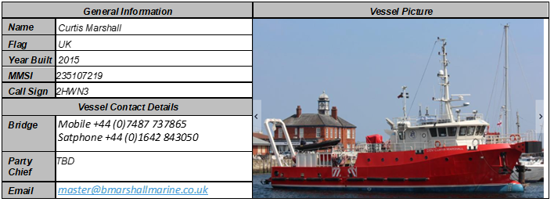
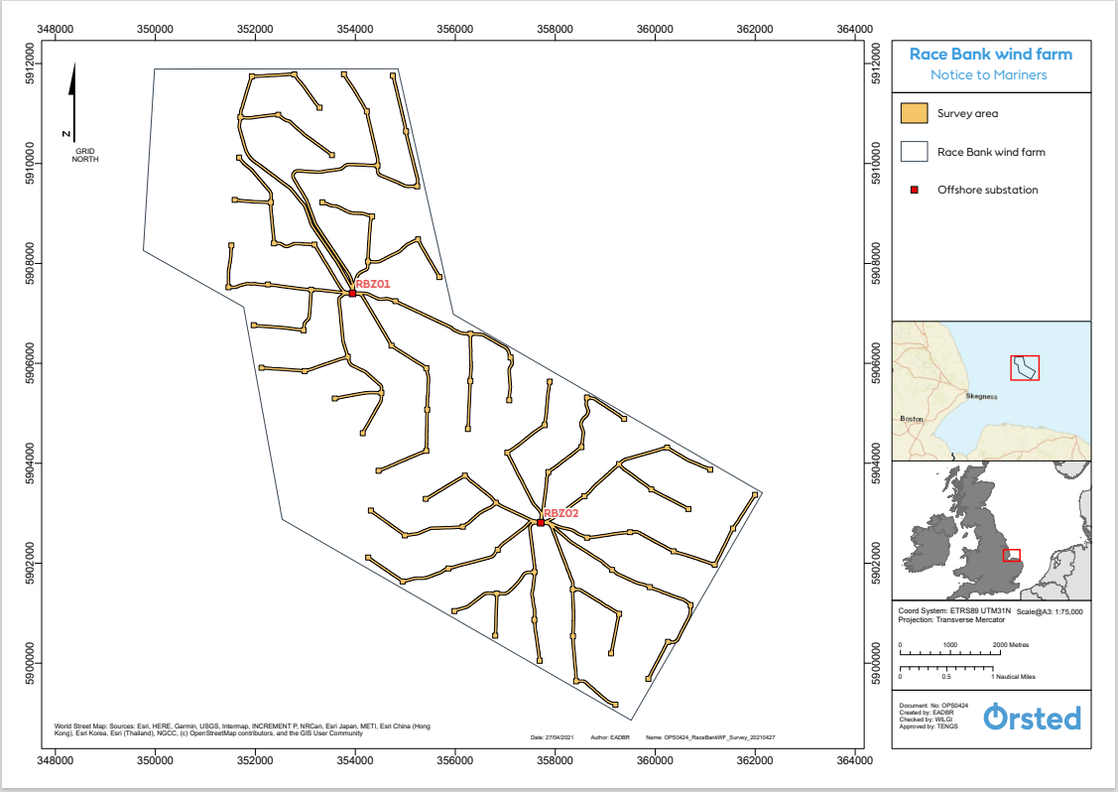

Westermost Rough – Notice to Mariners

Lighting and Marking Status
The lighting and/ or navigational warning systems are currently operational. No planned outages.

Other Operations

Debris clearance survey

Towards the end of May, the Spectrum Nyquist will conduct a debris survey identified below.

Vessel Information

General Information |  | Vessel Picture
Name | Spectrum Nyquist | 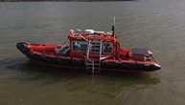
Flag | UK
Year Built | 2010
MMSI Number | 232031312
Call Sign | MIIG4
Vessel Contact Details
Bridge
Party Chief | TBD
Email

Figure 2

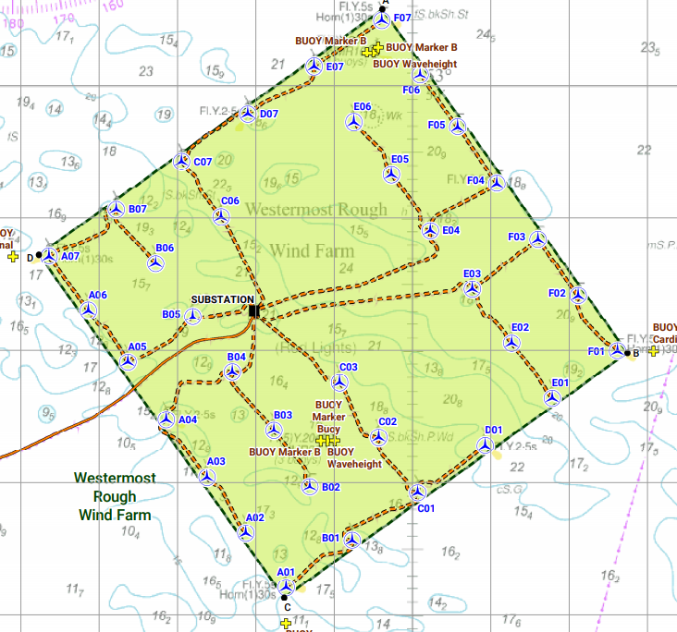

Table 2

WTG ID | Degrees, Decimal Minutes
 | Latitude | Longitude
E07 | 53°50.144’N | 00°08.744’E

Lincs – Notice to Mariners

Lighting and Marking Status
The lighting and/ or navigational warning systems are currently operational. No planned outages.

Other Operations

Debris clearance survey

Towards the end of May, the Spectrum Nyquist will conduct a debris survey identified below.

Vessel Information

General Information |  | Vessel Picture
Name | Spectrum Nyquist
Flag | UK
Year Built | 2010
MMSI Number | 232031312
Call Sign | MIIG4
Vessel Contact Details
Bridge
Party Chief | TBD
Email

Figure 3
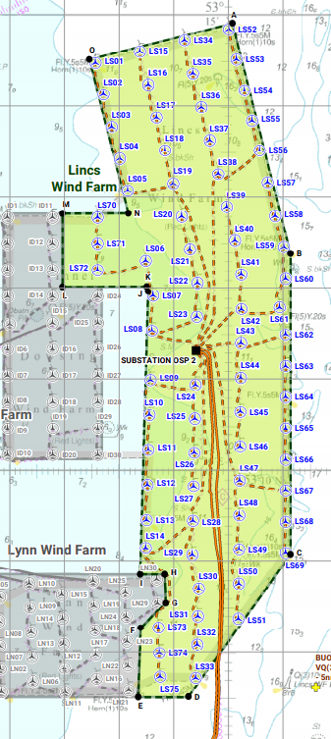

WTG ID | Degrees, Decimal Minutes
 | Latitude | Longitude
LS51 | 53°08.365’N | 00°30.183’N
LS75 | 53°07.726’N | 00°28.754’N
Table 2

Gunfleet Sands – Notice to Mariners

Lighting and Marking Status
The lighting and/ or navigational warning systems are currently operational. No planned outages.

Other Operations

Transition Piece Maintenance (paint campaign).

Transition Piece maintenance will be undertaken on all WTG’s on GFS01 + GFS02 from the 22nd March for a provisional 3 months. Sequence of locations and dates are unavailable as works will be weather dependant and coordinated to ensure no conflict with routine maintenance operations.

We request Mariners observe a safe distance from the affected turbine(s) while works are being carried out.

The CTV “WEM 1” will act as Guard Vessels during the maintenance programme with the vessel broadcasting the Turbine ID, establishment/cancellation of the safety zones and seeking contact with marine traffic approaching or nearing the areas on VHF Channel 16 and 12.

Vessel Information

General Information |  | Vessel Picture
Name | Wem 1 | 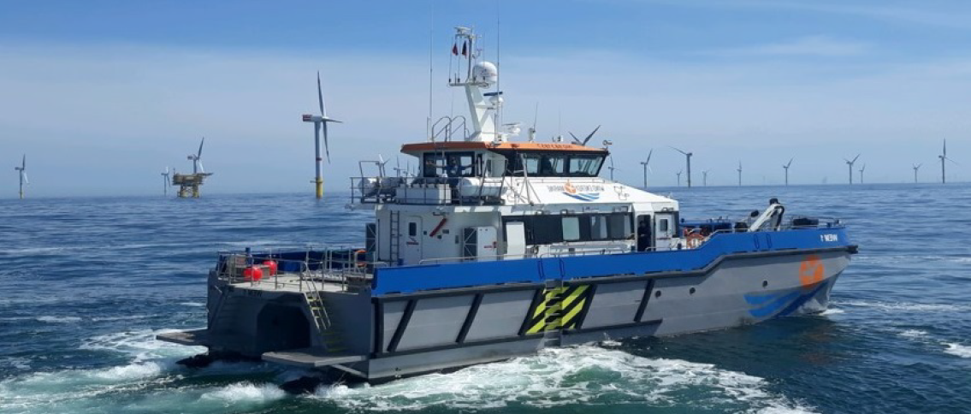
Flag | United Kingdom
Year Built | 2018
MMSI Number | 232013884
Call Sign
Vessel Contact Details
Bridge | +44 (0) 7944 886553
Party Chief
Email | wem1@windenergymarine.com

Hornsea One – Notice to Mariners

Lighting and Marking Status

The lighting and/ or navigational warning systems are currently operational. No planned outages.

Other Operations

Met mast removal

On the 24th April the vessel Neptune will be on site to remove the Met mast, location is shown below. All vessels are required to keep a safe distance of 500m away from the vessel Neptune. The work is anticipated to last 7 days.

Vessel Information

General Information |  | Vessel Picture
Name | Neptune | 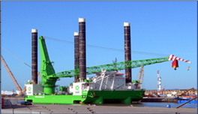
Flag | Luxemburg
Year Built | 2012
MMSI Number | 253532000
Call Sign | LXNP
Vessel Contact Details
Bridge | +49421517219174 +32470891308
Party Chief | Cyril Girardeux +32470892190
Email | Neptune@DEME-GROUP.com

Figure 5

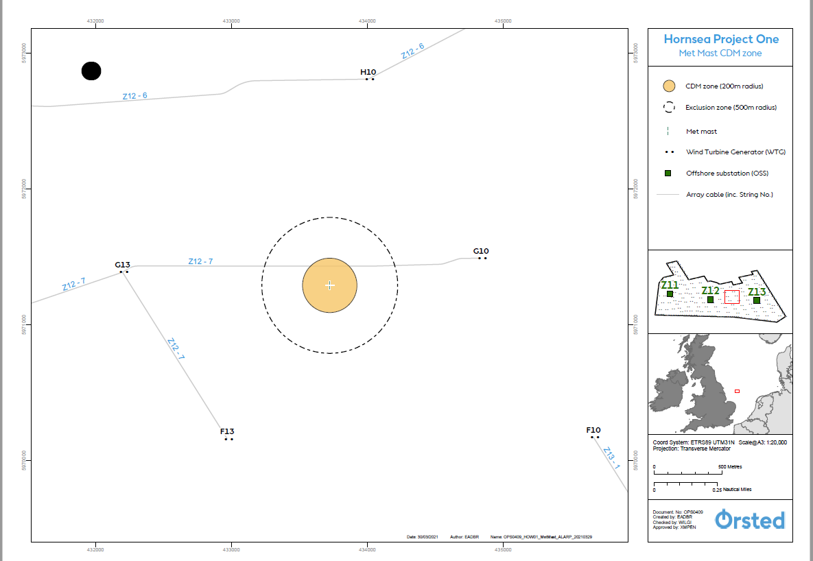

Coordinates

WTG ID | Degrees, Decimal Minutes
 | Latitude | Longitude
Met mast | 53°53.149’N | 01°59.499’E

