NOTICE TO MARINERS
Issue Date: 28th April 2021
VIKING LINK Project
HVDC Cable Laying and Burial Work
Mariners are advised about landfall works at Boygrift, Lincolnshire (English Landfall) planned for the Viking Link project which is an HVDC electricity transmission interconnector between Denmark and England, a joint venture between National Grid and Energinet. The works include cable lay and burial works operations.
Cable lay and burial works of the HVDC installation are planned to take place from:
- Cable lay 10th May –23rd June 2021
- Cable Burial 12th May – 30th July 2021
The route length of the main HVDC interconnection (2x bundles power cables + 1x Fibre Optic Cable) is in the order of 620km. The work covered by this NtM is covering the first campaign of 51km in length starting from the UK the landfall at Boygrift.
The works covered within this Notice to Mariners are divided in the following activities:
- Cable Lay
- Cable Burial
The Cable Lay works are being carried out by:
Prysmian PowerLink using Cable Enterprise (IMO 8645806; MMSI 235093018; Call Sign 2FOV9). Supported by a tug Norne (IMO 9612806; MMSI 245460000; Call Sign PCJR).
The Cable burial works are being carried out by:
Asso.subsea using Atalanti (IMO 8661616; Call Sign 5BYY2) using the trenching tool AssoTrencher V and the Argo (IMO 9523366; Call Sign 5BDF3) using the jetting tool AssoJet III and trenching tool AssoTrencher IV.
Vessels and their contact details are given in Table 1 below.
Vessels are requested to pass at a safe speed and distance and fishing vessels are advised to remain a safe distance, approximately 550m (0.3 nautical miles) from the areas identified. During these works the vessel will have restricted manoeuvrability as it completes its work scope. Deployed Guard Vessels will monitor the exposed areas of cable while burial progresses and advise of safe distances locally.
VHF CH 16 will be monitored at all times and will be used to contact the coastguard in the event of an emergency.

Vessel Name | Vessel Photograph | Vessel Details
Cable Lay Vessel – “Cable Enterprise” | 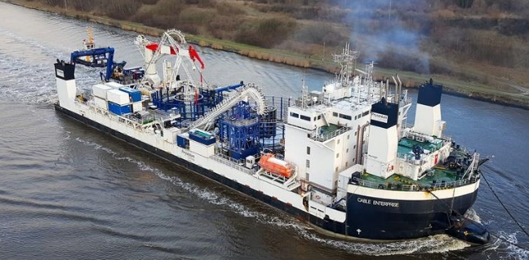 | MMSI: 235093018  Call Sign: 2FOV9
TUG - “Norne” | 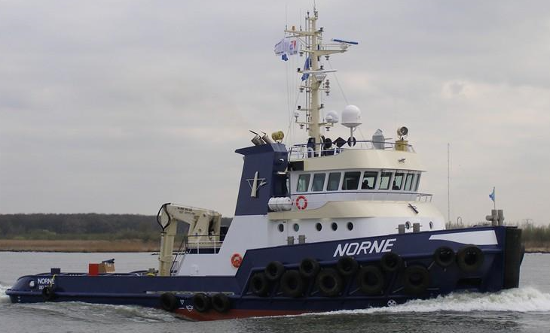 | MMSI: 245460000  Call Sign: PCJR
Cable Laying Barge as Support Vessel – “Atalanti” | 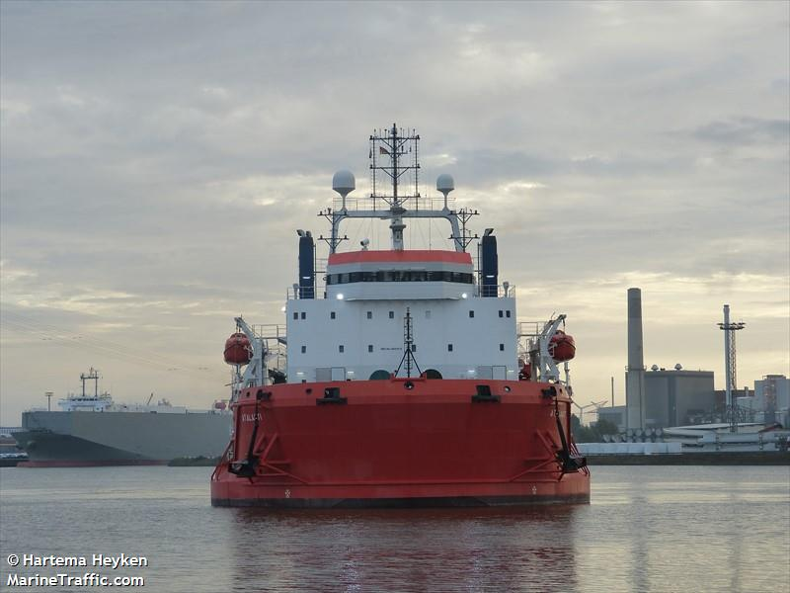 | MMSI: 212279000  Call Sign:  5BYY2
Trenching Support Vessel – “Argo” | 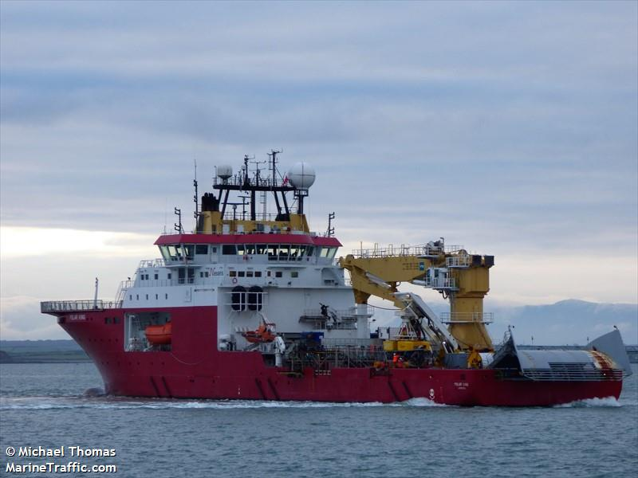 | MMSI: 209023000  Call Sign:  5BDF3

Table 1: Work vessel details

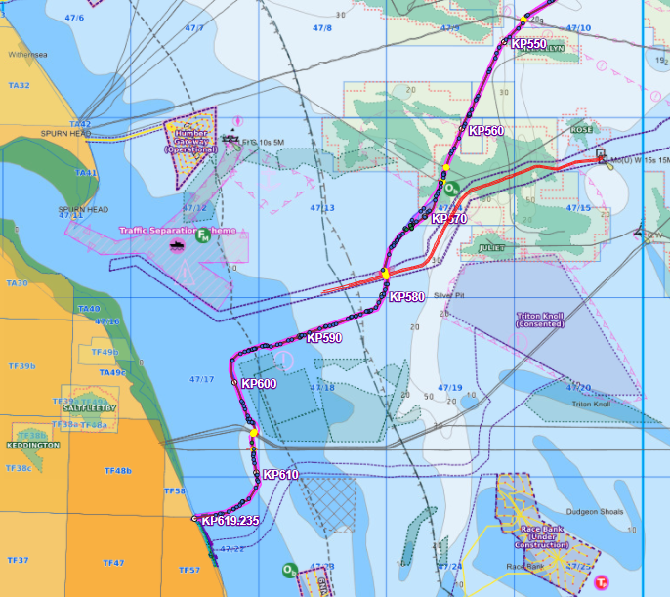
Figure 1: Overview of the Viking Link Interconnector area of work
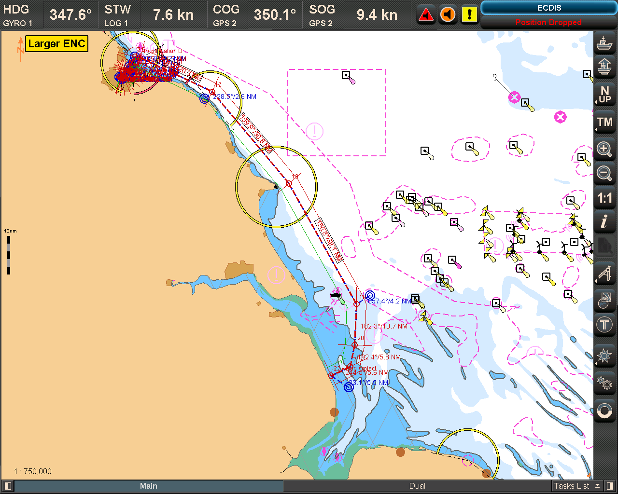
Figure 2: Cable Enterprise” Transit Route and Passage Plan

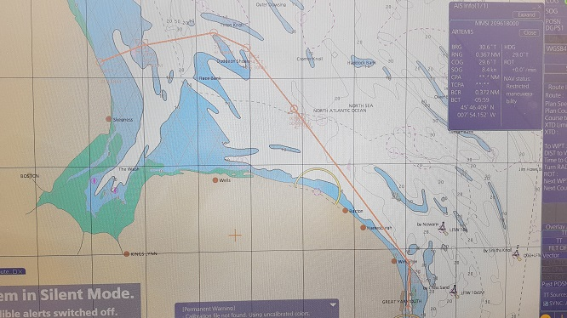
Figure 3: CLB “Atalanti” Transit Route and Passage Plan
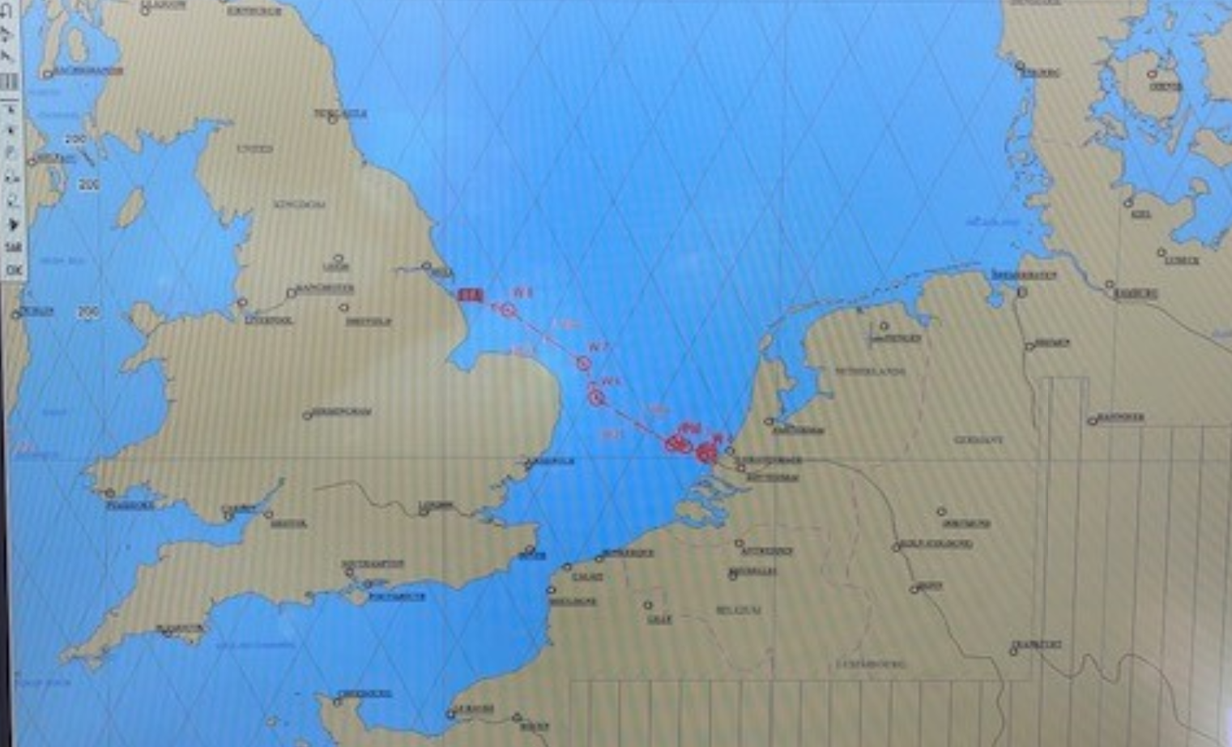
Figure 4: TSV “Argo” Transit Route and Passage Plan

Works overview
Following completion of the landfall the Cable Laying vessel Cable Enterprise will surface lay the cable on the seabed along the HVDC cable route, detailed in Figure 2. In periods while the cable is exposed on the seabed guard vessels will be stationed to monitor the cable and provide advice to mariners.
Cable Burial will follow soon after the cable lay operations carried out by two vessels Atalanti and Argo.
Where cable burial is not possible (due to service crossings and / or where seabed conditions are unfavourable), guard vessels will remain on site.
Service crossing
As part of the first campaign the Viking Link HVDC cable crosses 11 existing service.
While awaiting the post lay protection operation, Guard vessels will remain in place to monitor the exposed cable.

DESCRIPTION | ETRS 1989 UTM 31N |  | ETRS89 |  | WD LAT (m) | WD MSL (m)
 | Easting [m] | Northing [m] | Latitude | Longitude
Viking AR to Theddlethorpe 28-inch Gas 3-inch Methanol PL | 326314 | 5915227 | 53° 21.456'N | 000° 23.403'E | 13.2 | 16.8
LOGGS PP to Theddlethorpe 4-inch Methanol Pl | 326355 | 5916842 | 53° 22.327'N | 000° 23.387'E | 13.3 | 17.0
LOGGS PP to Theddlethorpe 36 Gas PL | 326366 | 5916859 | 53° 22.336'N | 000° 23.397'E | 13.3 | 16.8
Pickerill A_to Theddlethorpe 24-inch Gas PL | 326423 | 5916940 | 53° 22.381'N | 000° 23.445'E | 12.8 | 16.3
Theddlethorpe to Murdoch UK Inshore 4-inch Methanol PL | 326484 | 5917027 | 53° 22.430'N | 000° 23.498'E | 13.1 | 16.7
Theddlethorpe to Murdoch MD UK Inshore 26-inch Gas PL | 326496 | 5917045 | 53° 22.439'N | 000° 23.508'E | 13.0 | 16.6
Hornsea 1 eastern | 340724 | 5932617 | 53° 31.099'N | 000° 35.855'E | 17.8 | 21.7
Hornsea 1 central | 340689 | 5932735 | 53° 31.162'N | 000° 35.820'E | 18.3 | 22.3
Hornsea 1 western | 340643 | 5932887 | 53° 31.243'N | 000° 35.773'E | 17.8 | 21.8
HOW02 NS NE | 340610 | 5933012 | 53° 31.309'N | 000° 35.740'E | 17.7 | 21.7
HOW02 NS SW | 340591 | 5933107 | 53°31,360'N | 000°35,719'E | 17.3 | 21.3
HOW02 NS NW | 340561 | 5933249 | 53°31,436'N | 000°35,689'E | 17.0 | 21.1
Table 2: Locations for the Service Crossing

Contact Details:
Further enquiries should be addressed to the following contacts:
FLO contact Jonathan Keer
jonathan@brownmay.com
Mobile: +44 7850 604851

Freya Sandison
freya@brownmay.com
Mobile: +44 7857 500609

Prysmian Project Manager Alessandro Jared Crivelli
alessandro.crivelli@prysmiangroup.com
Mobile: +39 3454 595615

Prysmian Project Manager Cian McKeown
cian.mckeown@prysmiangroup.com
Mobile: +39 3666 889174

Master of Cable Enterprise Master
ce.master@prysmiangroup.com
VSAT number +44 203 1309591
Mobile: +44 779 8764403

ASSO Offshore Team Manager Lampros Merkouris
lmerkouris@assogroup.com
Mobile: +30 211 888 5102

Vessel Master of Atalanti atalanti@assogroup.com
Mobile: +30 6958 469 697

Vessel Master of Argo argo@assogroup.com
Mobile: +30 6944 447 825

