Ørsted - East Coast Operational Assets

Notice to Mariners

  - Period of Notice: July 2021

  - Version: Revision 4

Table of Contents

1 Introduction 4
1.1 Subsea Cables 4
1.2 Wind Farm Positional Data 4
2 Key Contacts 5
3 Notice to Mariners Summary: 6
4 Race Bank – Notice to Mariners 7
4.1 Lighting and Marking Status 7
4.2 Other Operations 7
4.2.1 Piggyback rectification work 7
4.2.2 Wave Buoy service 8
4.2.3 Cable Bandage Solutions 9
4.2.4 Above Water Inspections 10
4.2.5 Internal Blade Inspections 10
5 Westermost Rough – Notice to Mariners 11
5.1 Lighting and Marking Status 11
5.2 Other Operations 11
5.2.1 Blade Inspection 11
5.2.2 Emergent Bathymetric Survey 12
6 Lincs – Notice to Mariners 13
6.1 Lighting and Marking Status 13
6.2 Other Operations 13
6.2.1 Blade repair 13
7 Gunfleet Sands – Notice to Mariners 14
7.1 Lighting and Marking Status 14
7.2 Other Operations 14
7.2.1 Seabed survey 14
7.2.2 Internal corrosion protection 16
7.2.3 Cable exposure 16
8 Hornsea One – Notice to Mariners 17
8.1 Lighting and Marking Status 17
8.2 Other Operation 17

Introduction

Ørsted is an offshore wind farm owner and operator with ten operational wind farms in UK waters. Of these ten, the following offshore wind farms are located off the East Coast of England:

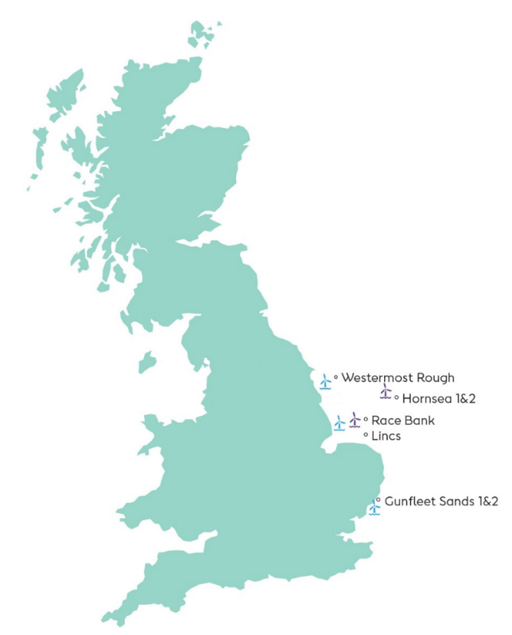
- Gunfleet Sands
- Westermost Rough
- Race Bank
- Lincs
- Hornsea One

The purpose of this monthly Notice to Mariners (NtM) is to ensure that mariners are aware of any non-routine operations across the East Coast assets that could pose a risk to other sea users. Safety is paramount to Ørsted and this notice should assist in ensuring that both mariners and the Ørsted operational team can operate safely offshore. This NtM will provide:

- A regular, clear and consistent overview of non-routine operations
- Updates relating to lighting and marking
- Key contact details
- Access to detailed site information and figures
- Clarity on when Safety Zones and recommended safe separation distances are in force or requested

This Notice to Mariners will not provide:

- Information relating to routine maintenance carried out by Crew Transfer Vessels (CTV) or Service Operation Vessels (SOV).
- Any information relating to export cables
- Any information relating to offshore wind farms currently in development, construction or not operated by Ørsted

Subsea Cables
Subsea cables are installed across each offshore wind farm and are marked on the KIS ORCA charts referenced in Section 1.2. Please note the following advice from NP 100 The Mariners Handbook “Every care should be taken to avoid anchoring, trawling, fishing, dredging, drilling, or carrying out any other activity in the vicinity of cables which might damage them.” This warning is repeated on all admiralty charts.

Wind Farm Positional Data
KIS ORCA Awareness Charts (including the layout and coordinates) and Fishing Plotter Files of the offshore assets referenced in this NtM can be found via the KIS ORCA website: http://www.kis-orca.eu/downloads#.XWUTQUxFwjZ. Should mariners require further information or any data in a format that can be used in a plotter or other device, please contact the Company Fisheries Liaison Officer, listed in Section 2 below.

Key Contacts
For further information on any of the activities listed within this notice, please use the contact details listed below.

Site | Ørsted Mailbox/ Offshore Coordination | Fisheries Industry Representative
Race Bank | Phone: 07826 943808  Email: rowoffshorec@orsted.co.uk | Ady Woods  Phone: 07468 898948  Email: firwoods@hotmail.com
Westermost Rough | Phone: 07867 674941  Email: wmroffshorec@orsted.co.uk | Guy Pasco  Phone: 07880 362082  Email: guy@seascopefisheries.co.uk
Lincs | Phone: 07766443319  Email: lincsoffshorec@orsted.co.uk | Ady Woods  Phone: 07468 898948  Email: firwoods@hotmail.com
Gunfleet Sands |  | Merlin Jackson  Phone: 07989 520484  Email: merlinjackson@btinternet.com
Hornsea One | Phone: 07775005465  Email: HOWoffshoreC@orsted.co.uk | Nick Garside  Phone: 07538 827013  Email: nick.garside@live.co.uk

Company Fisheries Liaison Officer

The Ørsted Company Fisheries Liaison Officer can be contacted using the details below:

Courtney French
Email: CONFR@Orsted.co.uk

Notice to Mariners Summary:

Site | Lighting and Marking Status | Survey | Jack-Up Vessel | Other Works
Race Bank | OK | None | None | Piggyback campaign,  Wave buoy service,  Cable Bandage Solutions**  Above Water Inspections  Internal Blade Inspections
Westermost Rough | OK | None | None | Blade repair***  Emergent Bathymetric Survey
Lincs | OK | None | None | Blade repair***
Gunfleet Sands | OK | Yes | None | Corrosion campaign
Hornsea One | OK | None | None | Wave buoy service

* Formal 500m safety zone in place
° Licensable activity
** 500m safety distance requested
*** 200m safety distance requested

Status of lighting & marking is correct at time of issue, any changes will be communicated through an updated version being issued.

Race Bank – Notice to Mariners

Lighting and Marking Status

The lighting and/ or navigational warning systems are currently operational. No planned outages.

Other Operations

Piggyback rectification work

On the 10th June the Eden Rose will be on site to conduct some WTG internal repairs. The scope is expected to last until mid-August and will be across the full wind farm.

Vessel information
General Information |  | Vessel Picture
Name | Eden Rose | 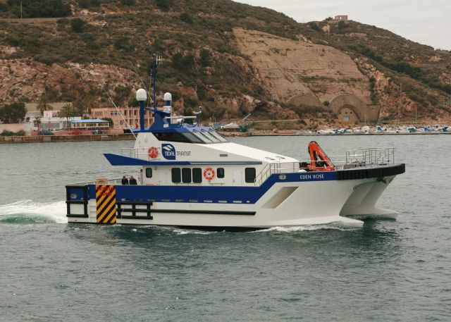
Flag | UK
Year Built | 2012
MMSI Number | 235092732
Call Sign | 2FNN5
Vessel Contact Details
Bridge | Master (TBC)
Party Chief | 07852125057
Email | edenrose@tidal-transit.com

Wave Buoy service

We will undertake an offshore service of a Measurement Buoy. Mariners should note that the service of the Measurement Buoy is scheduled for 21st to 24th July (weather permitting) and service works should last 6 hours. An example image of a Measurement Buoy is shown in the figure below as well as the vessel details.

Vessel information

General Information |  | Vessel Picture
Name | Voe Vanguard | 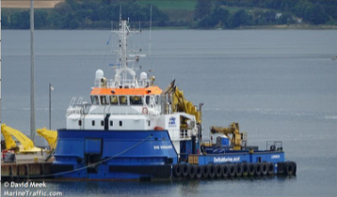
Flag | UK
Year Built | 2017
MMSI Number | 232008636
Call Sign | MBEN9
Vessel Contact Details
Bridge | +44 7766 798 48
Party Chief
Email | voevanguard@deltamarine.scot

Location - ROW: 53° 14.320’ N, 000° 54.007’ E

MEASUREMENT BUOY

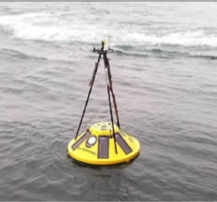

Cable Bandage Solutions

Start date: 7th July 2021
Duration of work scope: Expected 6 weeks
Description of work: Orsted will be performing diving works on cable ends, repairing the cable protection system at a number of selected WTG positions on ROW. During nights ROV inpections will be performed on all WTG positions
Is this a licensed activity: Yes – Consent has been obtained with the MMO
Safety zone required. During dive operations a 500m safetyzone shall apply (approx 2 x 1 hrs per day)
The Eden Rose will support the works as CTV between Piggyback Campaign.

Vessel information
Name | HBC Achiever | 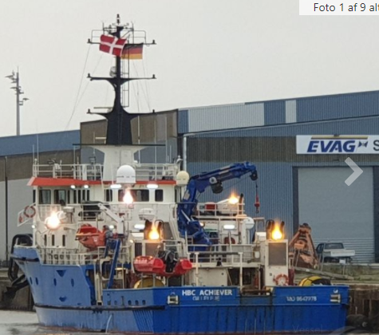
Flag | DK
Year Built | 2014
MMSI Number | 219305000
Call Sign | OWMH2
Vessel Contact Details
Bridge | +45 28 56 47 99 / +45 82 13 10 43
Party Chief
Email | achieverbridge@hbc-tec.dk
WTG ID | Degrees, Decimal Minutes
 | Easting (ETRS89 UTM31N) | Northing (ETRS89 UTM31N)
A02 | 351700,00 | 5910926,00
A03 | 351675,00 | 5910116,00
A04 | 351586,00 | 5909271,00
A05 | 351521,00 | 5908361,00
B03 | 352310,00 | 5909221,00
B06 | 351967,00 | 5906765,00
C04 | 353341,00 | 5909222,00
D08 | 353590,00 | 5905297,00
E07 | 354466,00 | 5903852,00
F07 | 354946,00 | 5901636,00
G05 | 356151,00 | 5902731,00
G06 | 355863,00 | 5901896,00
H06 | 356829,00 | 5901396,00
Z01 | 353944,00 | 5907400,00

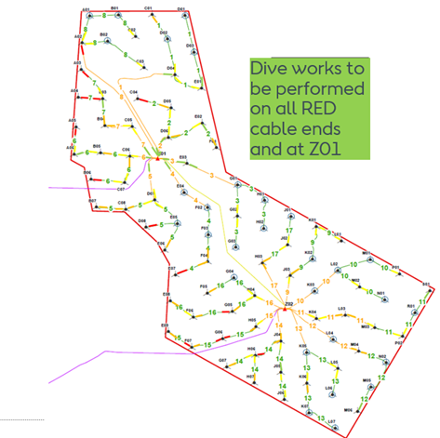

Above Water Inspections

Above water inspection campaign due to start 3rd July for approx 2 months, teams will carry out TP and Internal inspections on the basement of all WTG and will be supported by the NOS Maker.

Vessel information
General Information |  | Vessel Picture
Name | Nos Maker | 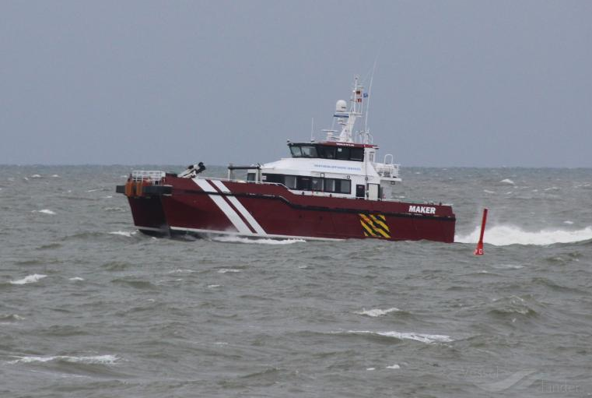
Flag | Denmark
Year Built
MMSI Number | 219026749
Call Sign | OZJD2
Vessel Contact Details
Bridge | +46 738 62 76 02
Party Chief
Email | maker@n-o-s.eu

Internal Blade Inspections

The workscope is to complete internal Blade inspections across all locations on Racebank Wind farm, supported by the Rix Lion. The works will start around 8th July and last approx 2 months with all works being contain inside the WTG and no requirements for Safety Zones.

Vessel information
General Information |  | Vessel Picture
Name | Rix Lion | 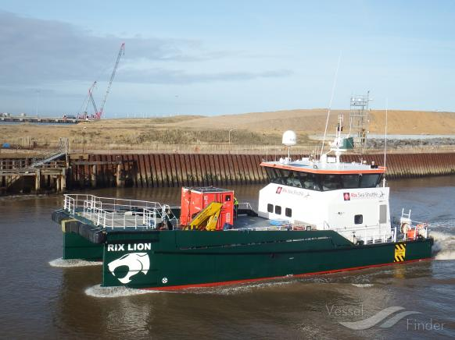
Flag | UK
Year Built | 2014
MMSI Number | 235105282
Call Sign | 2HOH3
Vessel Contact Details
Bridge | 07702 975599
Party Chief
Email | rix.lion@rix.co.uk

Westermost Rough – Notice to Mariners

Lighting and Marking Status
The lighting and/ or navigational warning systems are currently operational. No planned outages.

Other Operations

Blade Inspection
Current on hold UFN!
On the 8th July, we will be carrying out a blade Inspection and collect a sample from E03 shown below. A 200m exclusion zone will be required for the duration of the works, it is anticipated at being completed by the 10th July. One of the site CTV’s will be used for this work.

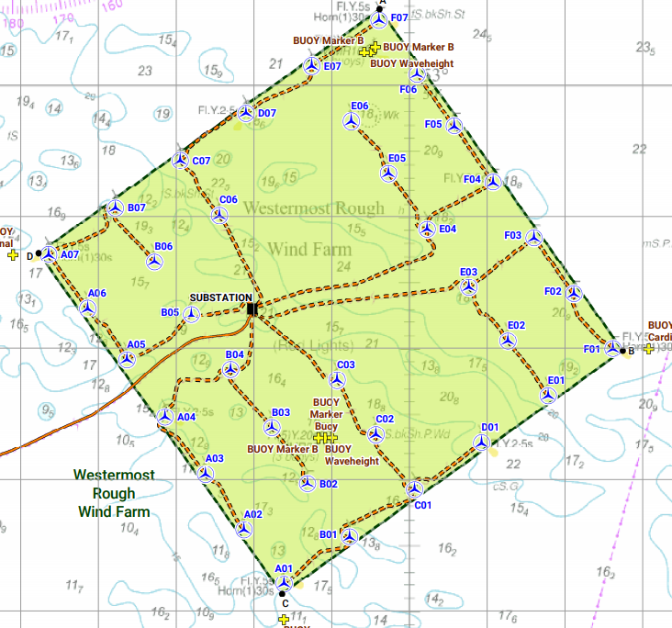

Emergent Bathymetric Survey

Start day 17/07/2021
Duration 1 Day
Bathymetric survey of WTB 50mx50m plus RPL +/- 25m

General Information |  | Vessel Picture
Name | MHO Grimsby | 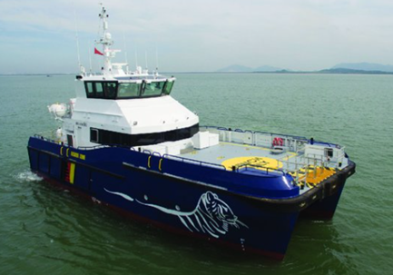
Flag | Denmark
Year Built | 2016
MMSI Number | 219025992
Call Sign | OYKR2
Vessel Contact Details
Bridge | mho-grimsby@mho-co.dk
Party Chief | Ryan Knight
Email | ryan.knight@spectrum-offshore.com

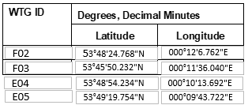

Lincs – Notice to Mariners

Lighting and Marking Status
The lighting and/ or navigational warning systems are currently operational. No planned outages.

Other Operations

Blade repair

On the 10th July, we will be carrying out a blade repair on LS54 shown below. A 200m exclusion zone will be required for the duration of the works, it is anticipated at being completed by the 13th July. One of the site CTV’s will be used for this work.

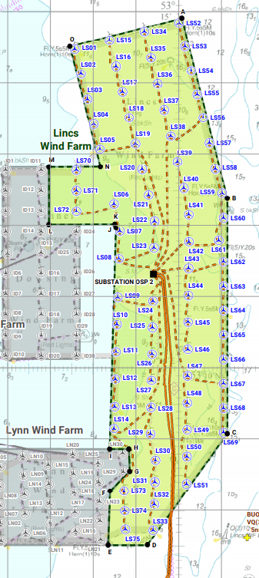

Gunfleet Sands – Notice to Mariners

Lighting and Marking Status
The lighting and/ or navigational warning systems are currently operational. No planned outages.

Other Operations

Seabed survey

On the 28th June the vessel Spectrum Nyquist will be conducting a 300m x 300m survey around locations C05 & D04 identified below.

Vessel Information

General Information |  | Vessel Picture
Name | Spectrum Nyquist | 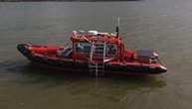
Flag | UK
Year Built | 2010
MMSI Number | 232031312
Call Sign | MIIG4
Vessel Contact Details
Bridge | +44 (0)7803 031728  Tt
Party Chief | TBD
Email | +44 (0)7803 031728

WTG ID | Degrees, Decimal Minutes
 | Latitude | Longitude
C05 | 51°44.334’N | 01°14.267’E
D04 | 51°43.876’N | 01°13.790’E

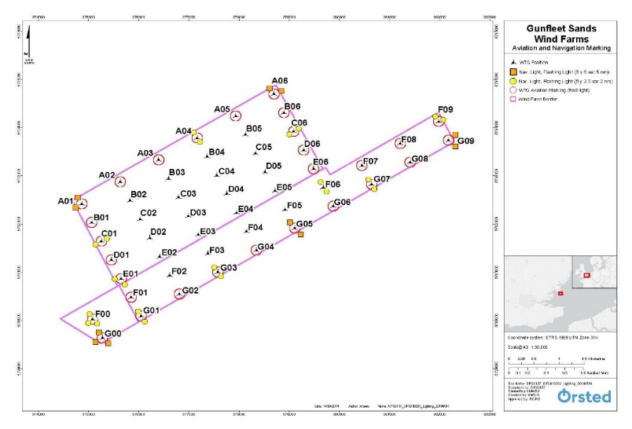

Internal corrosion protection

We will conduct a corrosion protection campaign around the 12th July, all locations will be visited, and the campaign is anticipated to last around 6 weeks.

Vessel Information

General Information |  | Vessel Picture
Name | CWind Adventure | 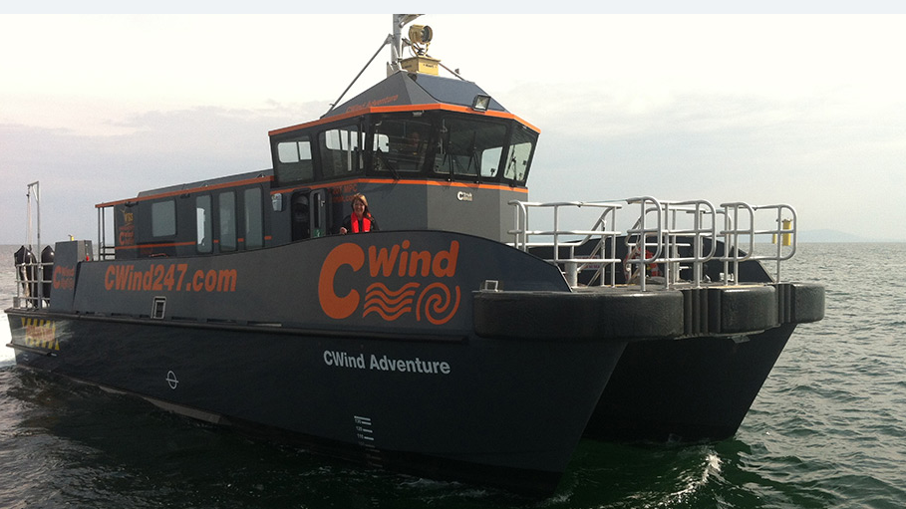
Flag | UK
Year Built | 2013
MMSI Number | 235097139
Call Sign | 2GGG9
Vessel Contact Details
Bridge | 07508452177
Party Chief
Email | Adventure@cwind.global

General Information |  | Vessel Picture
Name | CWind Challenger | 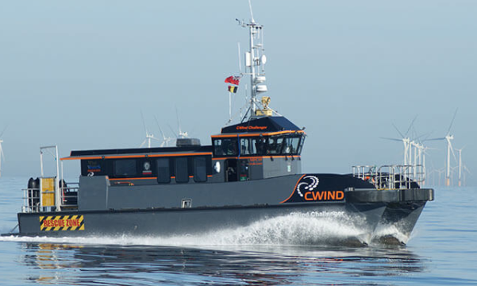
Flag | UK
Year Built | 2013
MMSI Number | 235099967
Call Sign | 2GRU4
Vessel Contact Details
Bridge | 07944639671
Party Chief
Email | challenger@cwind.global

Cable exposure

There are subsea cables currently exposed as shown on the below chart and coordinates.

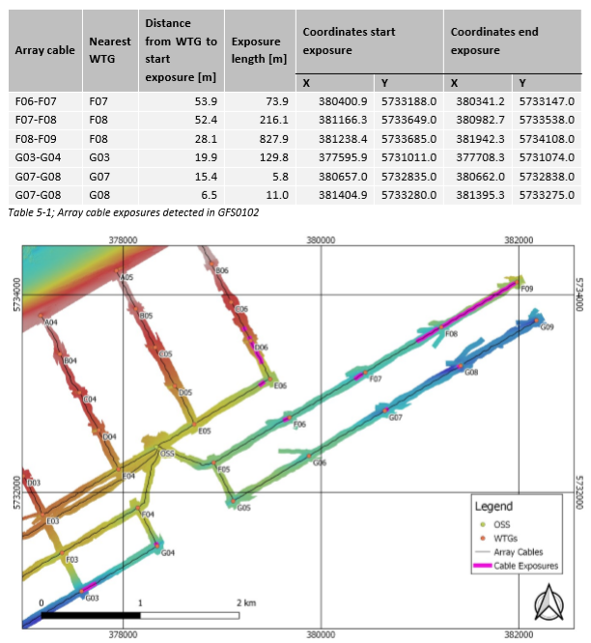

Hornsea One – Notice to Mariners

Lighting and Marking Status

The lighting and/ or navigational warning systems are currently operational. No planned outages.

Other Operation

We will undertake an offshore service of a Measurement Buoy. Mariners should note that the service of the Measurement Buoy is scheduled for 21st to 24th July (weather permitting) and service works should last 6 hours. An example image of a Measurement Buoy is shown in the figure below as well as the vessel details.

Vessel information

General Information |  | Vessel Picture
Name | Voe Vanguard
Flag | UK
Year Built | 2017
MMSI Number | 232008636
Call Sign | MBEN9
Vessel Contact Details
Bridge | +44 7766 798 48
Party Chief
Email | voevanguard@deltamarine.scot

Location - HOW1: 53° 50.203′ N, 001° 49.253′ E

MEASUREMENT BUOY

