Notice to Mariners
Shell Annual Pipeline Inspection Survey – Marine Survey Operations
Date of Issue – 05 August 2021
Effective Date – 11 Aug 2019 to 31 Aug 2021
Area – South North Sea
Mariners are advised of marine survey operations in the North Sea, the survey routes begin East North East of Bacton.

The operations are scheduled to commence on 11th of August 2021.

The operations will continue for approximately 2-3 weeks.

The 83 m long DP2 survey vessel Relume (Callsign: C6TR4) operated by survey company MMT will undertake an annual pipeline inspection survey.
Relume will be operating on a 24-hr basis and will have tethered subsea vehicles in use.
The vessel will display all applicable day shapes and lights, and will maintain a listening watch on VHF channel 16, and local working channels as appropriate, as well as transmitting on AIS.

Contact Details
Further enquiries should be addressed to the following people in the following order:

- Karin Gunnesson (MMT Project Manager),
T: +46 709 101 603,
karin.gunnesson@mmt.se
- Kalle Flink (MMT Operations)
T: +46 708 11 28 43,
kalle.flink@mmt.se

Survey Area Co-Ordinate Table
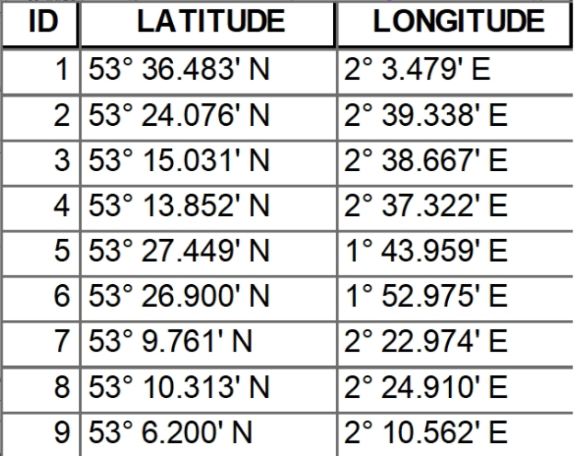

Survey Vessel RELUME Specification
Vessel description
Name | Relume
MMSI | 311753000
IMO | 9280720
Callsign | C6TR4
Ships type | DP2 Multipurpose Vessel
Phone number | Inmarsat Phone: +870 773247540
E-mail | relume_master@relume-mmsl.com
Length over all | 82.60m
Width | 16.50m
Draft | 4.00m
Survey Operating speed | 0.2 to 2 knot with WROV Deployed
Confirming AIS on board | Yes
Restricted maneuverability | Yes
Requested safe distance other vessels | 0.5 Nm
Supporting-/guard vessel(s) details | none
Deployed equipment | WROV
Communications during work (24/7) | VHF CH 16
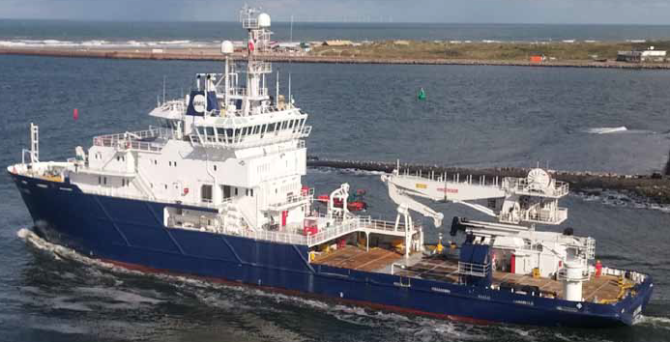

Survey Area
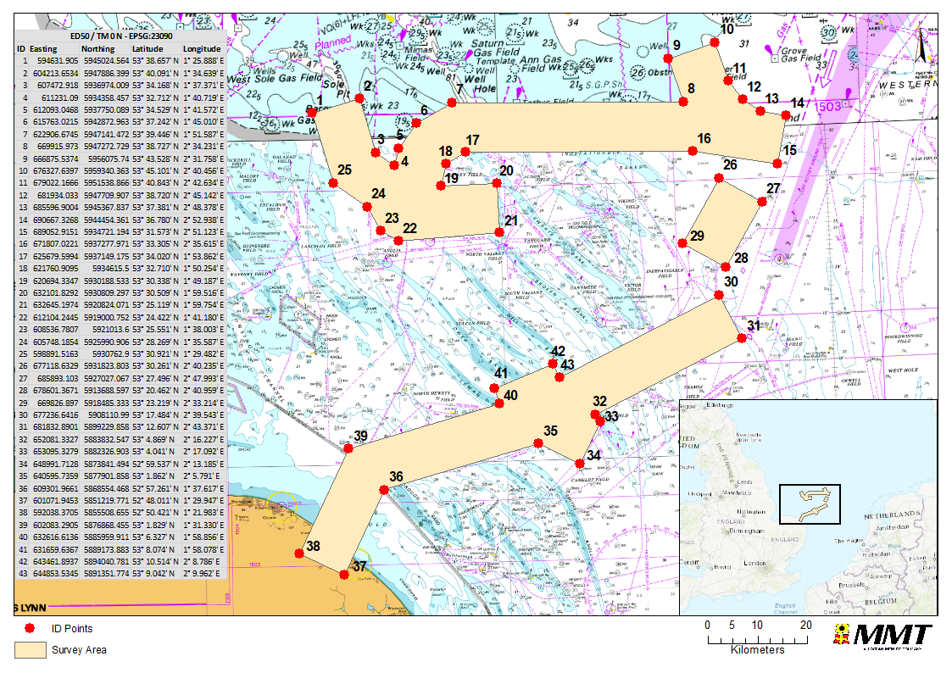
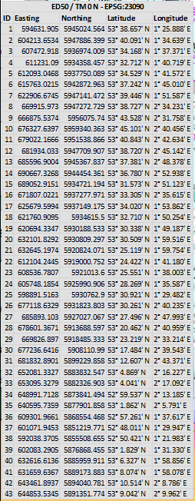

Port of Lowestoft & Gt Yarmouth | GHorton@abports.co.uk  anthony.vandamme@abports.co.uk
MCA VTS | Heidi.clevett@mcga.gov.uk  Tony.evans@mcga.gov.uk
Trinity House | navigation.directorate@thls.org  navigation@trinityhouse.co.uk
UKHO | navwarnings@ukho.gov.uk  SDR@ukho.gov.uk
Eastern IFCA | mail@eastern-ifca.gov.uk

