|  |
| --- |
| Ørsted - East Coast Operational Assets  Notice to Mariners  Period of Notice: September 2021  Version: Issue 3 |

**Table of Contents**

1 Introduction 3

1.1 Subsea Cables 4

1.2 Wind Farm Positional Data 4

2 Key Contacts 4

3 Notice to Mariners Summary: 5

4 Race Bank – Notice to Mariners 6

4.1 Lighting and Marking Status 6

4.2 Other Operations 6

4.2.1 Piggyback rectification work 6

4.2.2 Internal Blade Inspections 6

4.2.3 Rock Placement 7

5 Westermost Rough – Notice to Mariners 9

5.1 Lighting and Marking Status 9

5.2 Other Operations 9

5.1.1 Main Bearing Replacement 9

5.1.2 Rock Placement 10

6 Lincs – Notice to Mariners 13

6.1 Lighting and Marking Status 13

6.2 Other Operations 13

6.2.1 Blade repair 13

6.2.2 Corrosion Monitoring System 14

7 Gunfleet Sands – Notice to Mariners 15

7.1 Lighting and Marking Status 15

7.2 Other Operations 15

7.2.1 Internal corrosion protection 15

7.2.2 Cable exposure 16

7.2.3 Main component exchange 17

8 Hornsea One – Notice to Mariners 18

8.1 Lighting and Marking Status 18

8.2 Other Operations 18

# Introduction

Ørsted is an offshore wind farm owner and operator with ten operational wind farms in UK waters. Of these ten, the following offshore wind farms are located off the East Coast of England:

* 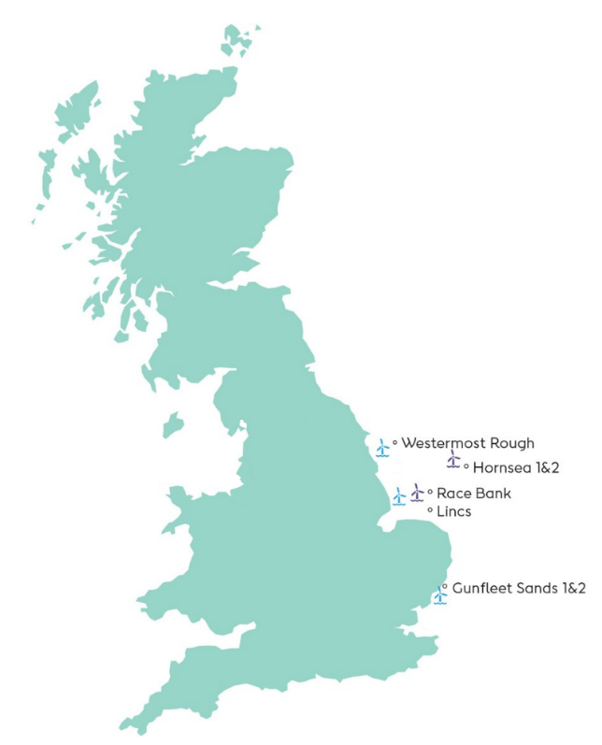Gunfleet Sands
* Westermost Rough
* Race Bank
* Lincs
* Hornsea One

The purpose of this monthly Notice to Mariners (NtM) is to ensure that mariners are aware of any non-routine operations across the East Coast assets that could pose a risk to other sea users. Safety is paramount to Ørsted and this notice should assist in ensuring that both mariners and the Ørsted operational team can operate safely offshore. This NtM will provide:

* A regular, clear and consistent overview of non-routine operations
* Updates relating to lighting and marking
* Key contact details
* Access to detailed site information and figures
* Clarity on when Safety Zones and recommended safe separation distances are in force or requested

This Notice to Mariners *will not* provide:

* Information relating to routine maintenance carried out by Crew Transfer Vessels (CTV) or Service Operation Vessels (SOV).
* Any information relating to export cables
* Any information relating to offshore wind farms currently in development, construction or not operated by Ørsted

## Subsea Cables

Subsea cables are installed across each offshore wind farm and are marked on the KIS ORCA charts referenced in Section 1.2. Please note the following advice from NP 100 The Mariners Handbook “Every care should be taken to avoid anchoring, trawling, fishing, dredging, drilling, or carrying out any other activity in the vicinity of cables which might damage them.” This warning is repeated on all admiralty charts.

## Wind Farm Positional Data

KIS ORCA Awareness Charts (including the layout and coordinates) and Fishing Plotter Files of the offshore assets referenced in this NtM can be found via the KIS ORCA website: <http://www.kis-orca.eu/downloads#.XWUTQUxFwjZ>. Should mariners require further information or any data in a format that can be used in a plotter or other device, please contact the Company Fisheries Liaison Officer, listed in Section 2 below.

# Key Contacts

For further information on any of the activities listed within this notice, please use the contact details listed below.

|  |  |  |
| --- | --- | --- |
| **Site** | **Ørsted Mailbox/ Offshore Coordination** | **Fisheries Industry Representative** |
| Race Bank | Phone: 07826 943808  Email: [rowoffshorec@orsted.co.uk](mailto:rowoffshorec@orsted.co.uk) | Ady Woods  Phone: 07468 898948  Email: [firwoods@hotmail.com](mailto:firwoods@hotmail.com) |
| Westermost Rough | Phone: 07867 674941  Email: [wmroffshorec@orsted.co.uk](mailto:wmroffshorec@orsted.co.uk) | Guy Pasco  Phone: 07880 362082  Email: [guy@seascopefisheries.co.uk](mailto:guy@seascopefisheries.co.uk) |
| Lincs | Phone: 07766443319  Email: [lincsoffshorec@orsted.co.uk](mailto:lincsoffshorec@orsted.co.uk) | Ady Woods  Phone: 07468 898948  Email: [firwoods@hotmail.com](mailto:firwoods@hotmail.com) |
| Gunfleet Sands | Merlin Jackson  Phone: 07989 520484  Email: [merlinjackson@btinternet.com](mailto:merlinjackson@btinternet.com) |
| Hornsea One | Phone: 07775005465  Email: [HOWoffshoreC@orsted.co.uk](mailto:HOWoffshoreC@orsted.co.uk) | Nick Garside  Phone: 07538 827013  Email: [nick.garside@live.co.uk](mailto:nick.garside@live.co.uk) |

**Company Fisheries Liaison Officer**

The Ørsted Company Fisheries Liaison Officer can be contacted using the details below:

Courtney French

Email: CONFR@Orsted.co.uk

# Notice to Mariners Summary:

|  |  |  |  |  |
| --- | --- | --- | --- | --- |
| **Site** | **Lighting and Marking Status** | **Survey** | **Jack-Up Vessel** | **Other Works** |
| Race Bank | OK | None | None | Piggyback campaign,  Internal Blade Inspections, Rock Placement**. |
| Westermost Rough | OK | None | Wind Pioneer °* | Main Gearbox Replacement, Rock placement** |
| Lincs | OK | None | None | Blade repair***, corrosion monitoring system. |
| Gunfleet Sands | OK | None | Wind Pioneer °* | Corrosion campaign |
| Hornsea One | H27 Fog Signal | None | None | None |

* Formal 500m safety zone in place

° Licensable activity

** 500m safety distance requested

*** 200m safety distance requested

***Status of lighting & marking is correct at time of issue; any changes will be communicated through an updated version being issued.***

# Race Bank – Notice to Mariners

## Lighting and Marking Status

The lighting and/ or navigational warning systems are currently operational. No planned outages.

## Other Operations

### Piggyback rectification work

On the 10th June the Eden Rose will be on site to conduct some WTG internal repairs. The scope is expected to last throughout August and into September, it will be across the full wind farm.

**Vessel information**

|  |  |  |
| --- | --- | --- |
| ***General Information*** | | ***Vessel Picture*** |
| ***Name*** | *Eden Rose* |  |
| ***Flag*** | *UK* |
| ***Year Built*** | *2012* |
| ***MMSI Number*** | *235092732* |
| ***Call Sign*** | *2FNN5* |
| ***Vessel Contact Details*** | |
| ***Bridge*** | *Master (TBC)* |
| ***Party Chief*** | *07852125057* |
| ***Email*** | [*edenrose@tidal-transit.com*](mailto:edenrose@tidal-transit.com) |

### Internal Blade Inspections

The work scope is to complete internal Blade inspections across all locations on Racebank Wind farm, supported by the Rix Lion. The works will start around 8th July and last approx. 2 months with all works being contain inside the WTG and no requirements for Safety Zones.

**Vessel information**

|  |  |  |
| --- | --- | --- |
| ***General Information*** | | ***Vessel Picture*** |
| ***Name*** | *Rix Lion* |  |
| ***Flag*** | *UK* |
| ***Year Built*** | *2014* |
| ***MMSI Number*** | 235105282 |
| ***Call Sign*** | 2HOH3 |
| ***Vessel Contact Details*** | |
| ***Bridge*** | *07702 975599* |
| ***Party Chief*** |  |
| ***Email*** | [*rix.lion@rix.co.uk*](mailto:rix.lion@rix.co.uk) |

### Rock Placement

Towards the end of September, the vessel Bravenes will be placing rocks by use of a fall pipe close to the WTG locations. The scope is anticipated to last around 30 days. A 500m safety zone will be required around the vessel at all times.

**Vessel information**

|  |  |  |
| --- | --- | --- |
| ***General Information*** | | ***Vessel Picture*** |
| ***Name*** | *Bravenes* |  |
| ***Flag*** | *NL* |
| ***Year Built*** | *2017* |
| ***MMSI Number*** | **244860916** |
| ***Call Sign*** | **PDCF** |
| ***Vessel Contact Details*** | |
| ***Bridge*** | *+ 4723398649* |
| ***Party Chief*** |  |
| ***Email*** | *0620.cpt@vanoord.com* |

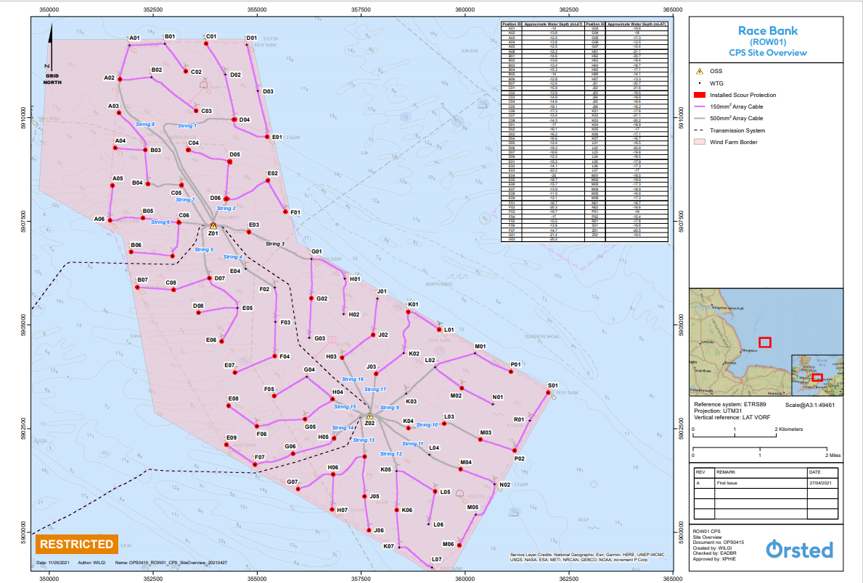



# Westermost Rough – Notice to Mariners

## Lighting and Marking Status

The lighting and/ or navigational warning systems are currently operational. No planned outages.

## 5.2 Other Operations

### Main Bearing Replacement

The work scope is a Main Bearing Replacement on E07 turbine, it is expected to commence on the 23rd September for approximately 6 days.

Mariners must observe an approved exclusion zone of 500m whenever The Wind Enterprise is attached/ anchored next to E07. A minimum separation distance of 500m is also requested when the vessel is observed manoeuvring into position.

**Vessel Information**

|  |  |  |
| --- | --- | --- |
| ***General Information*** | | ***Vessel Picture*** |
| ***Name*** | *Wind Enterprise* |  |
| ***Flag*** | *Denmark* |
| ***Year Built*** | *2011* |
| ***IMO/MMSI Number*** | *219370000* |
| ***Call Sign*** | *OZTU2* |
| ***Vessel Contact Details*** | |
| ***Bridge*** | *+45 21 82 21 80* |
| ***Party Chief*** | *WIP Master* |
| ***Email*** | *master.windenterprise@ziton.eu* |

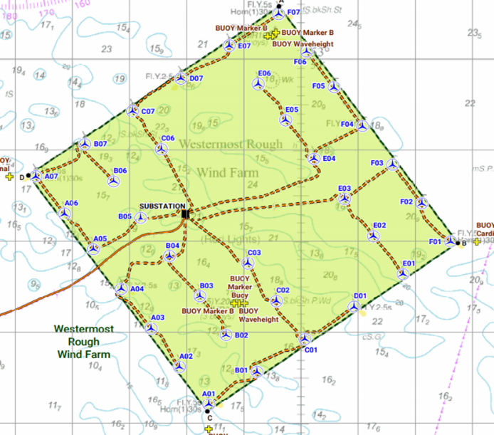

**Coordinates**

|  |  |  |
| --- | --- | --- |
| **TURBINE ID** | **WGS84 (Deg, decimal Minutes)** | |
| **LONGITUDE** | **LATITUDE** |
| E07 | 000° 08.74459922' E | 53° 50.14413601' N |

### Rock Placement

Towards the middle of October the vessel Bravenes will be placing rocks by use of a fall pipe close to the WTG locations. The scope is anticipated to last around 30 days. A 500m safety zone will be required around the vessel at all times.

**Vessel information**

|  |  |  |
| --- | --- | --- |
| ***General Information*** | | ***Vessel Picture*** |
| ***Name*** | *Bravenes* |  |
| ***Flag*** | *NL* |
| ***Year Built*** | *2017* |
| ***MMSI Number*** | **244860916** |
| ***Call Sign*** | **PDCF** |
| ***Vessel Contact Details*** | |
| ***Bridge*** | *+ 4723398649* |
| ***Party Chief*** |  |
| ***Email*** | *0620.cpt@vanoord.com* |

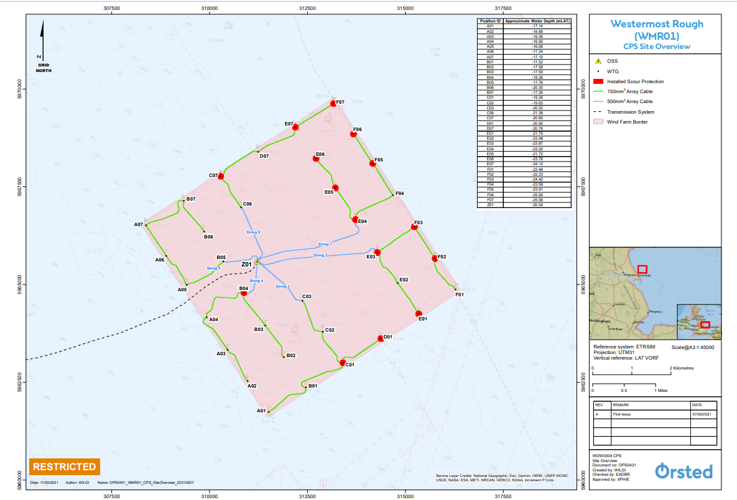



# Lincs – Notice to Mariners

## Lighting and Marking Status

The lighting and/ or navigational warning systems are currently operational. No planned outages.

## Other Operations

### Blade repair

During September (exact date is currently TBC), we will be carrying out a blade repair on LS54 shown below. A 200m exclusion zone will be required for the duration of the works. One of the site CTV’s will be used for this work.

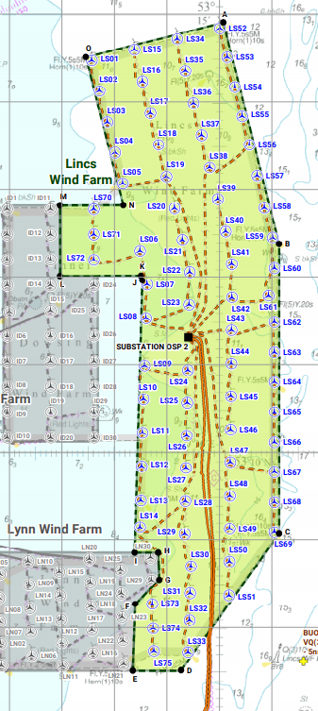

**Coordinates**

|  |  |  |
| --- | --- | --- |
| **TURBINE ID** | **WGS84 (Deg, decimal Minutes)** | |
| **LONGITUDE** | **LATITUDE** |
| LS54 | 000° 30.29313320' E | 53° 14.16938999' N |

### Corrosion Monitoring System

We will be installing a corrosion monitoring system on LS39, we expect to start the work on the 2nd September and anticipate it to take 7 days. The CTV will be the MCS Kaver.

**Vessel Information**

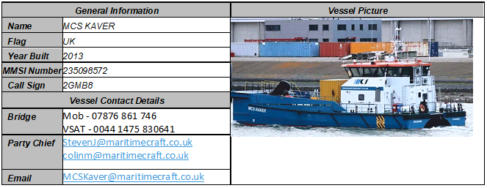

**Coordinates**

|  |  |  |
| --- | --- | --- |
| **TURBINE ID** | **WGS84 (Deg, decimal Minutes)** | |
| **LONGITUDE** | **LATITUDE** |
| LS39 | 000° 29.96857738' E | 53° 12.88830837' N |

# Gunfleet Sands – Notice to Mariners

## Lighting and Marking Status

The lighting and/ or navigational warning systems are currently operational. No planned outages.

## Other Operations

### Internal corrosion protection

We will conduct a corrosion protection campaign around the 12th July, all locations will be visited, and the campaign is anticipated throughout September.

**Vessel Information**

|  |  |  |
| --- | --- | --- |
| ***General Information*** | | ***Vessel Picture*** |
| ***Name*** | *CWind Adventure* |  |
| ***Flag*** | *UK* |
| ***Year Built*** | *2013* |
| ***MMSI Number*** | *235097139* |
| ***Call Sign*** | *2GGG9* |
| ***Vessel Contact Details*** | |
| ***Bridge*** | *07508452177* |
| ***Party Chief*** |  |
| ***Email*** | [*Adventure@cwind.global*](mailto:Adventure@cwind.global) |

|  |  |  |
| --- | --- | --- |
| ***General Information*** | | ***Vessel Picture*** |
| ***Name*** | *CWind Challenger* |  |
| ***Flag*** | *UK* |
| ***Year Built*** | *2013* |
| ***MMSI Number*** | *235099967* |
| ***Call Sign*** | *2GRU4* |
| ***Vessel Contact Details*** | |
| ***Bridge*** | *07944639671* |
| ***Party Chief*** |  |
| ***Email*** | [*challenger@cwind.global*](mailto:challenger@cwind.global) |

### Cable exposure

There are subsea cables currently exposed as shown on the below chart and coordinates.

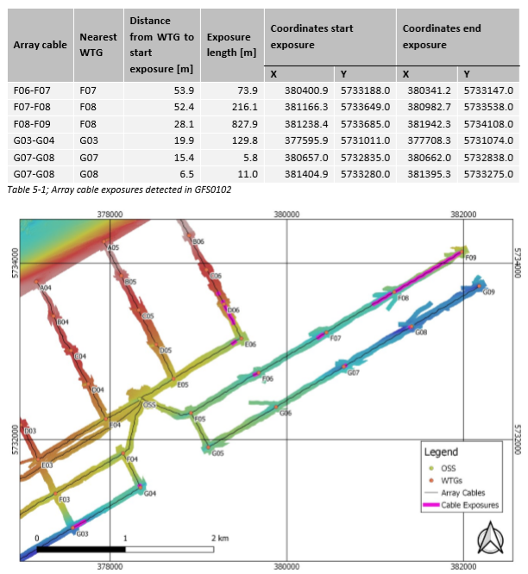

### Main component exchange

Jack up vessel, The Wind Pioneer will be carrying out a main bearing exchange on Gunfleet Sands windfarm on C05 on or around the 1st September. The CTV CRC Sentinel will be supporting this scope.

Mariners must observe an approved exclusion zone of 500m whenever The Wind Pioneer is attached/ anchored next to C05. A minimum separation distance of 500m is also requested when the vessel is observed manoeuvring into position. The duration of the work will be approximately 7 days.

**Vessel Information**

|  |  |  |
| --- | --- | --- |
| ***General Information*** | | ***Vessel Picture*** |
| ***Name*** | *Wind Pioneer* |  |
| ***Flag*** | *Denmark* |
| ***Year Built*** | *2010* |
| ***IMO/MMSI Number*** | *219017684* |
| ***Call Sign*** | *OWLA2* |
| ***Vessel Contact Details*** | |
| ***Bridge*** | *+45 21 82 21 80* |
| ***Party Chief*** | *WIP Master* |
| ***Email*** | *master.windpioneer@ziton.eu* |

|  |  |  |
| --- | --- | --- |
| ***General Information*** | | ***Vessel Picture*** |
| ***Name*** | *CRC Sentinal* |  |
| ***Flag*** | *UK* |
| ***Year Built*** | *2011* |
| ***IMO/MMSI Number*** | *235083968* |
| ***Call Sign*** | *2ECN8* |
| ***Vessel Contact Details*** | |
| ***Bridge*** | *TBC* |
| ***Party Chief*** | *TBC* |
| ***Email*** | *TBC* |

**WTG coordinates**

|  |  |  |
| --- | --- | --- |
| **TURBINEID** | **WGS84 (Deg, decimal Minutes)** | |
| **LONGITUDE** | **LATITUDE** |
| C05 | 001° 14.26745163' E | 51° 44.33395028' N |

# Hornsea One – Notice to Mariners

## Lighting and Marking Status

H27 Foghorn is active constantly due to a software error, to be rectified as soon as possible.

## Other Operations

**INTRODUCTION**

Mariners are advised that Ørsted will undertake an offshore service of a Measurement Buoy in the Hornsea 1 Offshore Wind Farm.

**AREA OF OPERATIONS**

The device is currently located within the Offshore Wind Farm limits with coordinates provided below.

Hornsea 1 Wind Farm – 53° 50.203′ N, 001° 49.253′ E

**PROPOSED ACTIVITIES**

Mariners should note that an emergency service of the Measurement Buoy is scheduled for 9 and 10th of September. An example image of a Measurement Buoy is shown in the figure below as well as the vessel details.

A local assessment of the buoy damage (suspected vessel collision) will be done in-situ and a decision will be made on a site repair or buoy and mooring recovery to shore.

**AIDS TO NAVIGATION**

Navigational light and radar reflector have been damaged and assumed inoperative at his time.

**IMMEDIATE CONTACTS**

Enquiries regarding the contents of this Notice to Mariners or any other matters should be directed to:

Measurement Engineer, Measurement Department (Ørsted)

(Office hours only)

Vasco Nunes

Tel: +44 78 2 7566175

E-mail: [VASNU@orsted.co.uk](mailto:VASNU@orsted.co.uk)

Measurement Manager, Measurement Department (Ørsted)

(Office hours only)

Solveig Holberg Nilsen

Tel: +45 99 55 86 38

E-mail: [SOLHO@orsted.dk](mailto:SOLHO@orsted.dk)

**VESSEL DETAILS**

Vessel: Voe Vanguard

Vessel telephone M: +44 7766 798 481 S: +881 631 448 600 T: +44 1595 922 073

Vessel email: [voevanguard@deltamarine.scot](mailto:voevanguard@deltamarine.scot)

Call Sign: MBEN9

MMSI: 232008636

**MEASUREMENT BUOY**

