LYNN AND INNER DOWSING
OFFSHORE WIND FARMS
Notice to Mariners
March 2022
Scope of Works – Major Component Replacements
Lynn and Inner Dowsing (LID) Offshore Wind Farm wish to advise mariners that the Jack Up vessel Wind Enterprise is planned to commence works within the boundary of the wind farm on 24th March 2022.

The duration of the work scope is planned to be no longer than 10 days subject to weather conditions.

The wind turbine location is as below:
- LN04 – Coordinates: LATITUDE - 53⁰08.341’N LONGITUDE - 000⁰25.806’E
- LN22 – Coordinates: LATITUDE - 53⁰07.847’N LONGITUDE - 000⁰28.164’E

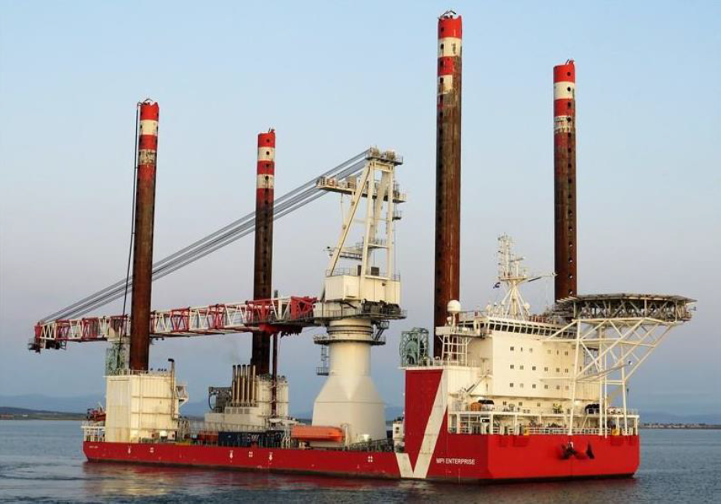

Vessel information
Name | Wind Enterprise
Call sign | OZTU2
MMSI | 219370000
Length | 120m
Beam | 40m

Lynn and Inner Dowsing Wind Turbine Locations
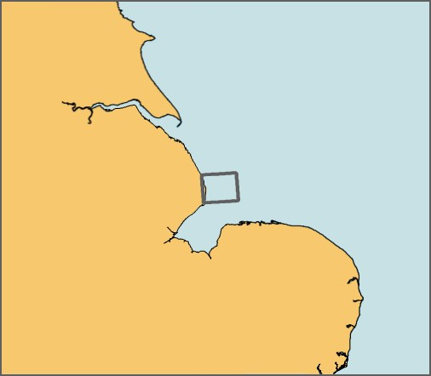
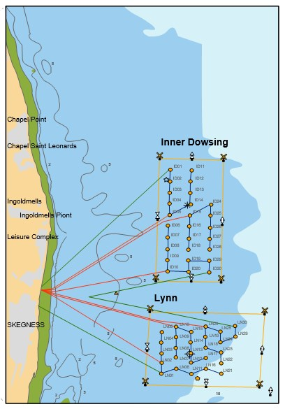

LN04

LN22
LN04

Mariners should maintain a safe distance of 500m from the Jack Up vessel when it is on station adjacent to the wind turbine.

Mariners are advised to exert caution in the vicinity of the wind farm during this time and should communicated with the SiemensGamesa Operational Marine Controller when operating near the site

SiemensGamesa Operational Marine Controller
Email: LIDOpoerationalmarinecontrol@siemensgamesa.com
Tel: 01472 806851 / 07921 249544
Radio Channel: 161.175MHz

Windfarm Liaison
Mariners are also adviser that Lynn and Inner Dowsing queries should be directed through the Site Owners Representatives – XceCo

Simon Matson  Tel: 07878207879  Email: simon@xceco.co.uk | Tony Lyon  Tel: 07789 573238  Email: tony@xceco.co.uk

