Galloper Offshore Wind Farm
Local Notice To Mariners
Issued by: Galloper Marine Coordination Centre | Date of Issue:29-03-2023
NTM: GWF-O&M 06-2023
For general enquiries please contact via email:  srv_galmcc.service@rwe.com  www.galloperwindfarm.com  For fisheries enquiries please contact via email: jonathan@brownmay.com  freya@brownmay.com | 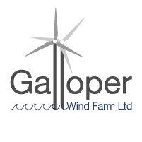
Dear Owners, Ships Agents, Masters, Pilots and Fishermen,

Re: Galloper Windfarm, RWE - NTM: GWF-O&M 06-2023 Drone Inspections

Please be advised that Galloper Windfarm will be carrying out Drone Inspections in the North & South fields of Galloper Windfarm as part of our planned maintenance and inspection programme from the 10th April for a duration of 10 days, weather dependent and the vessel will be operating in the daytime only.

Exclusion Zone – 250m

Survey operations will be carried out by the "Cardinal P" Call Sign: 2FKK9.

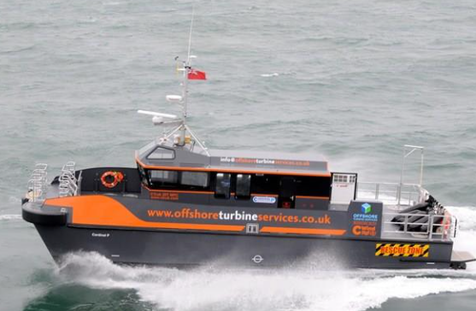

Scope: Drone Survey – Planned maintenance & inspection programme

Vessel: "Cardinal P" Call Sign: 2FKK9.

Schedule: 10th April 2023 – 20th April 2023

Locations: All 56 assets within the Galloper WF will be surveyed.

Positional data found in Kingfisher Wind farms chart “Galloper offshore wind farm January 2020” - Link
https://kis-orca.org/wp-content/uploads/2020/12/Chart-32-Galloper-2021.pdf
https://kis-orca.org/search/?searchTerm=galloper&action=searchSite

Galloper Marine Coordination Centre – Tel: 01793 896 599 / 07867 371 331

