



Notice to Mariners
Anchor and anchor wire on seabed

Hughes Doc No: | 1835-NTC-022 |  |  |  |  | Hughes Revision No: |  |  | C-01
Revision Status: | Draft | ☐ | Information | ☒ |  | Review | ☐ | Approved |  | ☐
Issue Date: | 09/11/2025
 | Print |  |  |  | Signed
Approved By: | Dave Roberts |  |  |  | 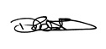
THIS DOCUMENT IS UNCONTROLLED ONCE PRINTED

Record of Issue
Revision | Drafted | Checked | Approved | Date
A-01 | D. Roberts | M. Clements | D. Roberts | 23/09/2025
C-01 | D. Roberts | M. Clements | D. Roberts | 23/09/2025

Document Change Record
Revision | Description of Changes | Pages | Section
A-01 | Issued for internal review | All | All
C-01 | Issued for Information | All | All

Statement of Copyright
This document is the intellectual property of HSSL Services Ltd. Possession, use and reference of this document is intended for workers of HSSL Services Ltd., authorised clients and subcontractors. All rights are reserved. This document may not in any part be replicated, reproduced, held physically or digitally, communicated or issued in by any means or in any format without the express permission of HSSL Services Ltd.

Notice summary
During anchor recovery operations, the vessel Tor Boreas picked up the first 3 anchors, and when attempting to recover the 4th and final anchor, starboard aft, ran into some issues. After trying to recover for roughly 4 hours, the anchor wire parted due to overloading.
The anchor is approx. 1.7m x 1.5m with 20mm diameter steel wire rope. Rope is negatively buoyant and will be on the seabed.
A lift plan is being generated to recover the anchor back to deck at the earliest opportunity.
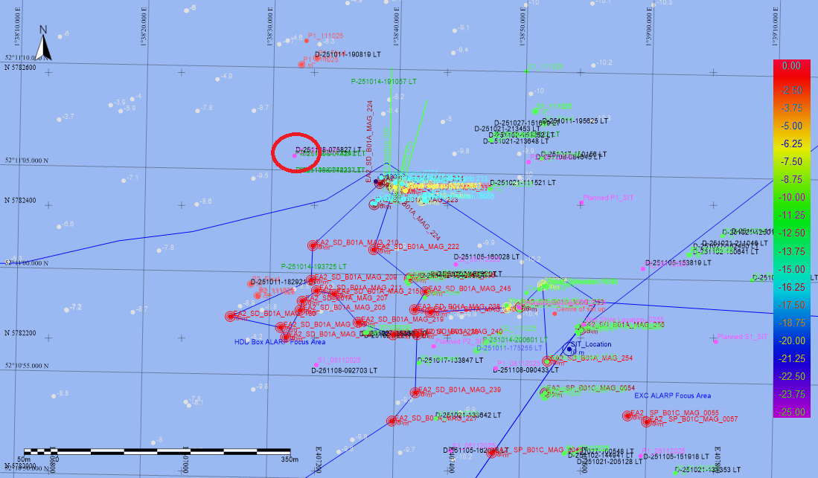
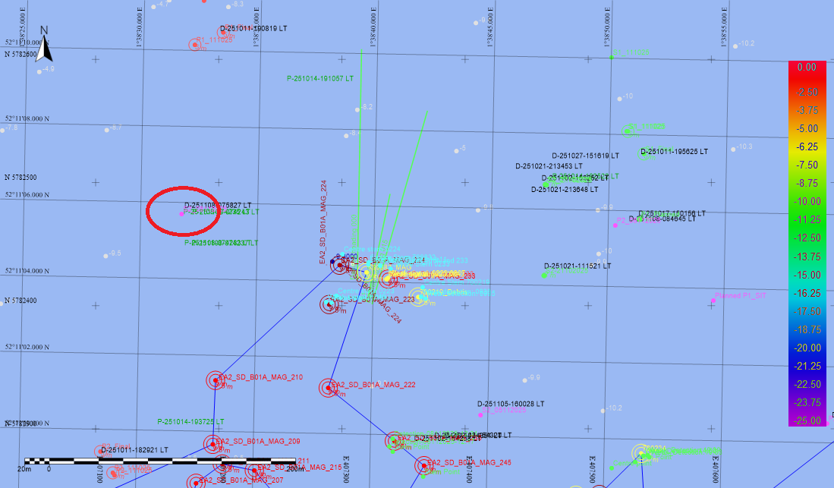
Dropped anchor location:
5782478.96N ; 407172.43E

Contacts
The contents of this notice are based on the current schedule of operations for the vessels, and is limited to investigation, survey light intervention activities within the designated areas. HSS will endeavour to update the contents of this notice as the project develops, and the vessel’s scope increases.
Enquiries regarding the contents of this notice, or associated matters, should be directed in the first instance to HSSL
For any matters relating to fisheries, or fishing activities, please contact the Fisheries Liaison Officer – Brown and May Marine Limited., using provided contact details.

HSSL Contact Details
Issuing Office Address
Hughes Subsea Services Limited, Units 3-5, Unity Grove, Knowsley Business Park, Prescot, Knowsley, L34 9GT
Key Personnel
- HSSL Project Manager
Email: maxc@hughes-subsea.com
- Glomar Worker Offshore Manager
Email: glomarworker.om@project.oeg.group
- Ross Eagle Offshore Manger
Email: rosseagle.om@project.oeg.group
- Tor Boreas Dive Supervisor
Email: EA2dive1.om@project.oeg.group

SPR (Client) Contact Details
Client Address
Scottish Power Renewables, 3rd Floor, 1 Tudor Street, London, EC4Y 0AH
Key Personnel
- SPR Package Manager
Email: gkent@scottishpower.com

Fisheries Contact Details
Brown and May Marine Limited Fisheries Liaison Officer
Key Personnel
- FLO’s
Email: jonathan@brownmay.com
Email: molly.jones@brownmay.com

Vessel Particulars

Tor Boreas
Name | Tor Boreas |  | Call Sign | MRRM8
Name |  |  | IMO Number | 9986489
Image | 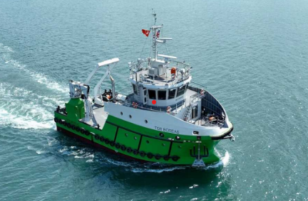
Vessel Type | Multipurpose support vessel
Owner | Inyanga Marine Energy Group
Flag | UK
LOA | 26.95m
Beam | 11.00m
Draft | Max 3.25m
Gross Tonnage | 397 T
Total POB | 18 – 6 crew and 12 pax
Communication | Bridge: | tor@inyanga.tech
Communication | Email: | tor@inyanga.tech
Communication | Tel: | Richard Parkinson 07966570364  Ben Baguely 07858504455

Distribution List
Distribution List External
The Crown Estate | consents@thecrownestate.co.uk
Marine Management Organisation | marine.consents@marinemanagement.org.uk
Marine Management Organisation | info@marinemanagement.gov.uk
Kingfisher | kingfisher@seafish.co.uk
Local Marine Management Organisation Office | lowestoft@marinemanagement.org.uk
Inshore Fisheries and Conservation Authority | mail@eastern-ifca.gov.uk
Trinity House | navigation.directorate@thls.org
Trinity House | navigation@trinityhouse.co.uk
Maritime and Coastguard Agency | navigationsafety@mcga.gov.uk
United Kingdom Hydrographic Office | navwarnings@ukho.gov.uk
United Kingdom Hydrographic Office | sdr@ukho.gov.uk
United Kingdom Hydrographic Office | offshore.energy@ukho.gov.uk
National Federation of Fishermen's Organisations | nffo@nffo.org.uk
National Coastguard | nmoccontroller@hmcg.gov.uk
Centre for Environment, Fisheries and Aquaculture Science | renewables@cefas.co.uk
Local Coastguard | zone9@hmcg.gov.uk
Local Coastguard | zone10@hmcg.gov.uk

Distribution List Internal
ScottishPower Renewables | ea3_mcc@scottishpower.com
ScottishPower Renewables | gkent@scottishpower.com
ScottishPower Renewables | r.stocks@scottishpower.com
ScottishPower Renewables - Fisheries | Molly.Jones@brownmay.com
ScottishPower Renewables - Fisheries | jonathan@brownmay.com
ScottishPower Renewables | f.murdoch@scottishpower.com
ScottishPower Renewables – Onboard Clients | rpsuxotorboreas@gmail.com  rpsuxorosseagle@gmail.com  rpsglomarwave@gmail.com
Hughes Subsea – Onshore Project Manager | maxc@hughes-subsea.com
Hughes Subsea – Offshore Project Managers | glomarworker.om@project.oeg.group  rosseagle.om@project.oeg.group  EA2dive1.om@project.oeg.group
Hughes Subsea – Asst. Project Manager | davidr@hughes-subsea.com
Hughes Subsea – HSEQ Coordinator | scottf@hughes-subsea.com

END OF DOCUMENT

