LYNN AND INNER DOWSING
OFFSHORE WIND FARMS
Notice to Mariners
6th January 2026 – 10th February 2026
Scope of Works – Seabed and Cable Survey
Lynn and Inner Dowsing (LID) Offshore Wind Farm wish to advise mariners that the survey vessel – Spectrum 1 is planned to commence works from the boundary of the wind farm to the shoreline until 10th February 2026, coordinates shown in image below.

The duration of the work scope is expected to take 30 days, subject to weather conditions

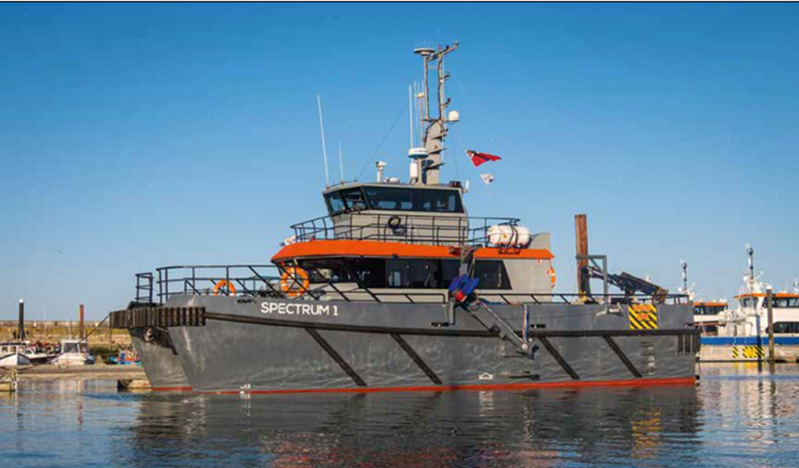

Vessel information
Name | Spectrum 1
Call sign | 2CQX3
MMSI | 235075021
Length | 17m
Beam | 6.5m

Survey Extent

The Lynn and Inner Dowsing (LID) Offshore Wind Farms project site are located approximately five kilometres (5KM) off the Skegness coastline in Lincolnshire. Three export cables service each wind farm respectively, co-terminating on the coastline between Skegness and Seathorne as shown below in figure 1. The water depth ranges up to twelve metres below the lowest astronomical tide to the shoreline.

Mariners should maintain a safe distance of 500m from the Spectrum 1 when it is on station surveying the export cables.

Mariners are advised to exert caution when operating in the vicinity of the wind farm and communicate with the Siemens Gamesa Operational Marine Controller when operating near the site.

Siemens Gamesa Operational Marine Controller
Email: LIDOperationalmarinecontrol@siemensgamesa.com
Tel: 01472 806851 / 07921 249544
Radio Channel: 161.175MHz

Windfarm Liaison
Mariners are also advised that Lynn and Inner Dowsing enquiries should be directed through the Site Owner Representative – XceCo.

Phone: 01472 806860
Email: flo@xceco.co.uk

