



Notice to Mariners
Confirmed Unexploded Ordinance
Target number EA2_WP2_VG_B02_MAG_0028

Hughes Doc No: | 1835-NTC-004 |  |  |  |  | Hughes Revision No: |  |  | C-01
Revision Status: | Draft | ☐ | Information | ☒ |  | Review | ☐ | Approved |  | ☐
Issue Date: | 25/02/2026
 | Print |  |  |  | Signed
Approved By: | Dave Roberts |  |  |  | 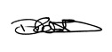

THIS DOCUMENT IS UNCONTROLLED ONCE PRINTED

Record of Issue
Revision | Drafted | Checked | Approved | Date
A-01 | BJ | WC | WC | 25/02/2026
C-01 | BJ | WC | WC

Document Change Record
Revision | Description of Changes | Pages | Section
A-01 | Issued for internal review | All | All
C-01 | Issued for construction

Statement of Copyright
This document is the intellectual property of Hughes Subsea Services Ltd. Possession use, and reference of this document is intended for workers of Hughes Subsea Services Ltd., authorised clients and subcontractors. All rights are reserved. This document may not in any part be replicated, reproduced, held physically or digitally, communicated or issued in by any means or in any format without the express permission of Hughes Subsea Services Ltd..

MARINE ACTIVITIES

1.1 Summary
Please be advised that confirmed unexploded ordinance has been identified at the following location displayed in section 2. It is advised a 1000m exclusion zone is in place around the given location.

1.2 Activity Description
Identification phase of the EA2 UXO Clearance Project

1.3 Programme schedule
N/A

1.4 Vessel Details

Name of vessel: | JU Wind | 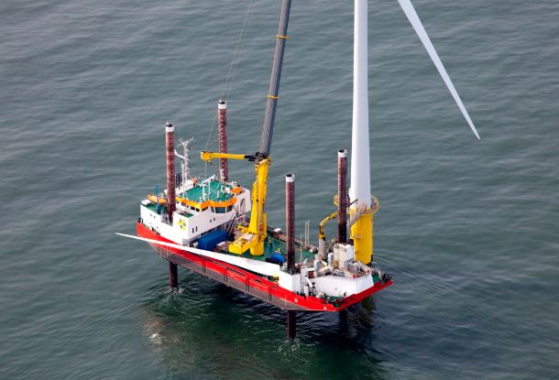
Call sign: | OXSW2
Onboard contact details: | EA2dive1.om@project.oeg.group
Shore based contact details: | See below

ACTIVITY AREA
Confirmed UXO has been identified at the following location:
Co-ordinates reference: WGS-84 / UTM31N / ITRF 2020
Location | Equipment | Latitude | Longitude
EA2_B02 | Target assessed as a German SC250 Air Dropped Weapon or similar. 1.2 x 0.36 x 0.36m | 52;14.3205089 N  5,788,357.53 N | 1;43.1626214 E  412,554.65 E

Figure showing map/chart of area in UTM31N
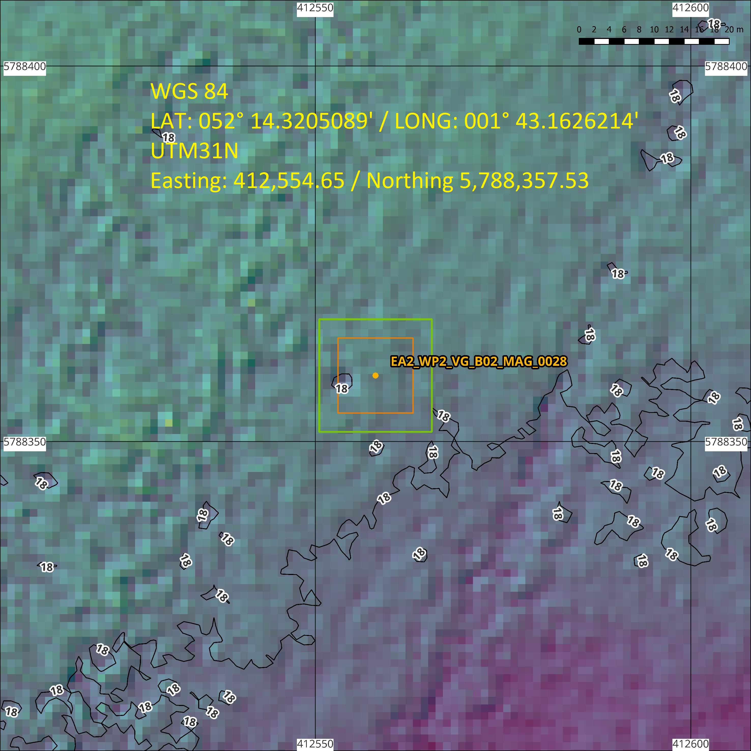

CONTACTS

  - Emergency Contact
Name | EA3 MCC
Contact telephone number | Emergency number - +44 (0) 141 614 4822
Email address | EA3_MCC@scottishpower.com
Address | East Anglia Three, Herring Market, Battery Green Road, Lowestoft, Suffolk, NR32 1BY

  - SPR Project Management
Name | Gavin Kent
Contact telephone number | +44 (0)7375 865478
Email address | gkent@scottishpower.com
Address | East Anglia Three, Herring Market, Battery Green Road, Lowestoft, Suffolk, NR32 1BY

  - OEG Project Management
Name | Dave Roberts
Contact telephone number | +44 (0)7872 136654
Email address | david.roberts@oeg.group
Address | Units 3-5, Unity Grove, Knowsley Business Park, Prescot, Knowsley, L34 9GT

NOTICE TO MARINERS’ DISTRIBUTION LIST

Distribution List - External
The Crown Estate | consents@thecrownestate.co.uk
Marine Management Organisation | marine.consents@marinemanagement.org.uk
Marine Management Organisation | info@marinemanagement.gov.uk
Kingfisher | kingfisher@seafish.co.uk
Local Marine Management Organisation Office | lowestoft@marinemanagement.org.uk
Inshore Fisheries and Conservation Authority | mail@eastern-ifca.gov.uk
Trinity House | navigation.directorate@thls.org
Trinity House | navigation@trinityhouse.co.uk
Maritime and Coastguard Agency | navigationsafety@mcga.gov.uk
United Kingdom Hydrographic Office | navwarnings@ukho.gov.uk
United Kingdom Hydrographic Office | sdr@ukho.gov.uk
United Kingdom Hydrographic Office | offshore.energy@ukho.gov.uk
National Federation of Fishermen's Organisations | nffo@nffo.org.uk
National Coastguard | nmoccontroller@hmcg.gov.uk
Centre for Environment, Fisheries and Aquaculture Science | renewables@cefas.co.uk
Local Coastguard | zone9@hmcg.gov.uk
Local Coastguard | zone10@hmcg.gov.uk

Distribution List - Project
ScottishPower Renewables | ea3_mcc@scottishpower.com
ScottishPower Renewables | gkent@scottishpower.com
ScottishPower Renewables | r.stocks@scottishpower.com
ScottishPower Renewables - Fisheries | Molly.Jones@brownmay.com
ScottishPower Renewables - Fisheries | jonathan@brownmay.com
ScottishPower Renewables | k.oreilly@iberdrola.de
ScottishPower Renewables | Jodum@scottishpower.com
ScottishPower Renewables | Fmurdoch@scottishpower.com
ScottishPower Renewables | Eahub_construction@scottishpower.com
ScottishPower Renewables | Marine@scottishpower.com
ScottishPower Renewables | Mmasters@scottishpower.com
ScottishPower Renewables | Jyoung@scottishpower.com
OEG – Onshore Project Manager | max.clements@oeg.group
OEG – Onshore Project Manager | david.roberts@oeg.group
OEG – Offshore Project Managers | glomarworker.om@project.oeg.group  rosseagle.om@project.oeg.group  EA2dive1.om@project.oeg.group
OEG – HSEQ Coordinator | scott.farman@oeg.group

END OF DOCUMENT

