LYNN AND INNER DOWSING
OFFSHORE WIND FARMS
Notice to Mariners
12th January 2026 – 16th February 2026
Scope of Works – Seabed /Cable Survey and Jack Up vessel
Lynn and Inner Dowsing (LID) Offshore Wind Farm wish to advise mariners that there will be two extra vessels operating in and around the windfarms.
There is a survey vessel – Spectrum 1 - is planned to commence works from the boundary of the wind farm to the shoreline until 16th February 2026, coordinates shown in image below.
Simultaneously, there is to be major component replacements at ID03 using the Wind Energy, a jack up vessel.

The duration of the survey work scope is expected to take 30 days, subject to weather conditions

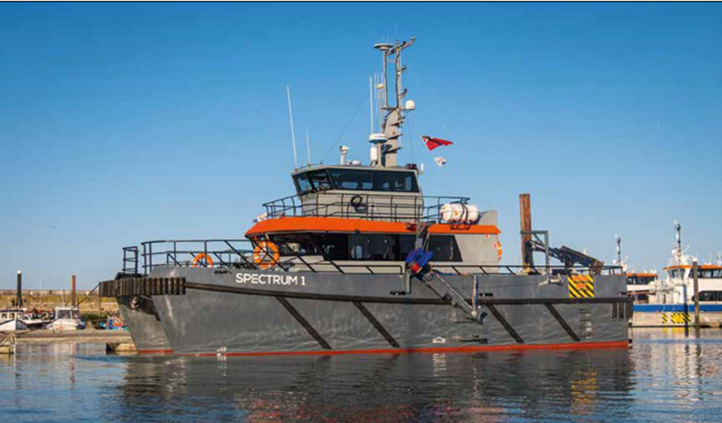

Vessel information
Name | Spectrum 1
Call sign | 2CQX3
MMSI | 235075021
Length | 17m
Beam | 6.5m

The Jack Up Vessel - Wind Energy - is planned to commence works within the boundary of the wind farm on 02nd February 2026.
The duration of the work scope is expected to take up to 10 days, subject to weather conditions

The wind turbine locations are as below:

ID03 Latitude 53⁰12.202’N Longitude 000⁰25.965’E
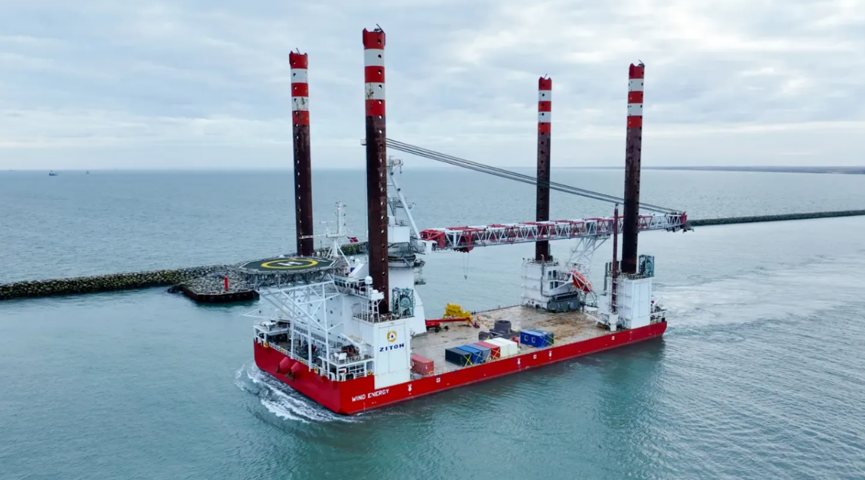

Vessel information
Name | Wind Energy
Call sign | OUYH2
MMSI | 219032199
Length | 120m
Beam | 40m

Lynn and Inner Dowsing Wind Turbine Locations

Mariners should maintain a safe distance of 500m from both vessels when they are on station.

Mariners are advised to exert caution in the vicinity of the wind farm during this time and should communicate with the Siemens Gamesa Operational Marine Controller when operating near the site.

Siemens Gamesa Operational Marine Controller
Email: LIDOperationalmarinecontrol@siemens-energy.com
Tel: 01472 806851 / 07921 249544
Radio Channel: 161.175MHz

Windfarm Liaison
Mariners are also advised that Lynn and Inner Dowsing inquiries should be directed to the Site Owners Representatives – XceCo.

Phone: 01472 806860
Email: flo@xceco.co.uk

